

Content:

Details:

1. Technical Design
2. Testing report
3. Error report

Pages:

3

63

66

Technical design:

Screenshots [1st attempt]:

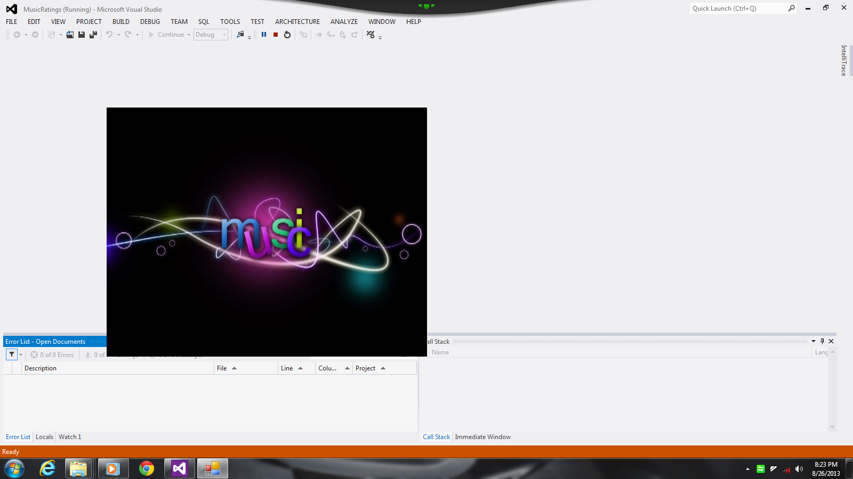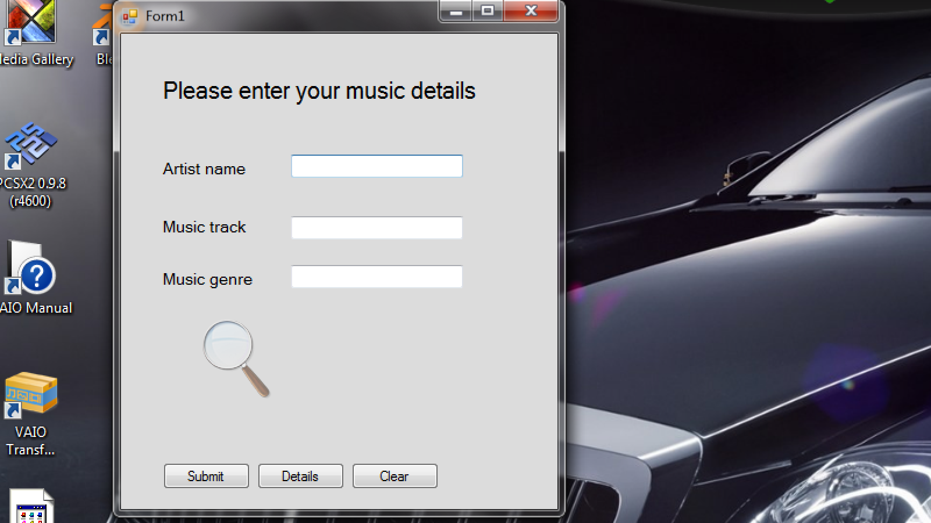

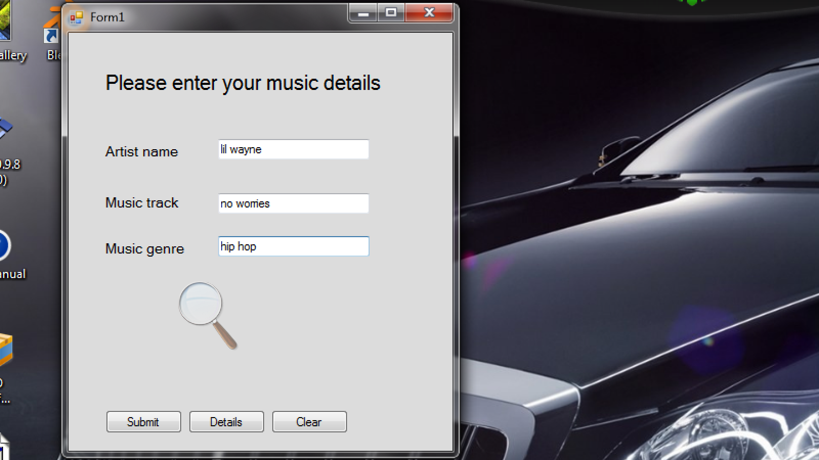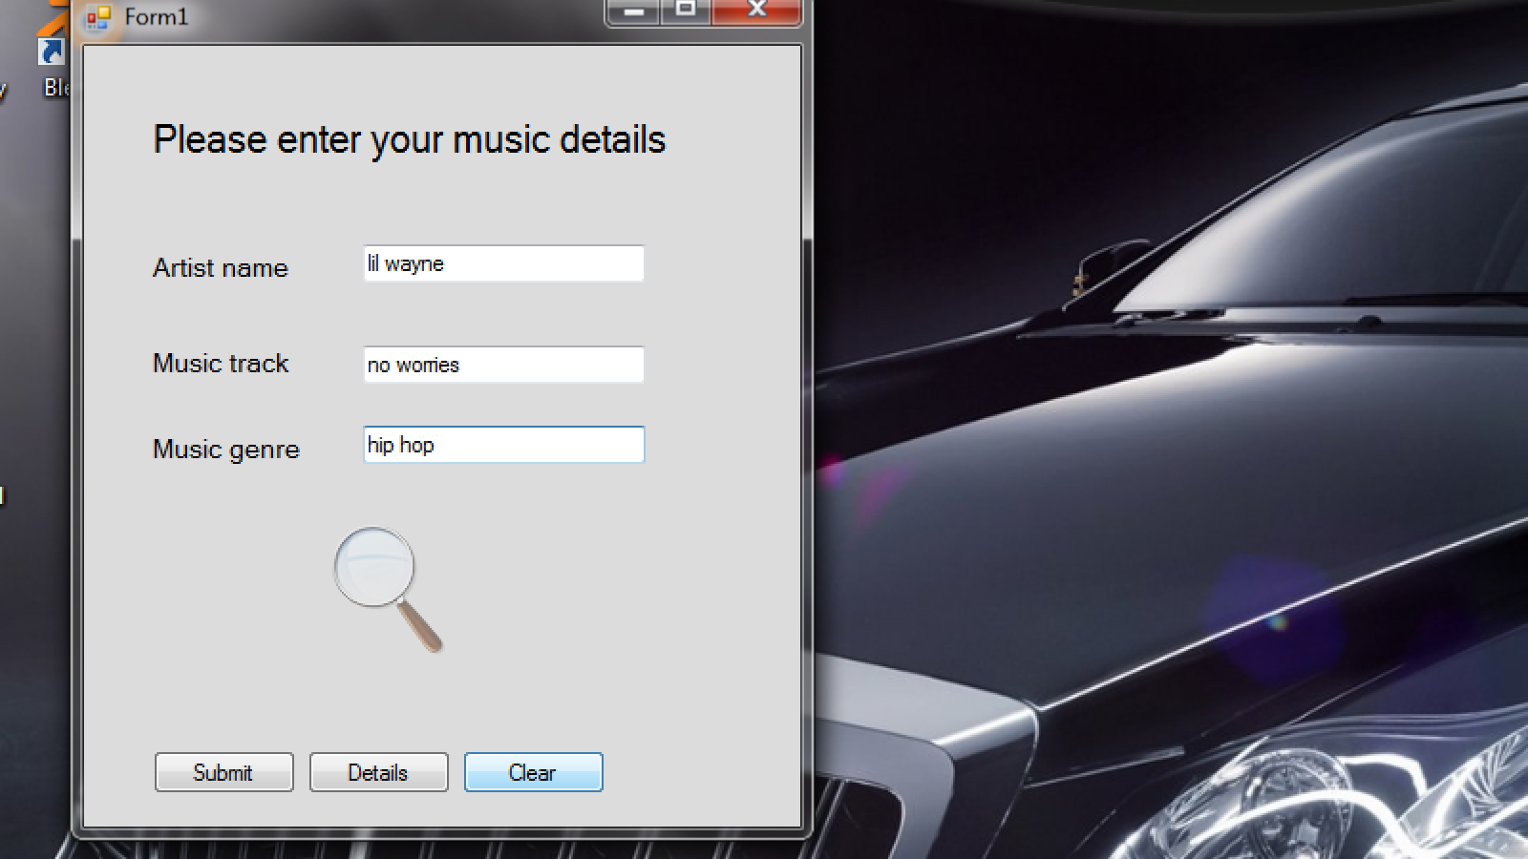

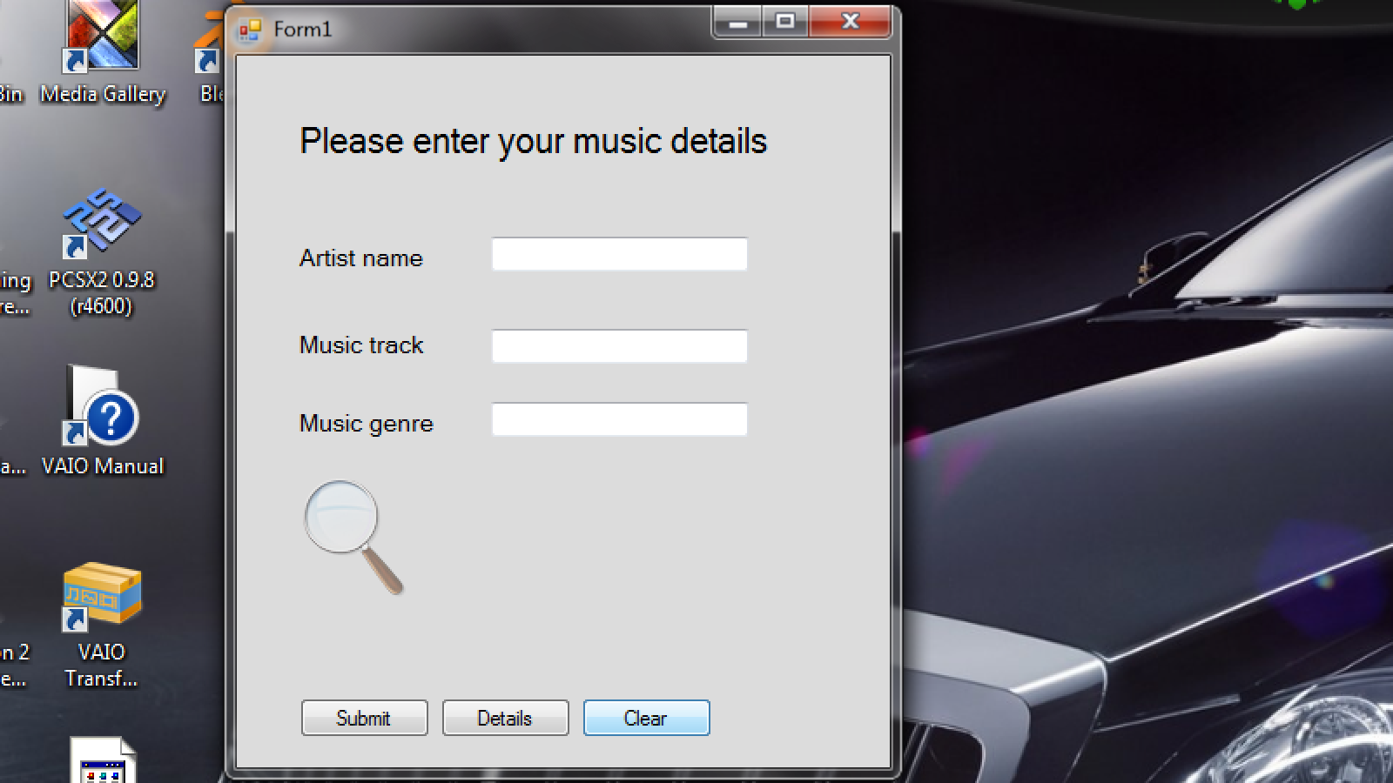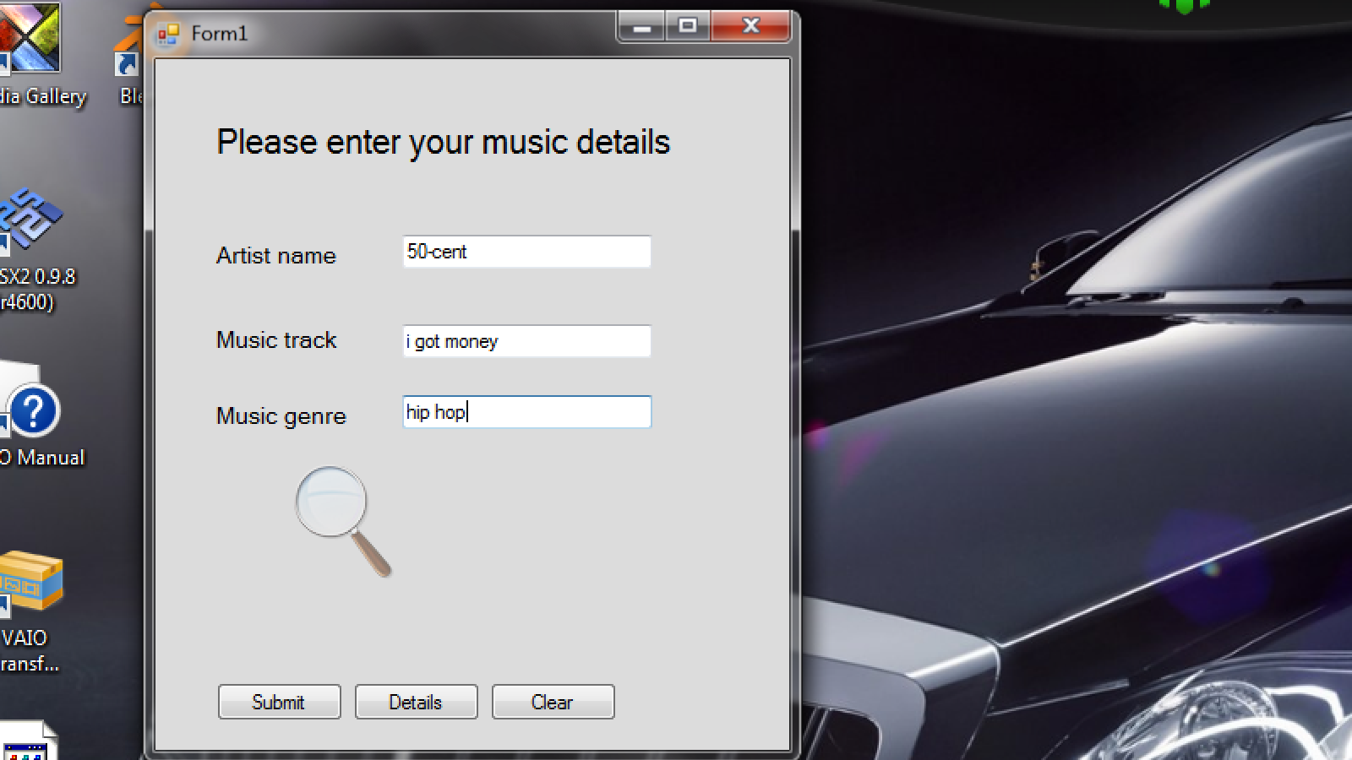

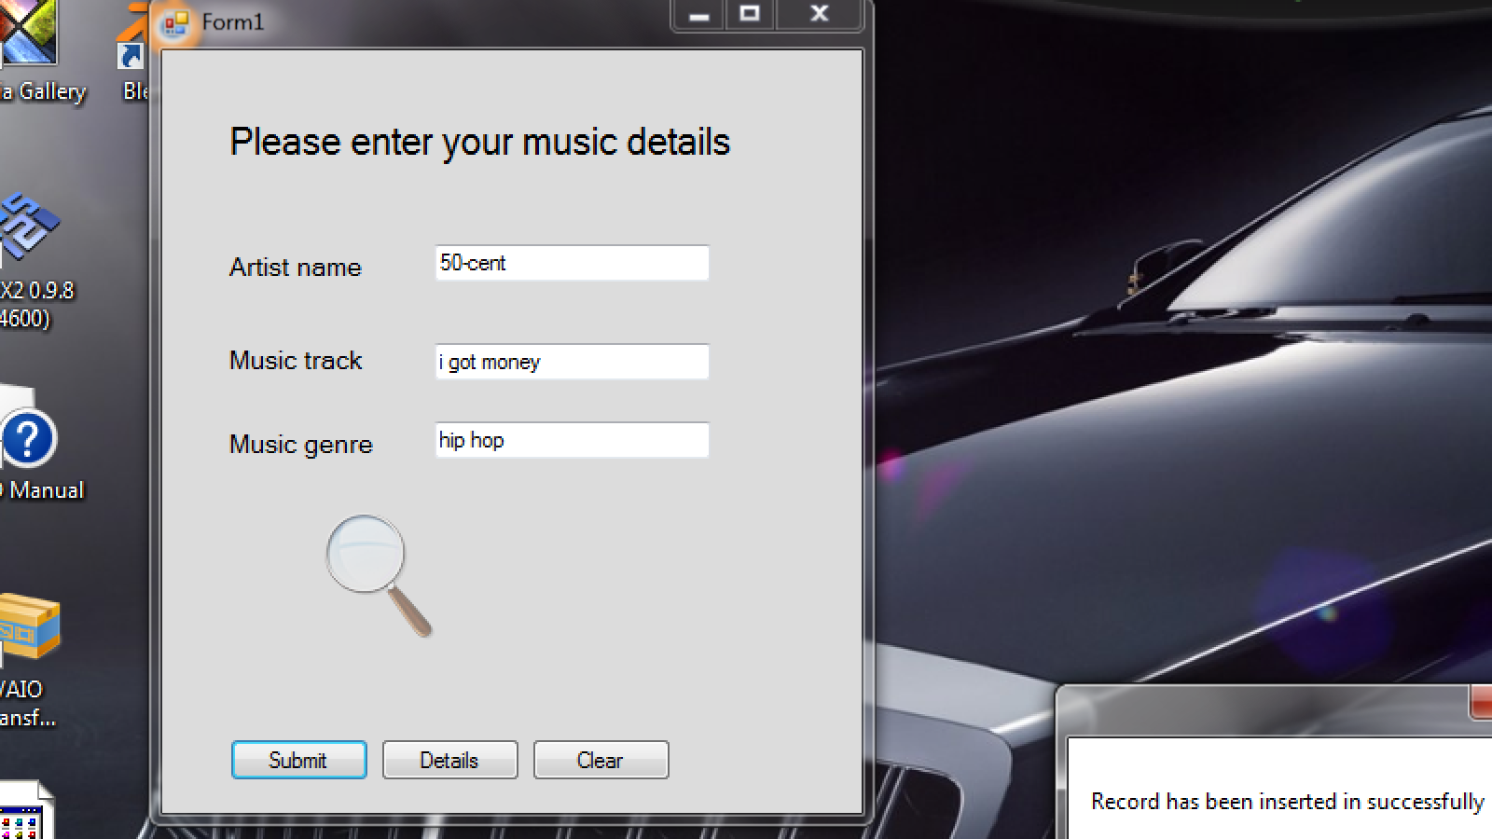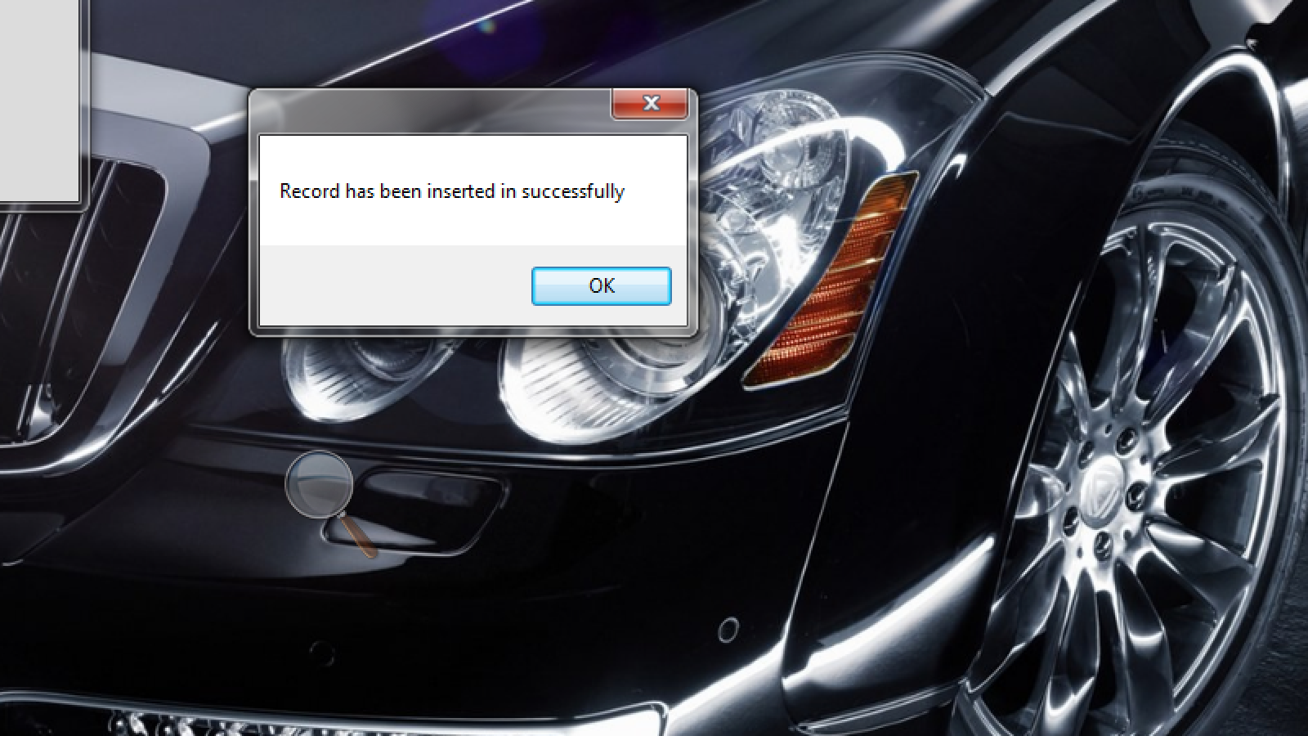

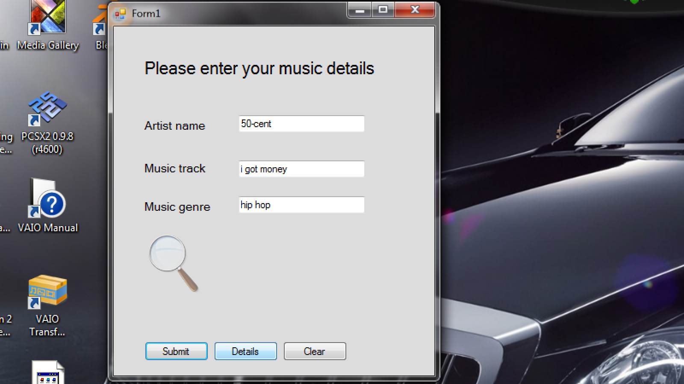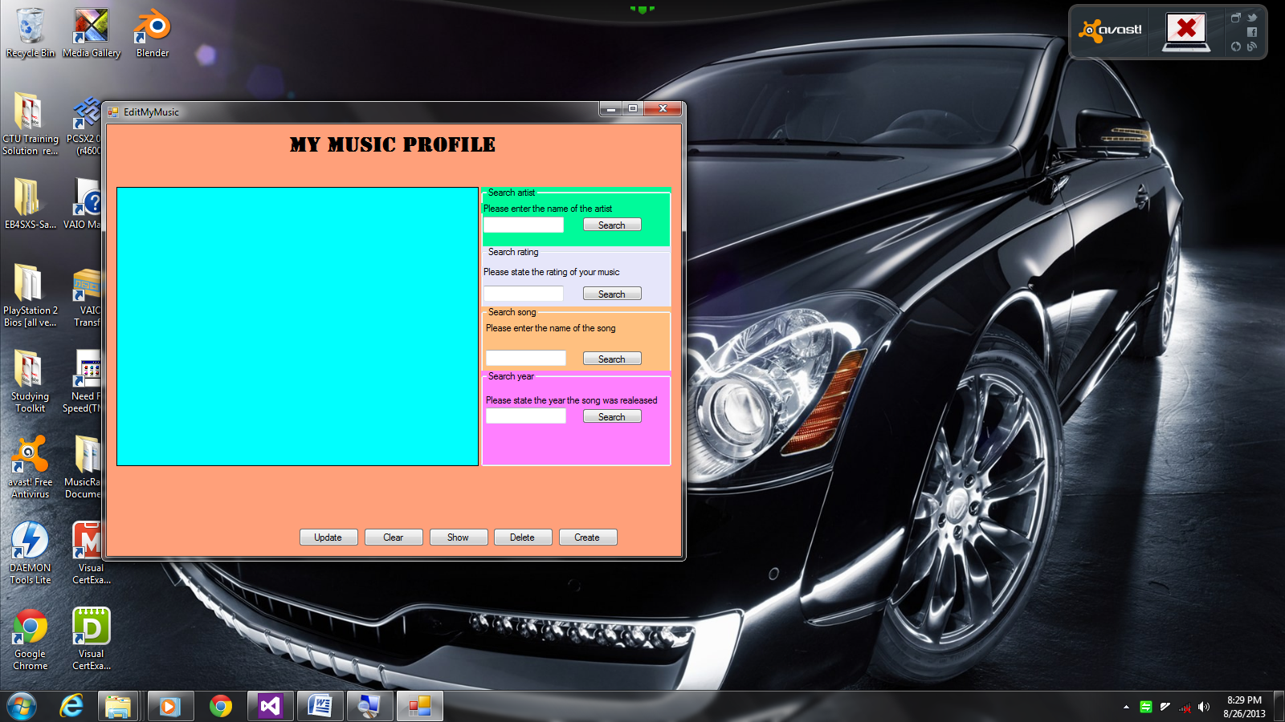

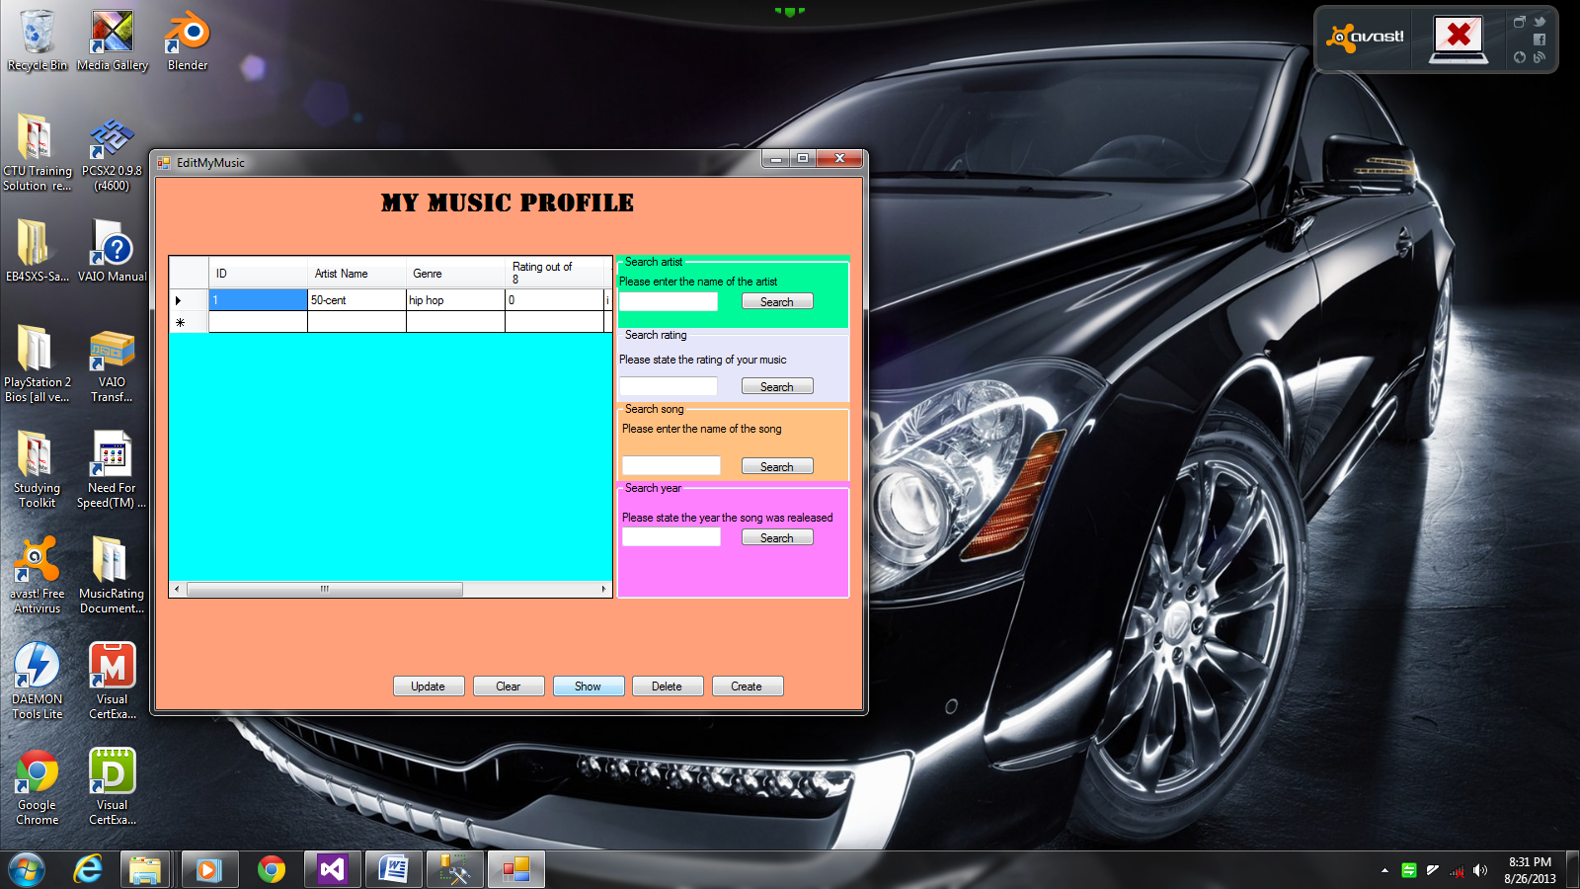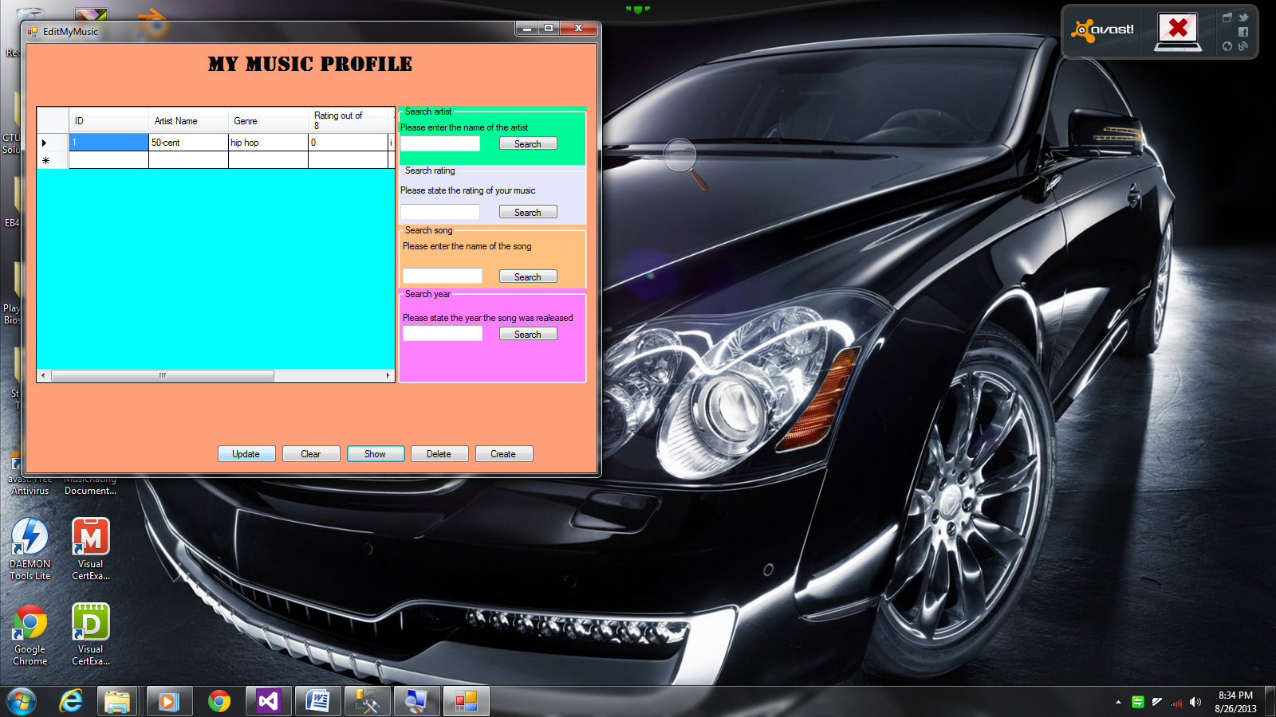

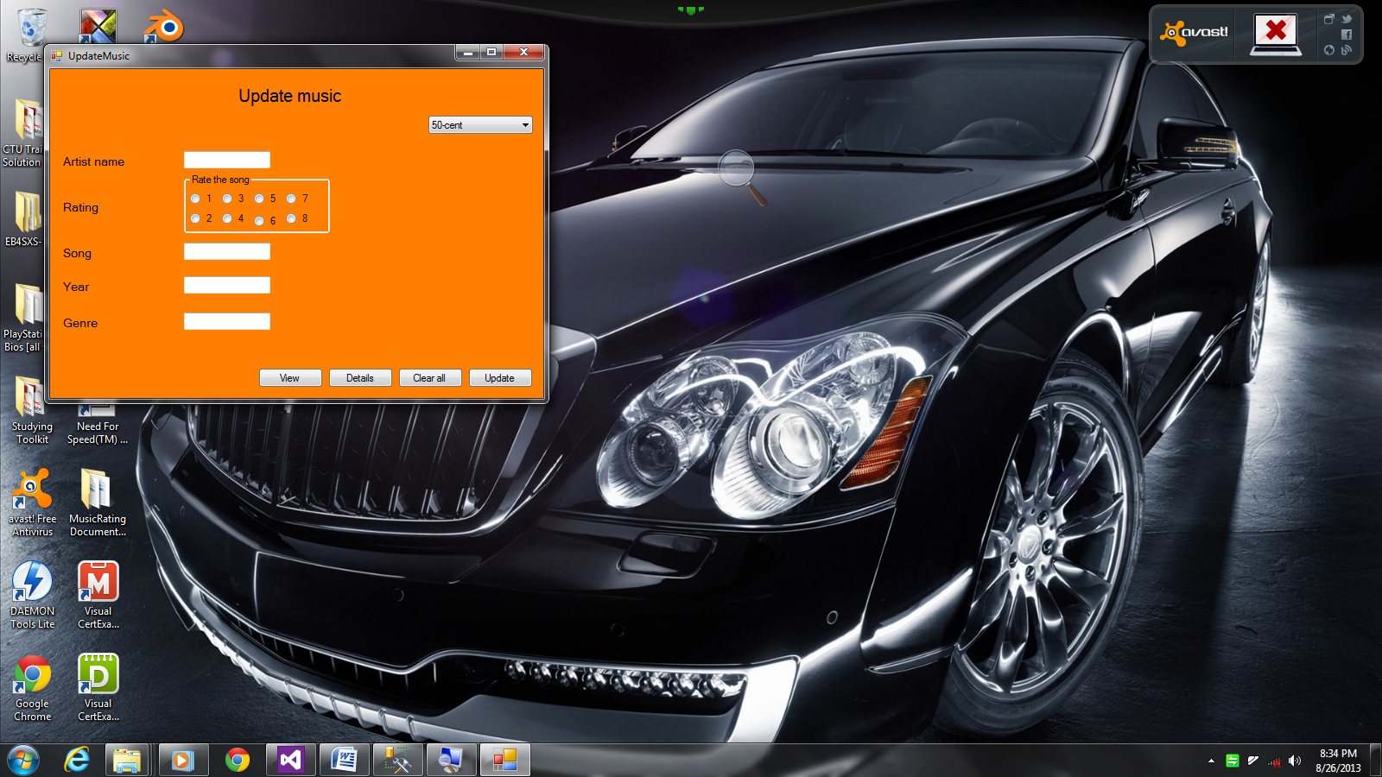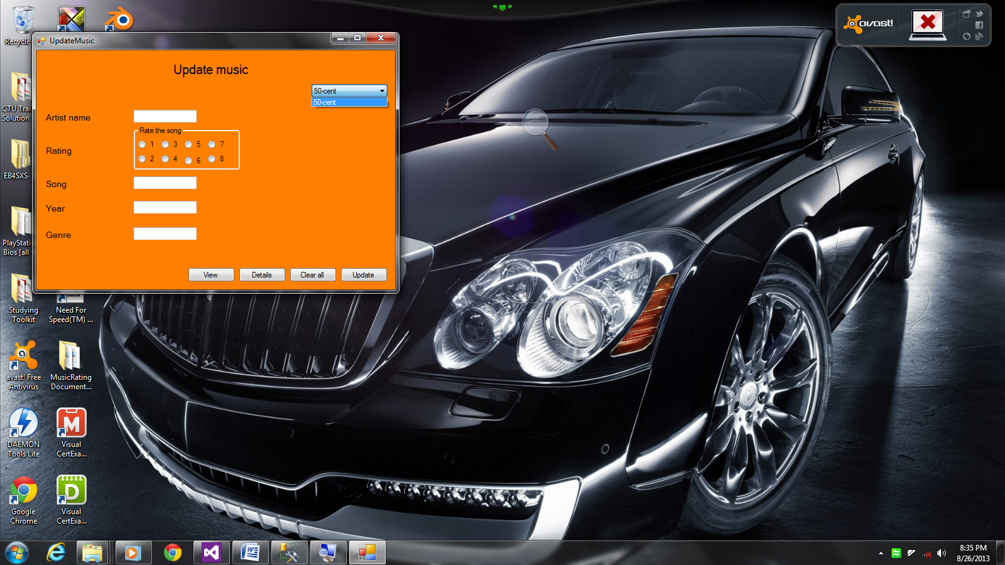

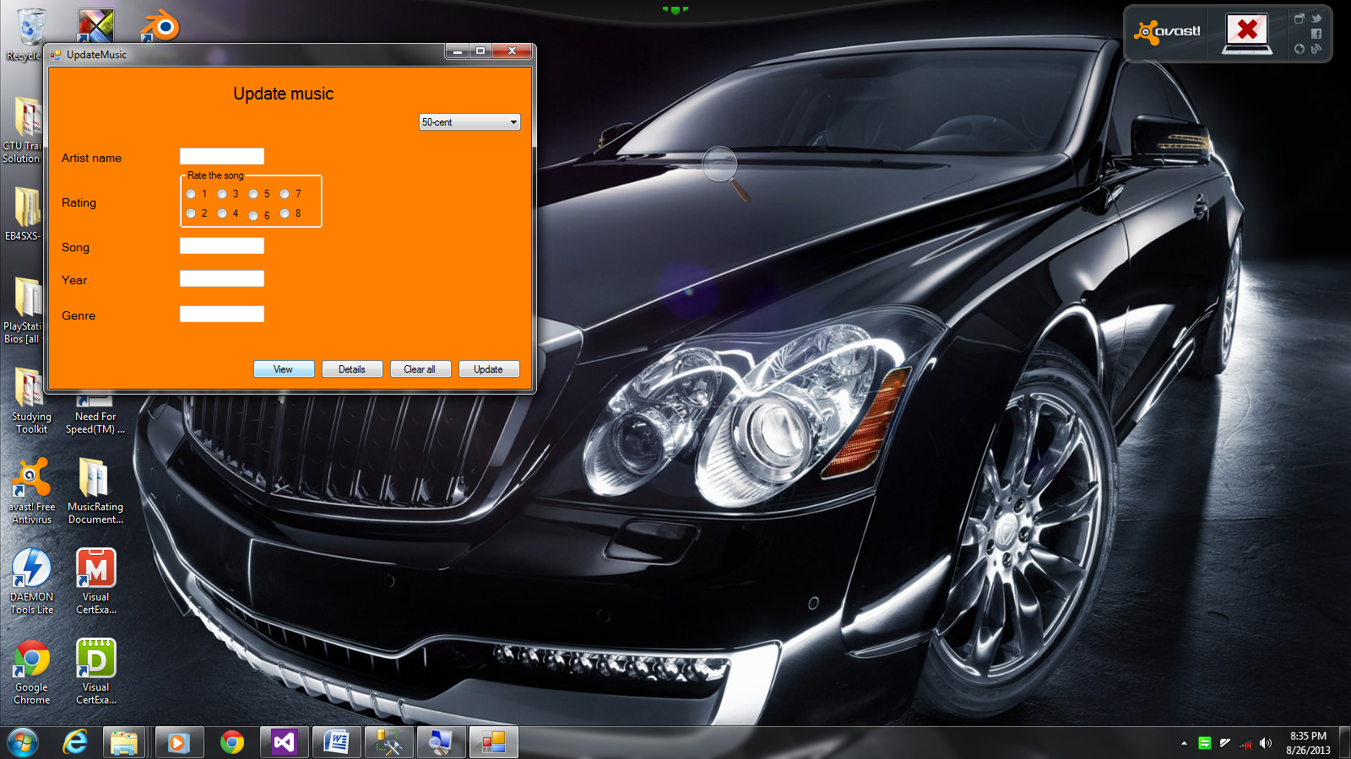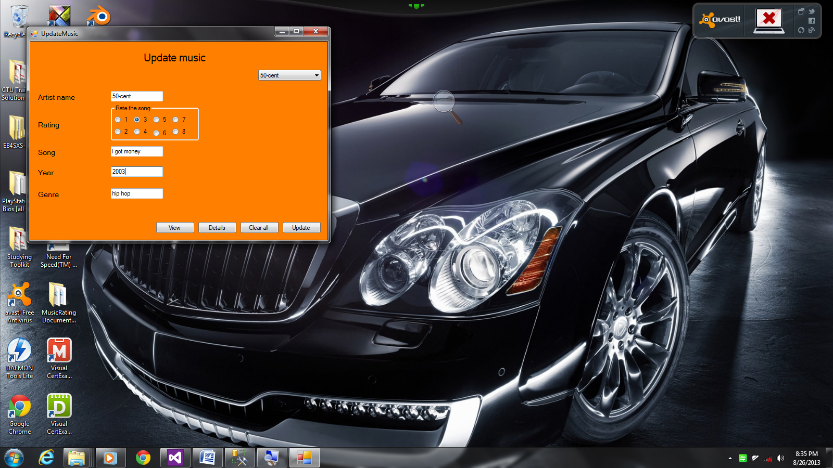

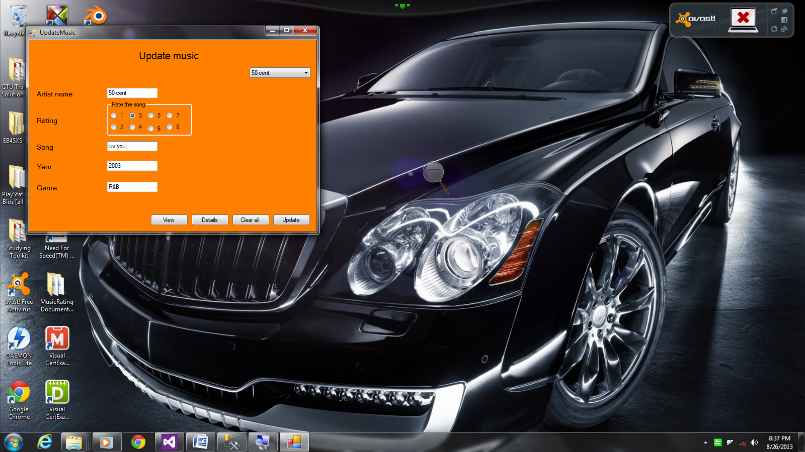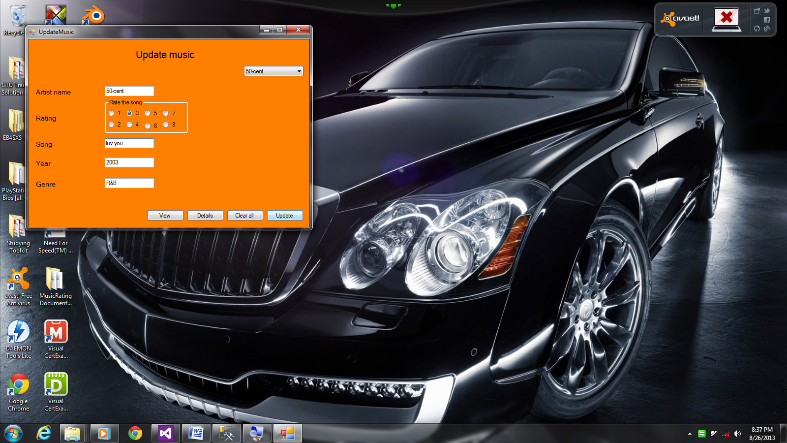

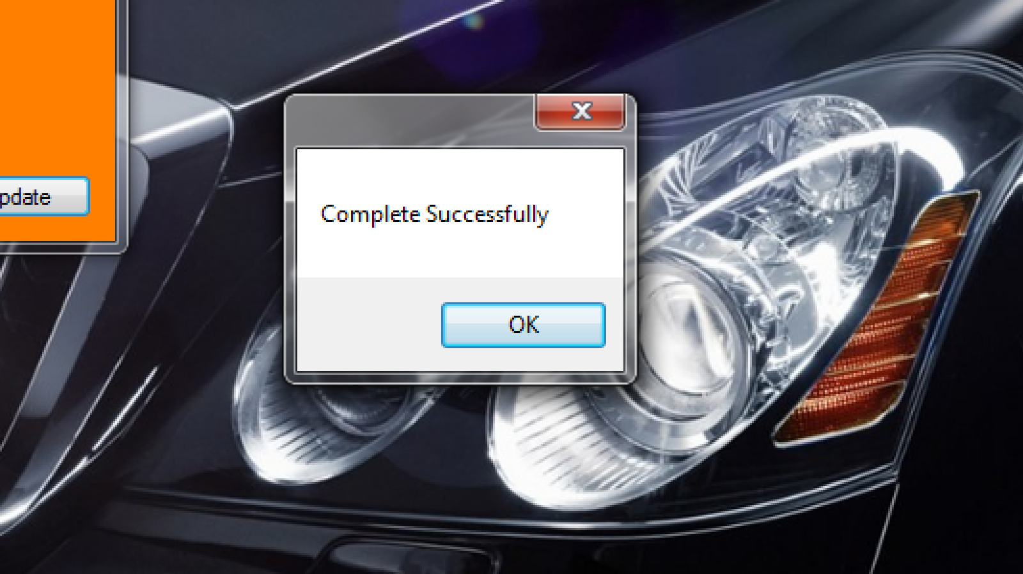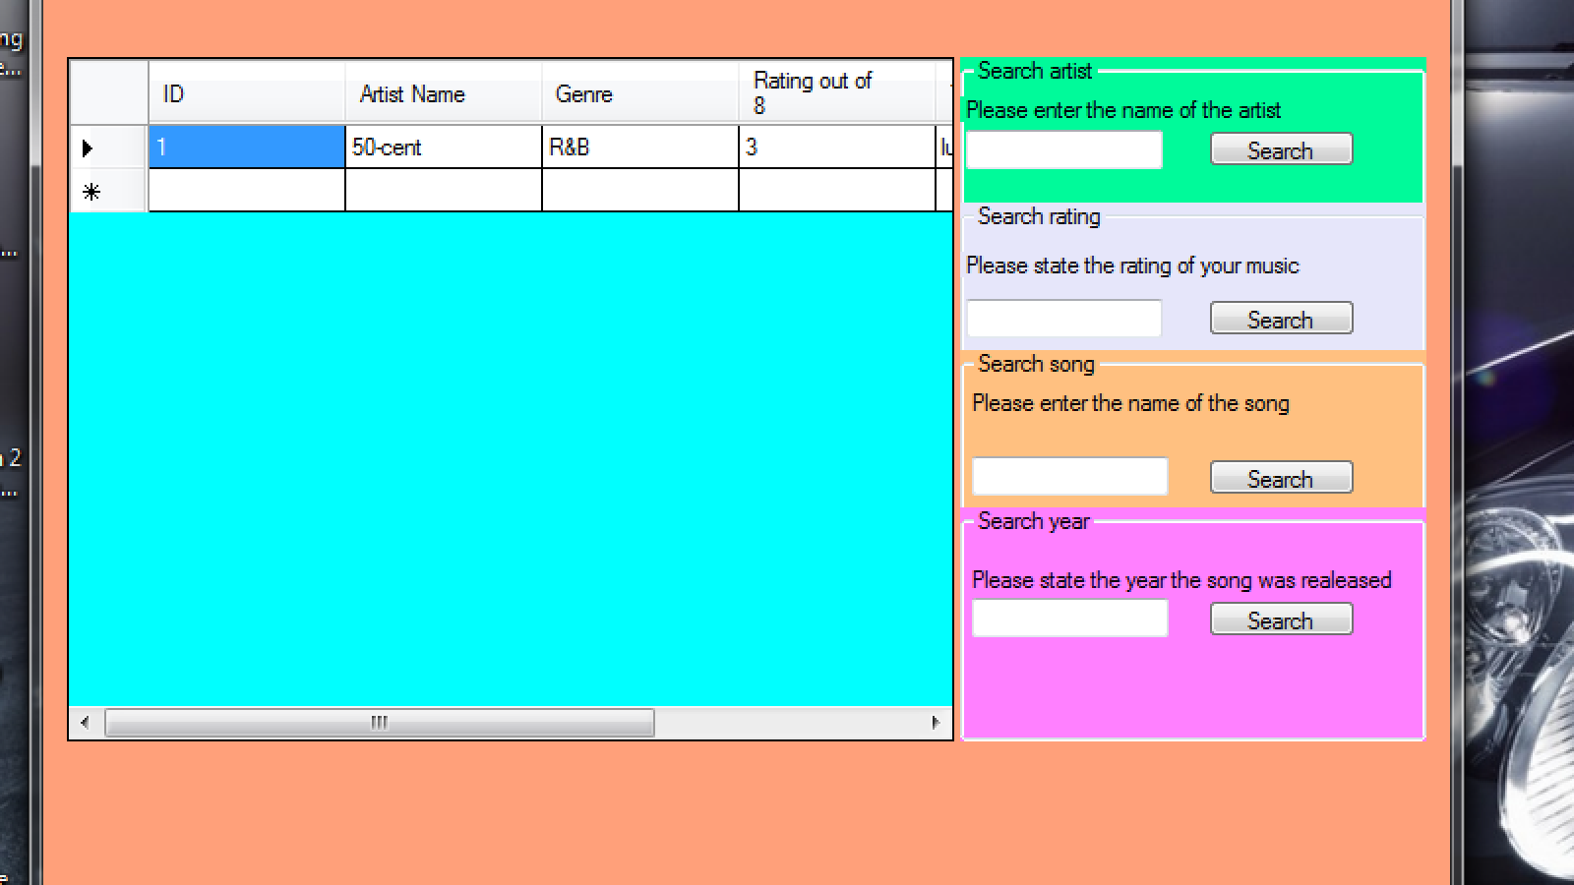

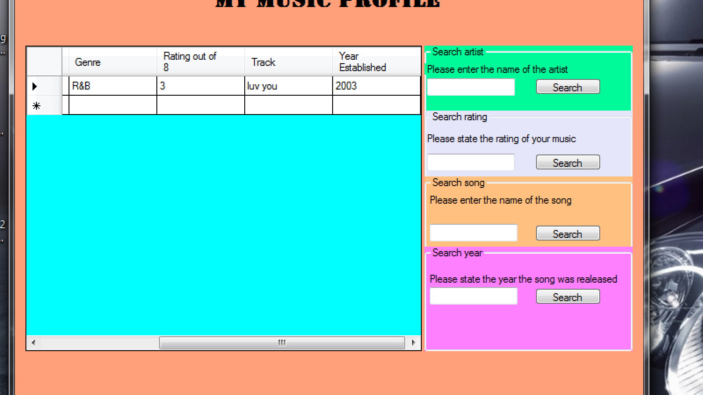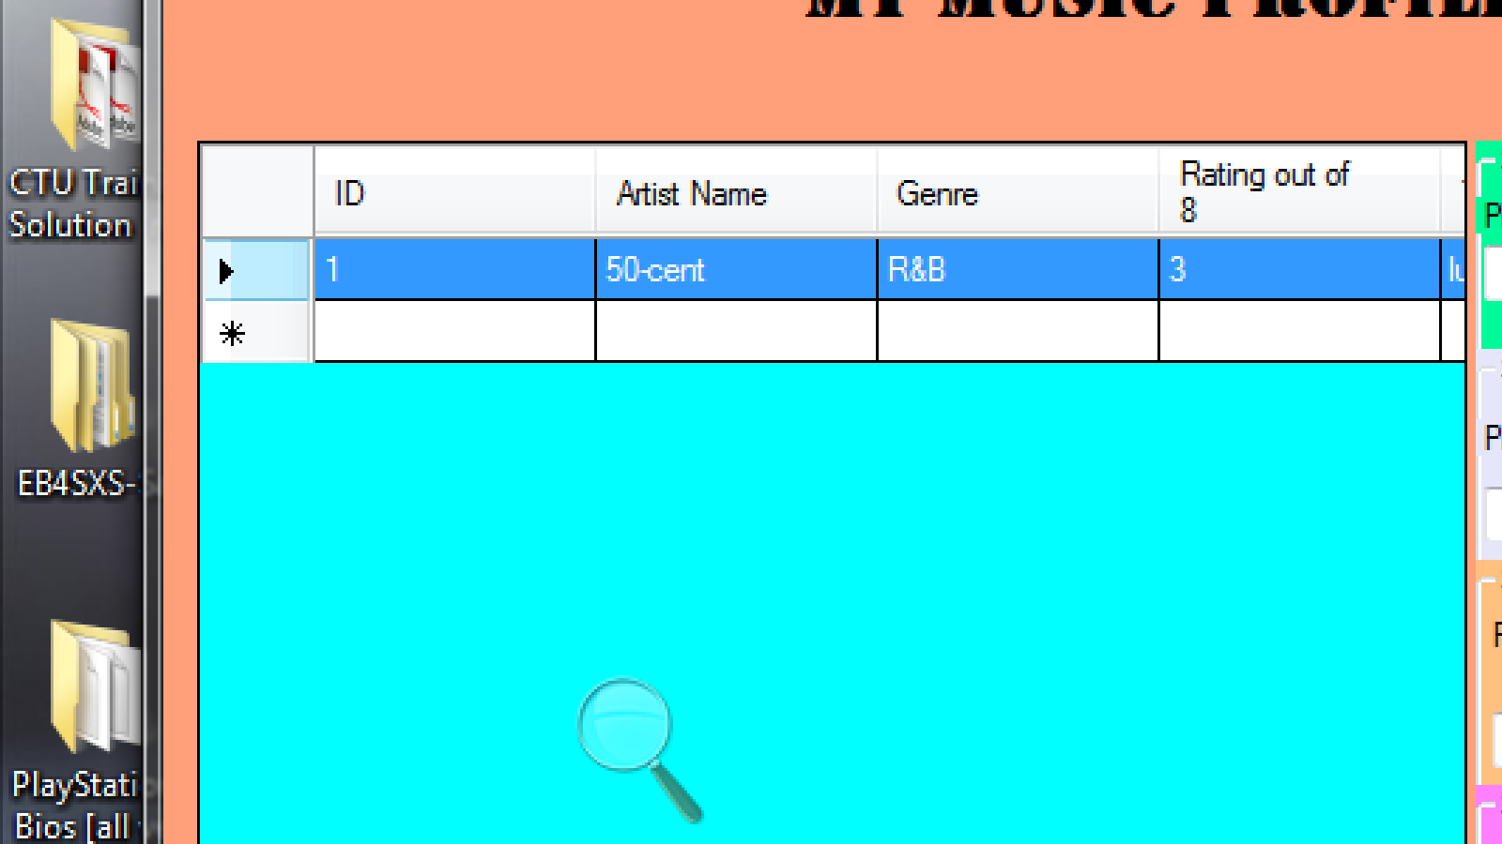

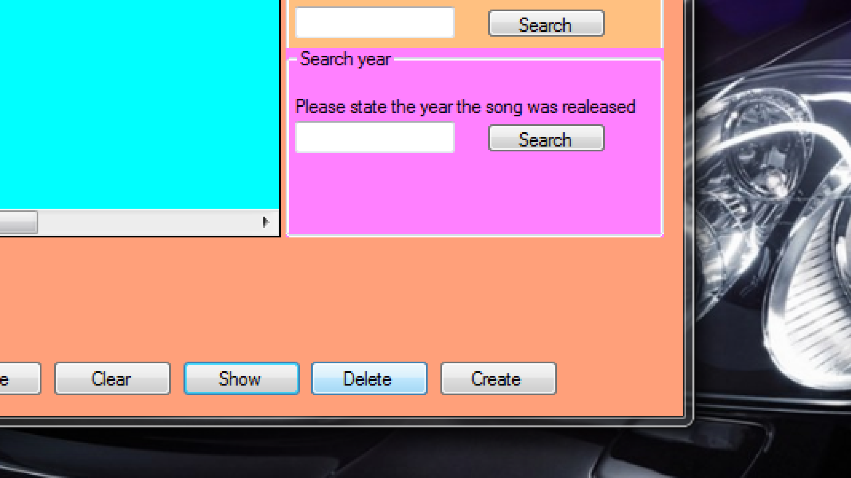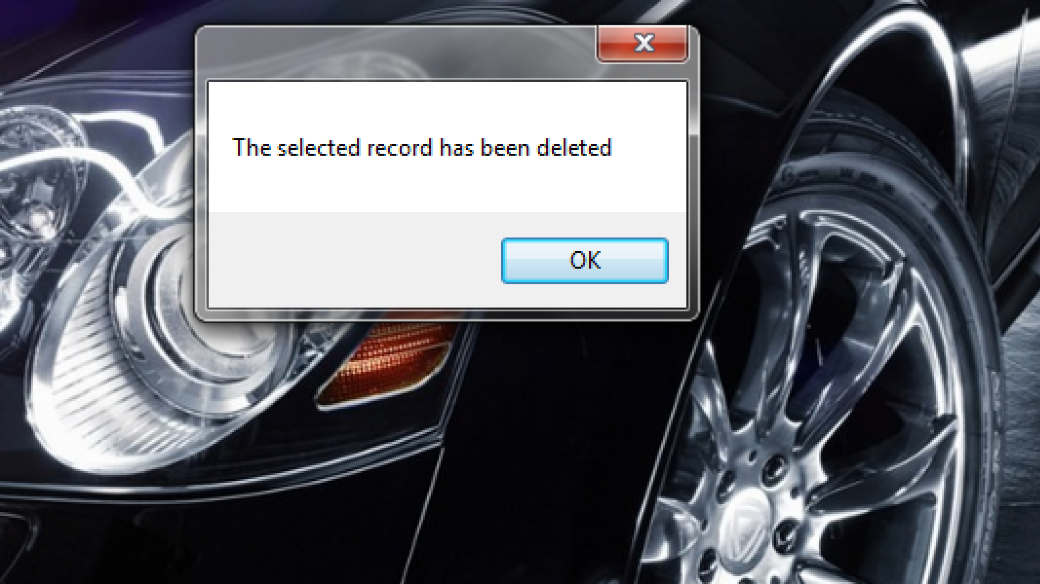

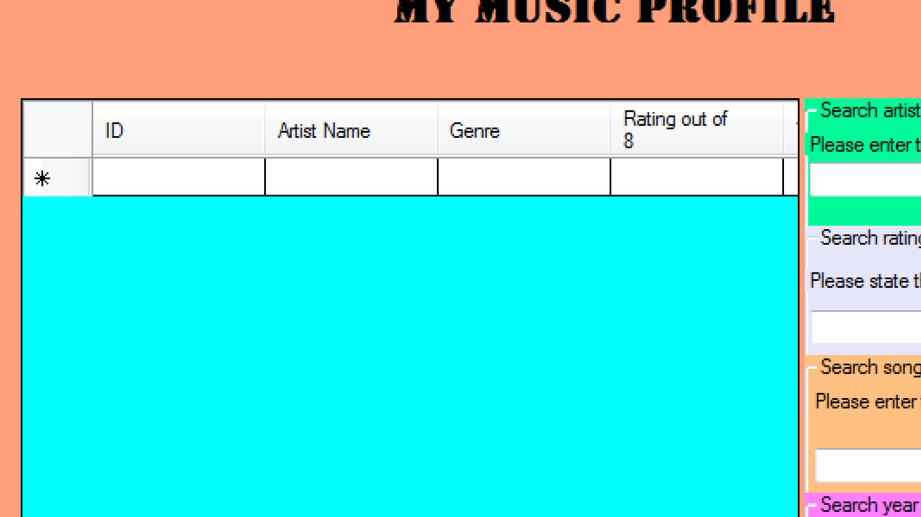

Screenshots [2nd attempt]:

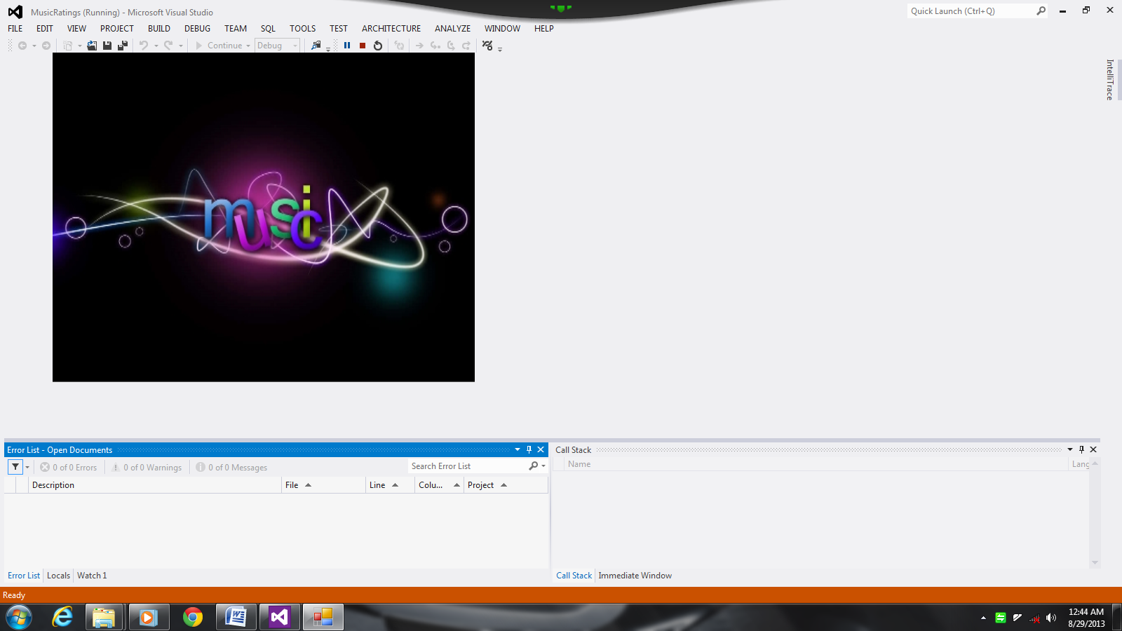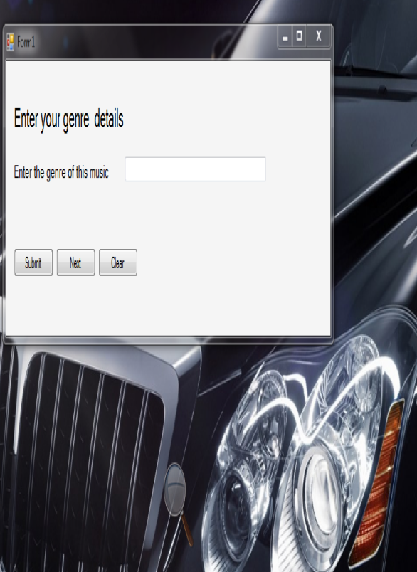

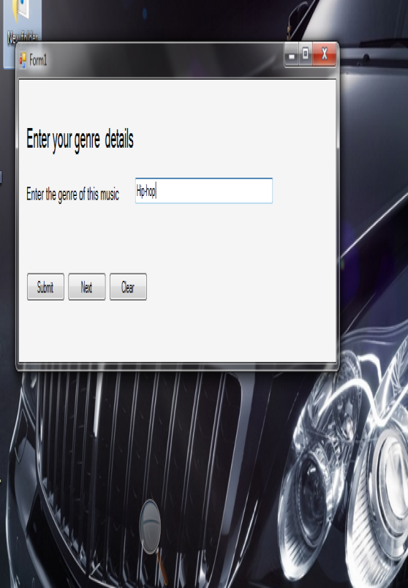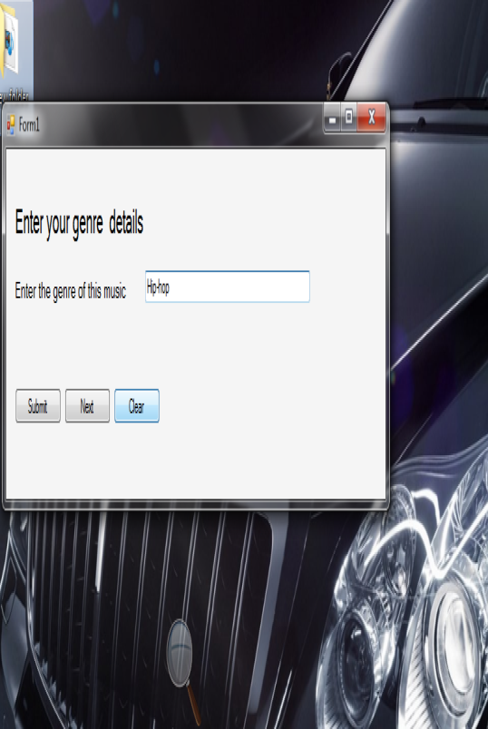

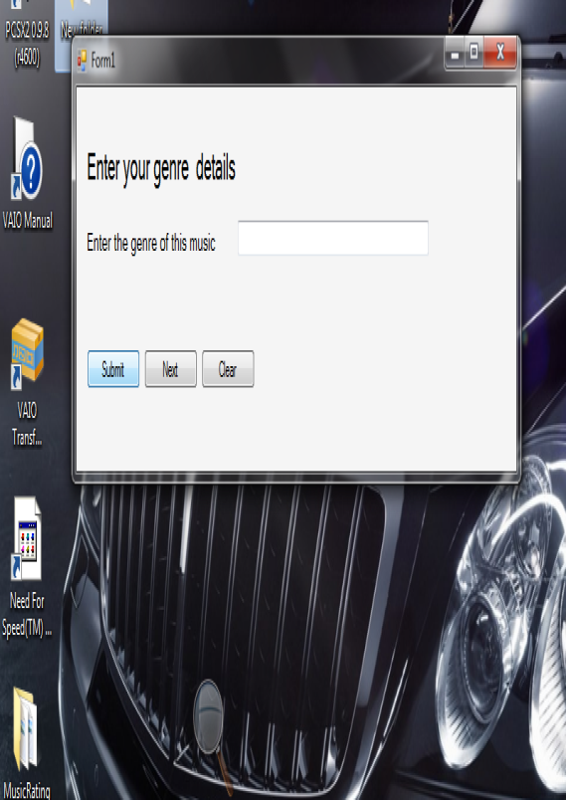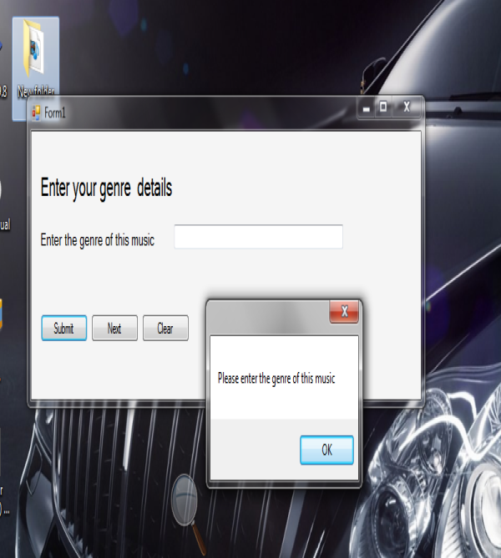

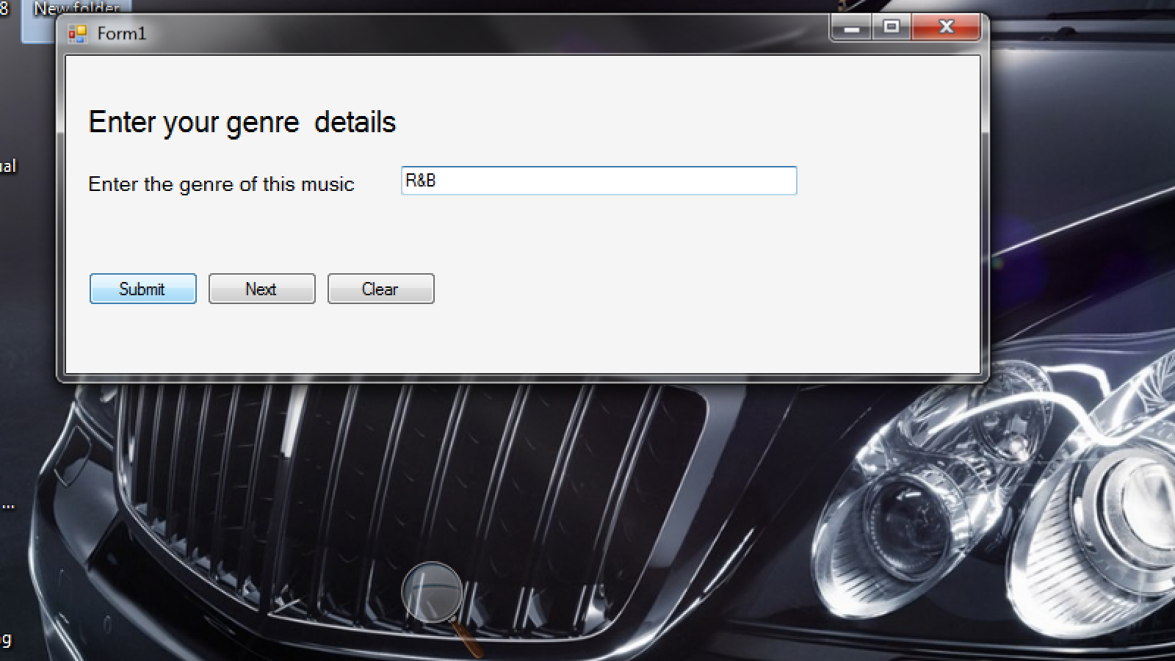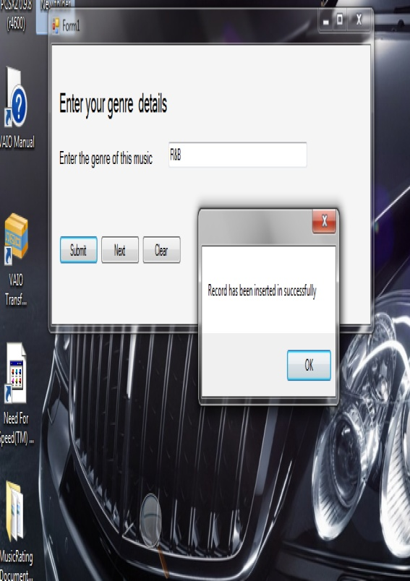

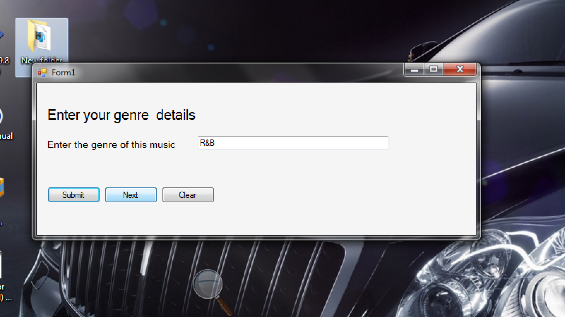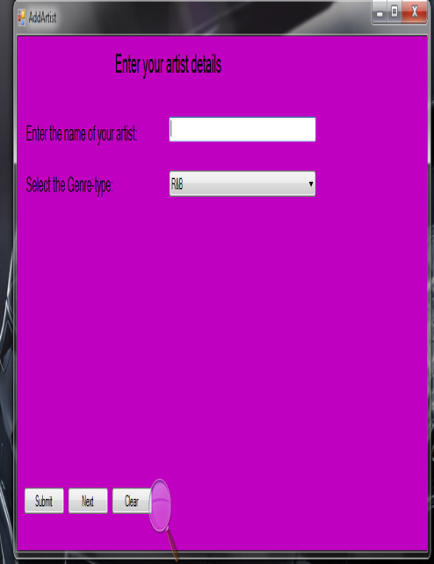

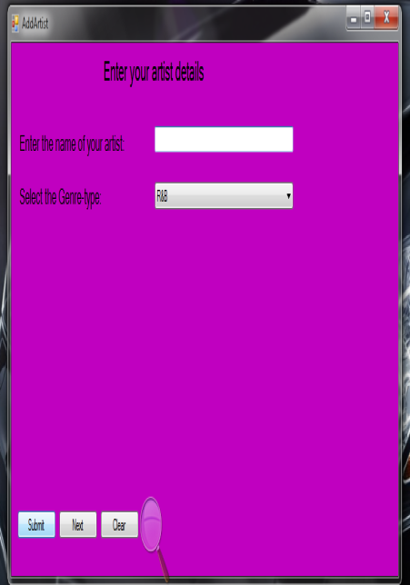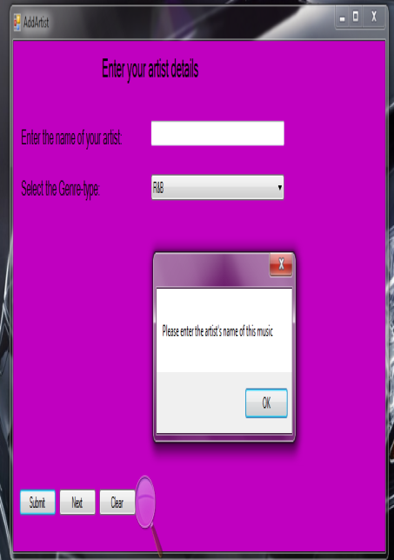

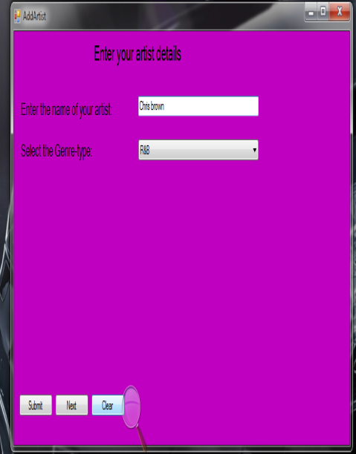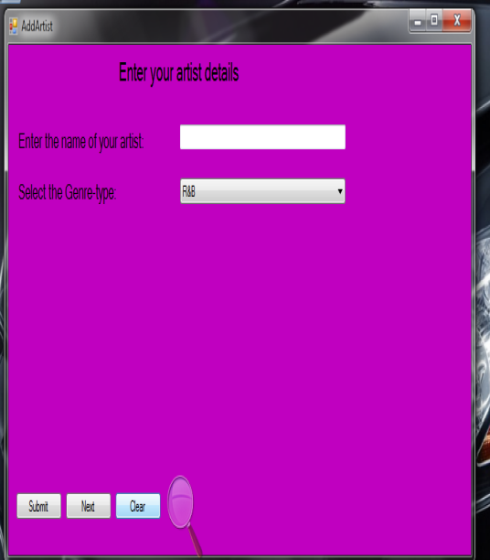

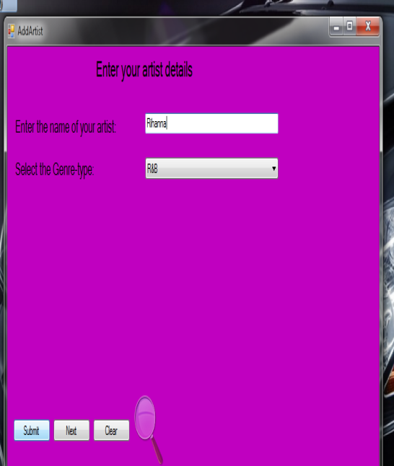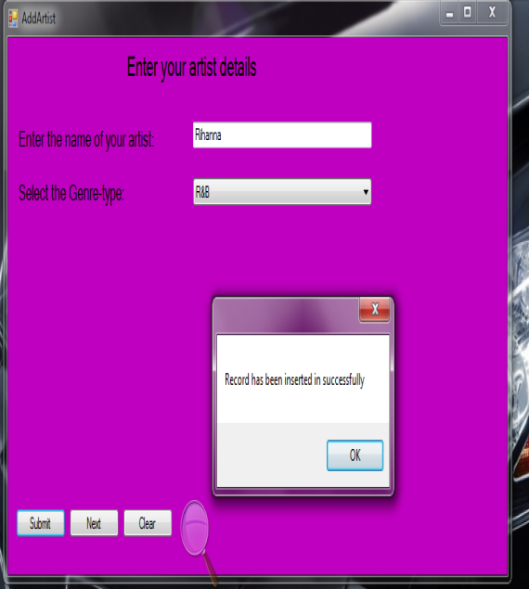

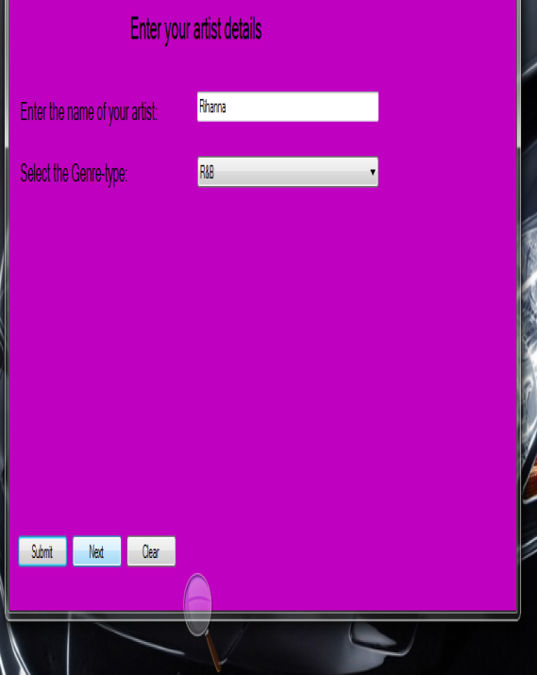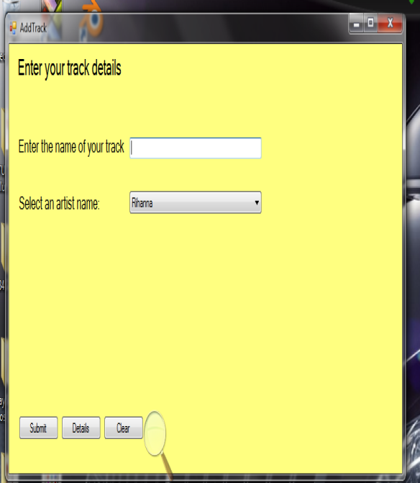

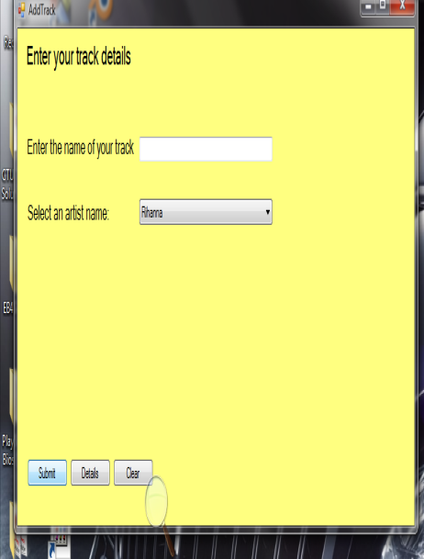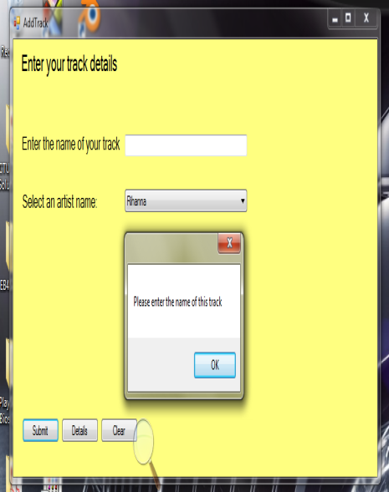

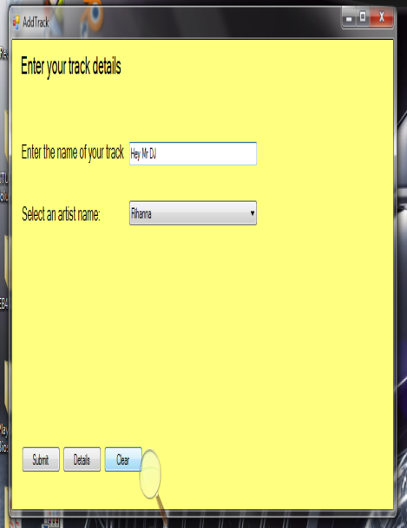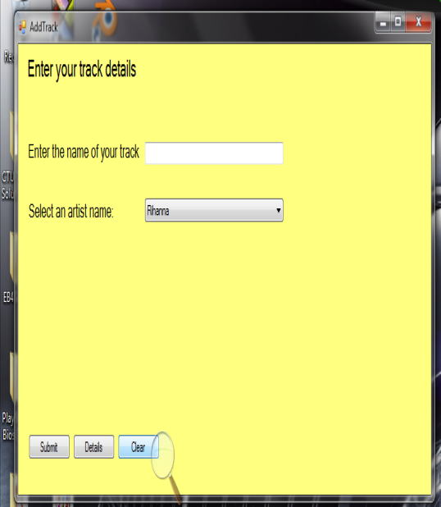

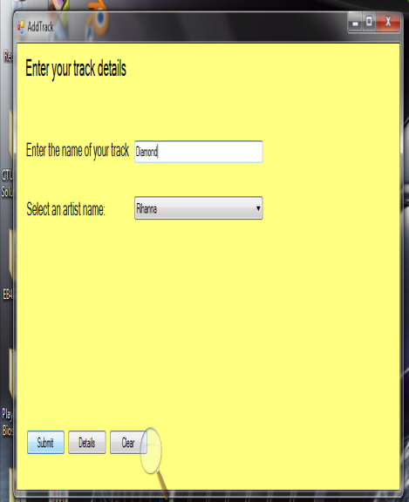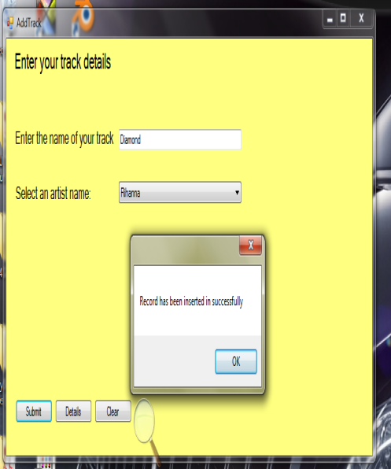

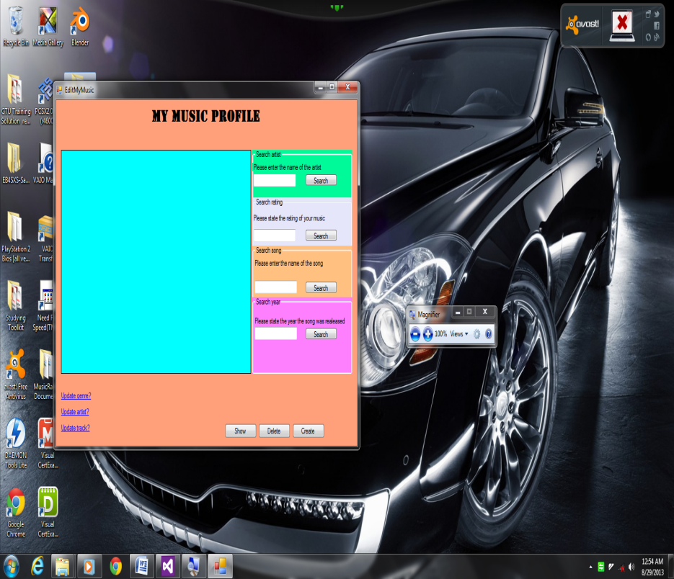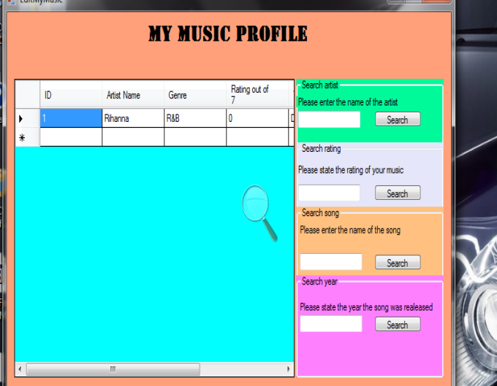

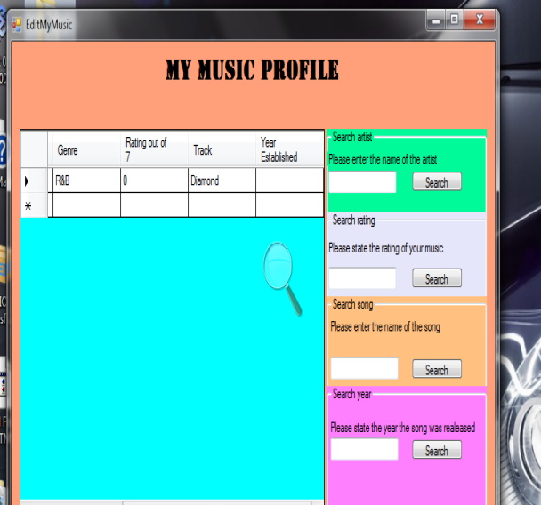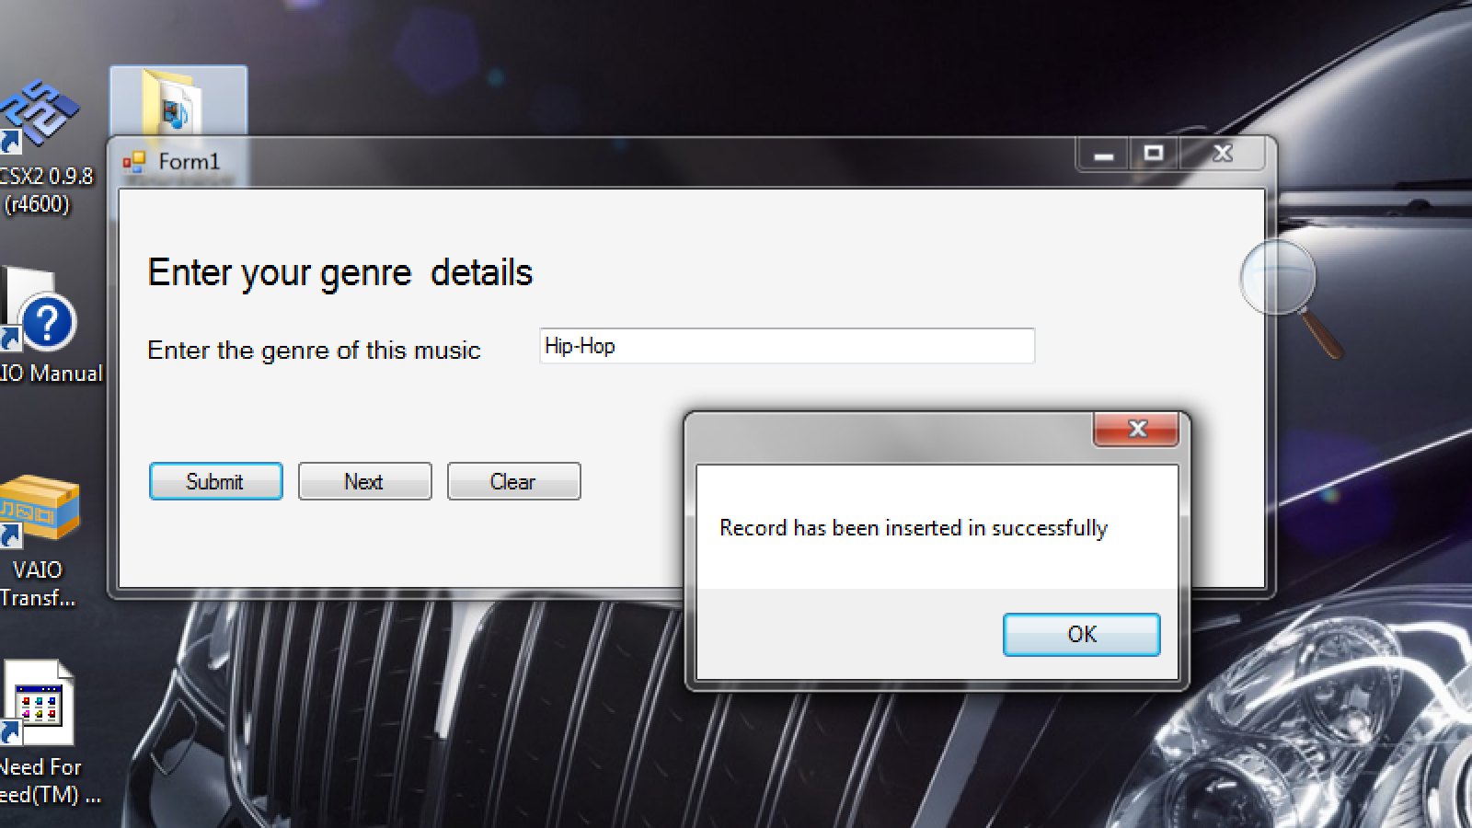

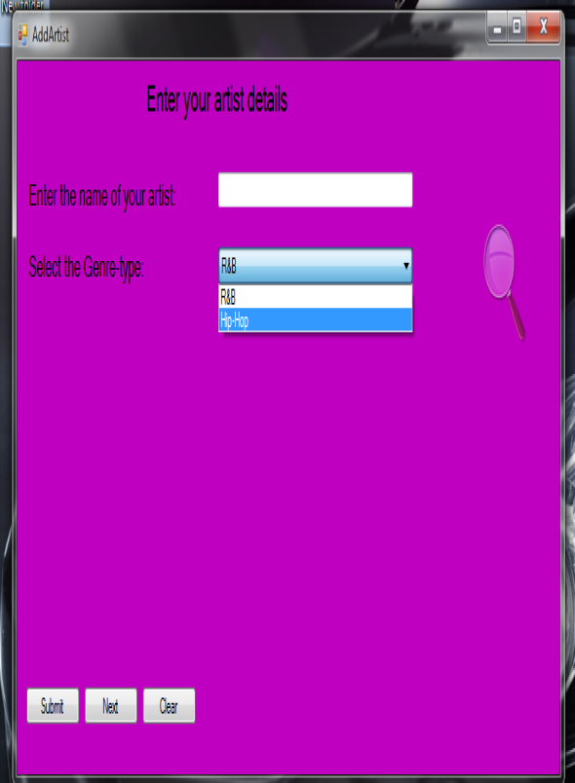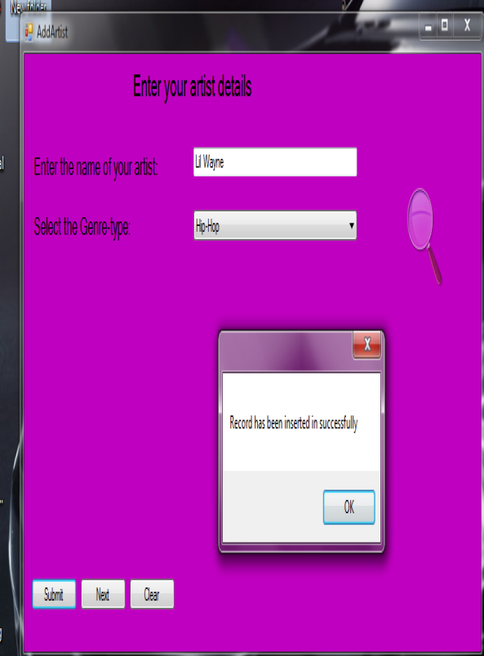

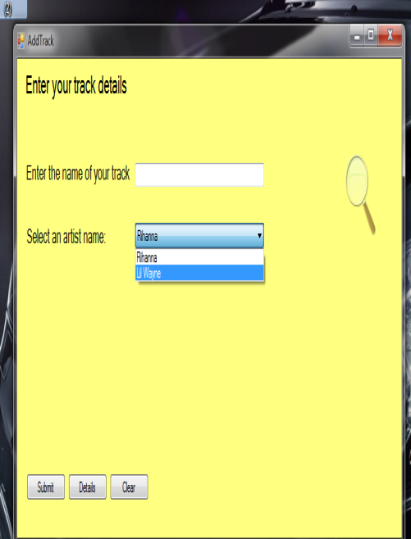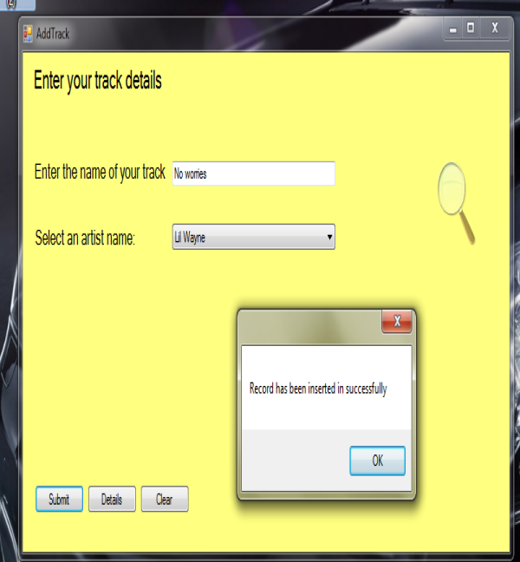

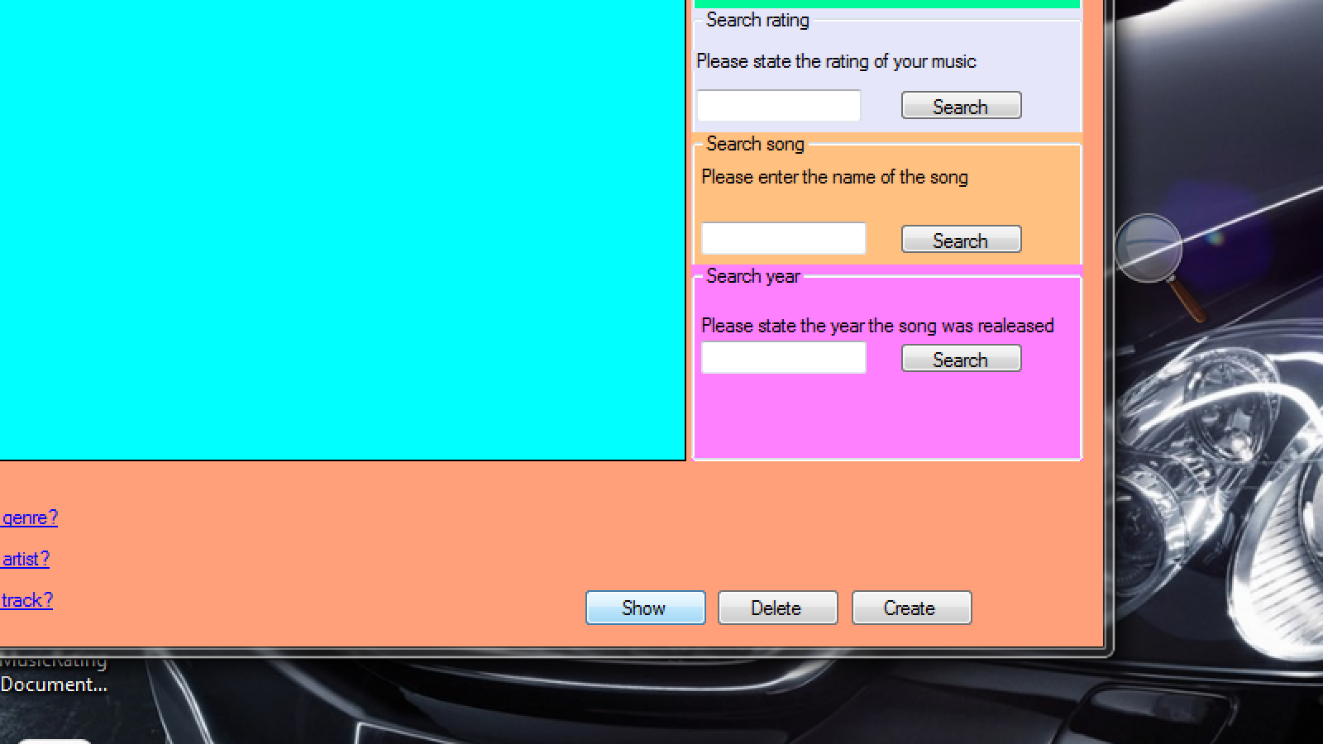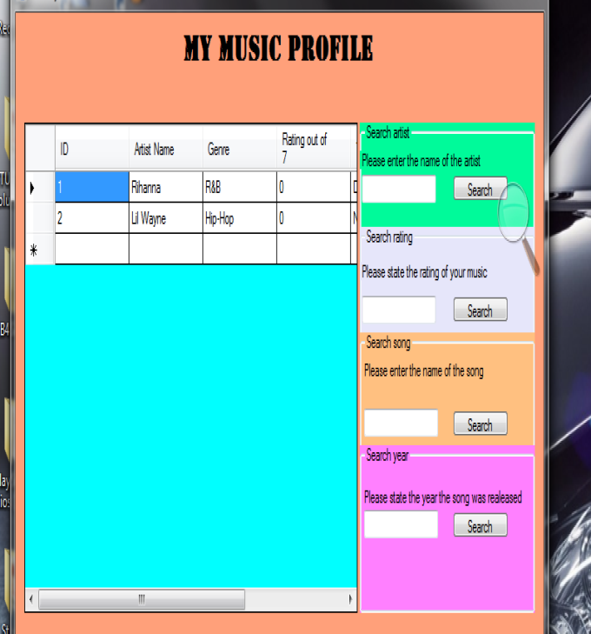

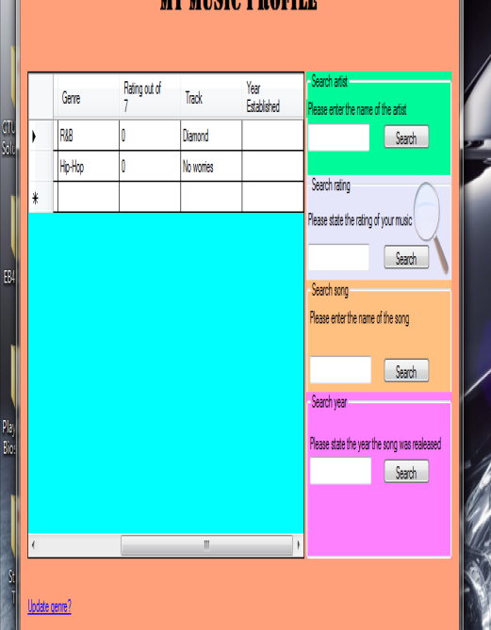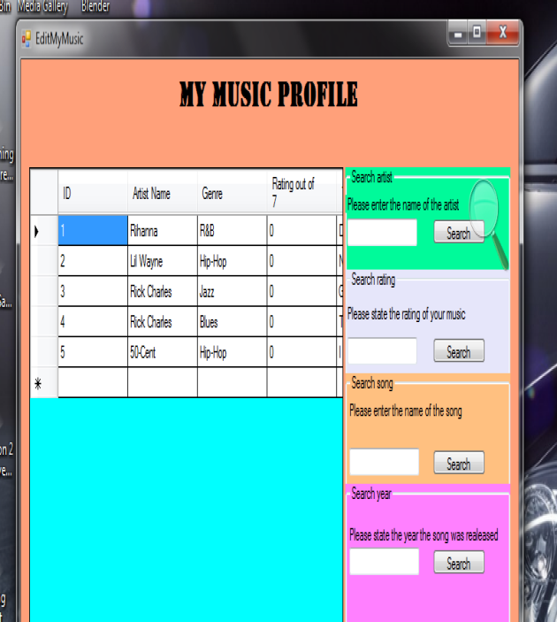

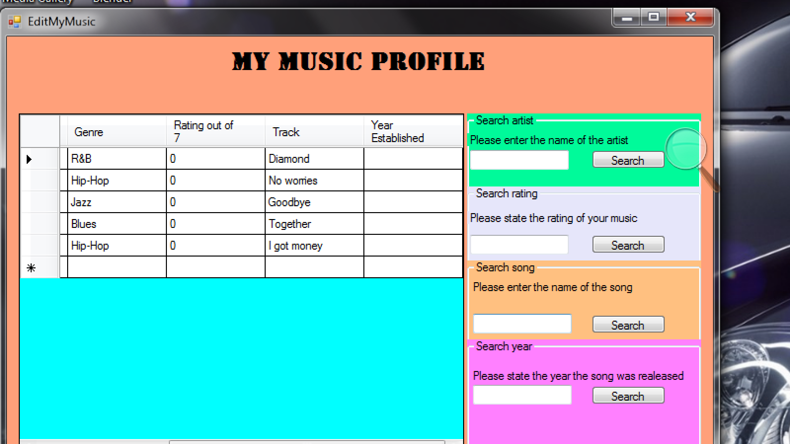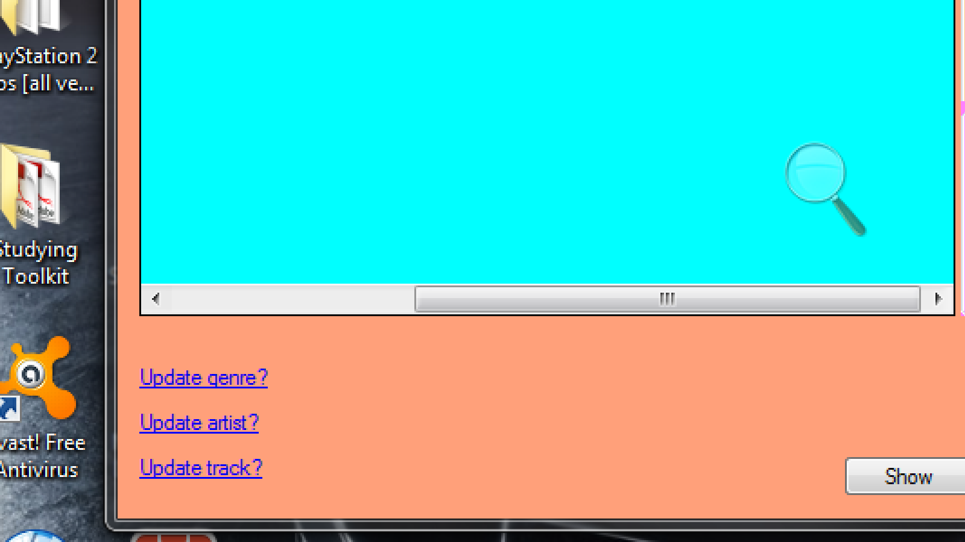

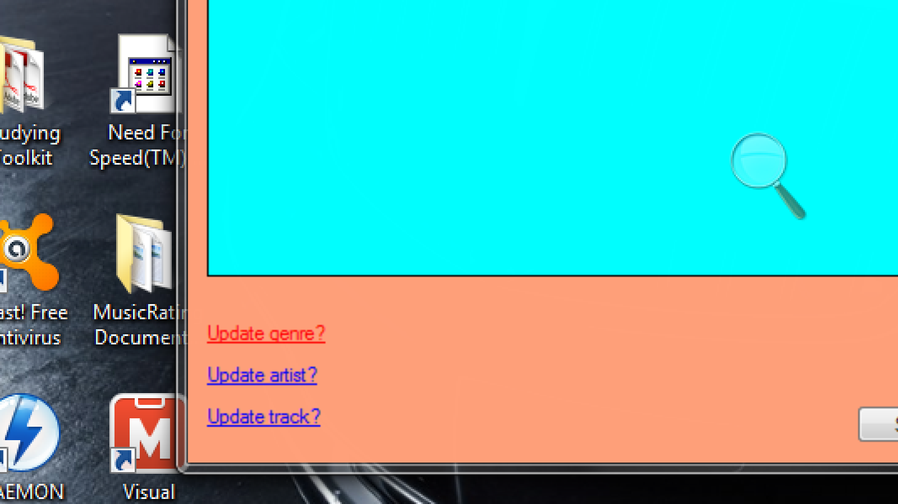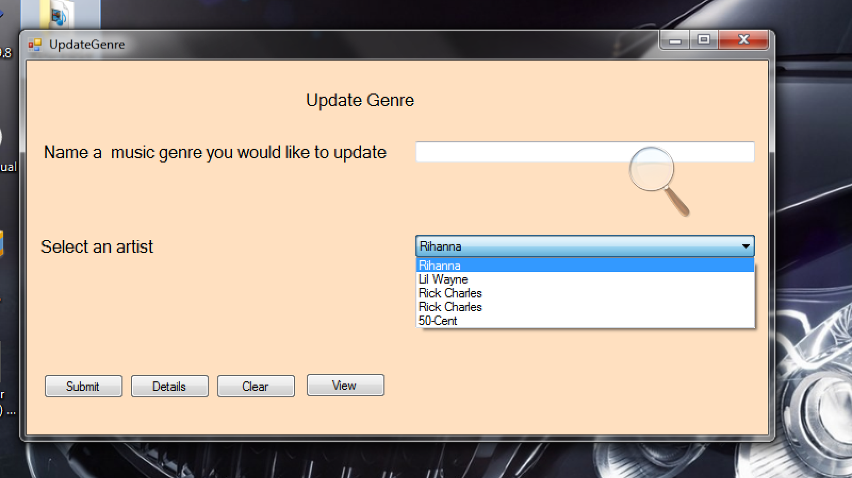

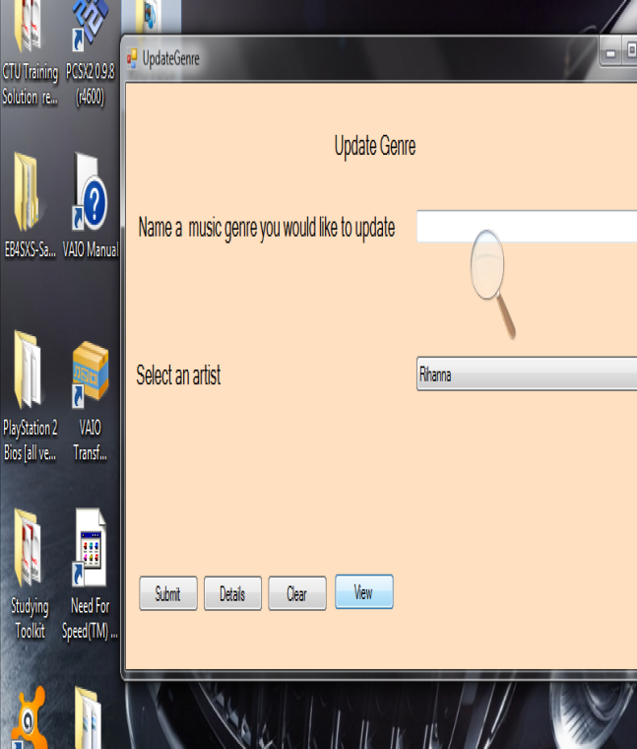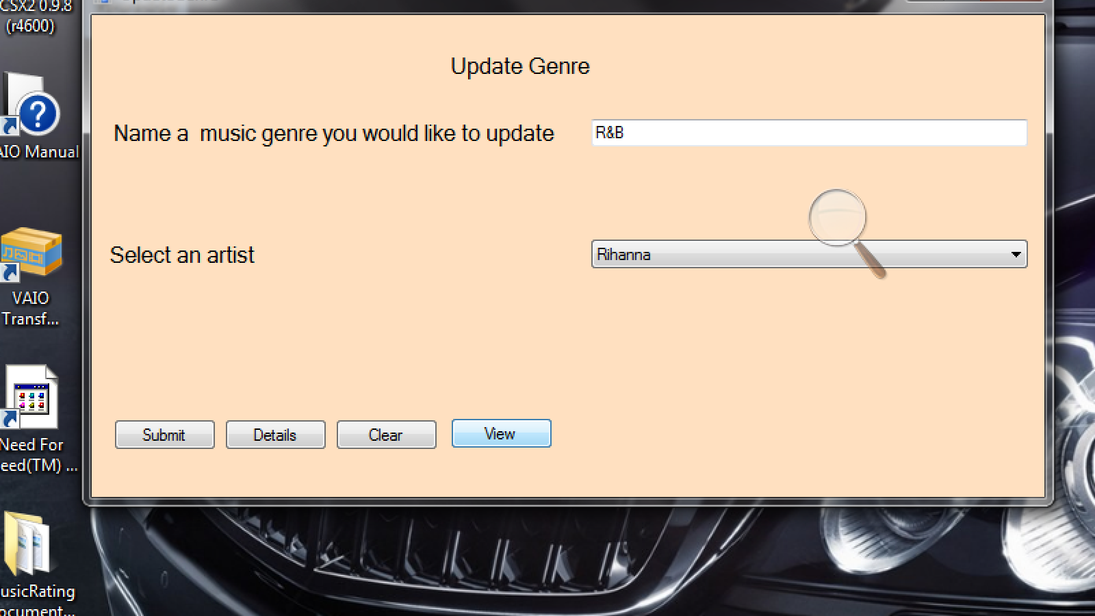

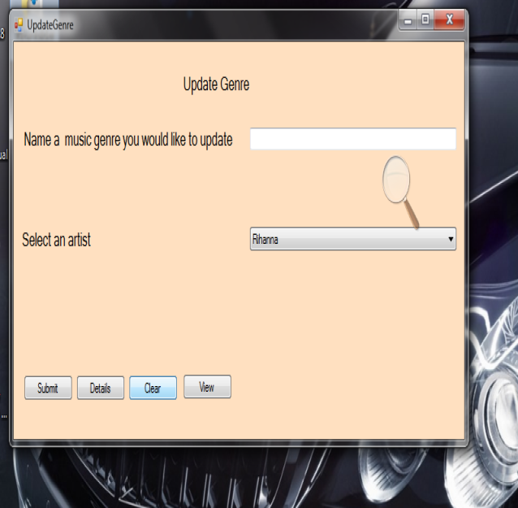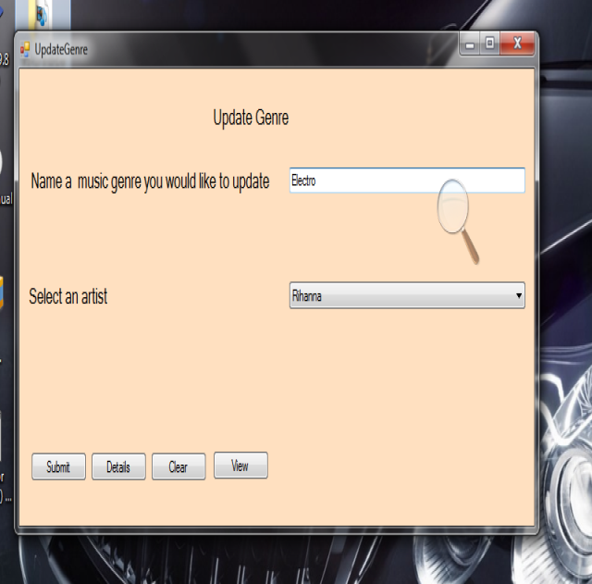

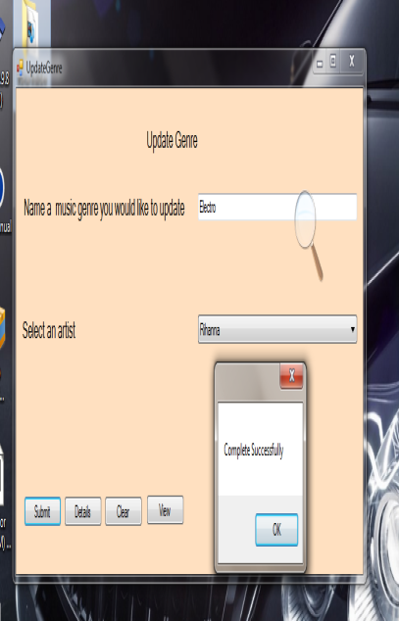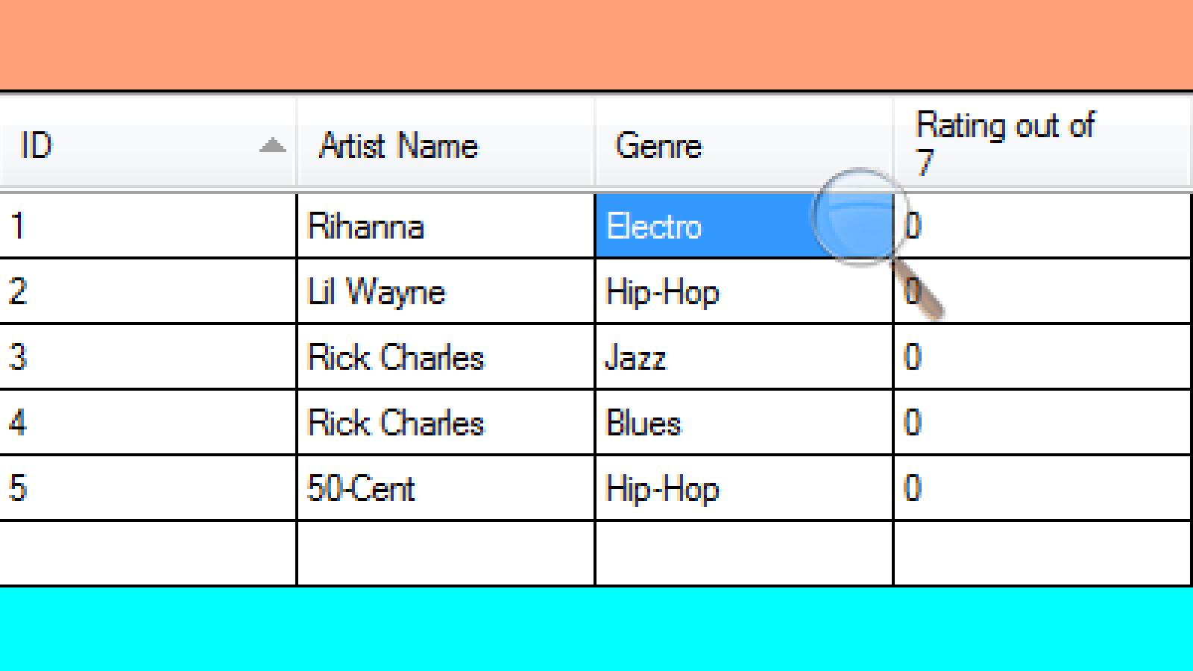

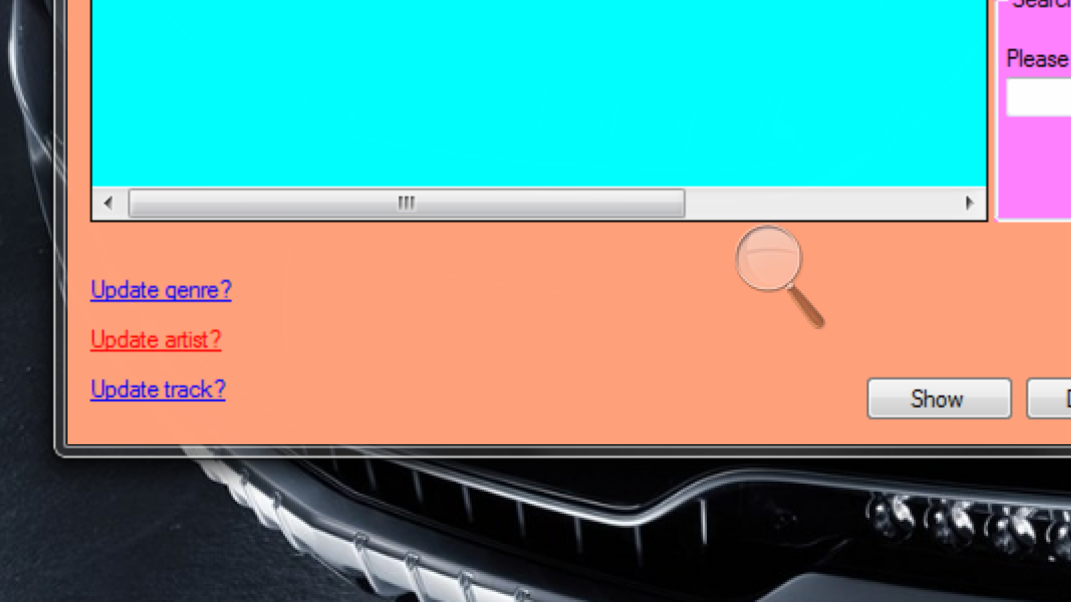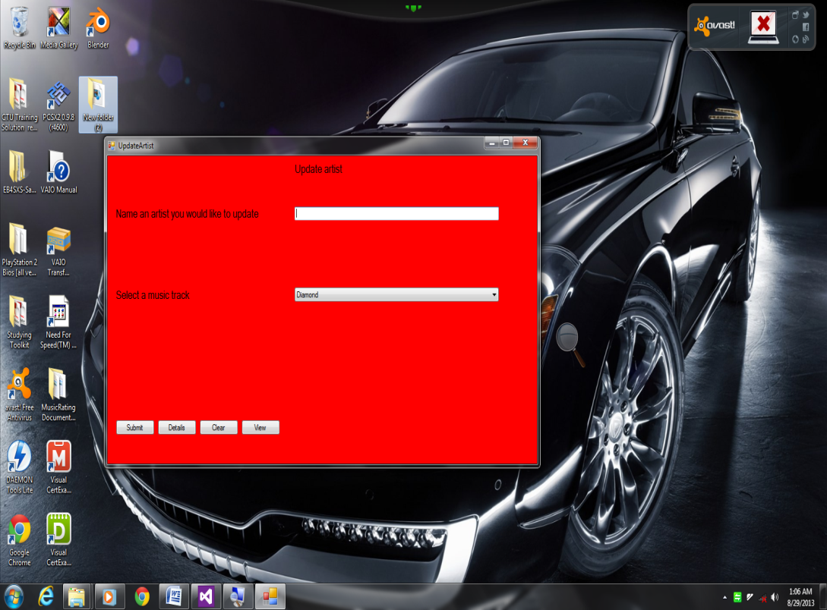

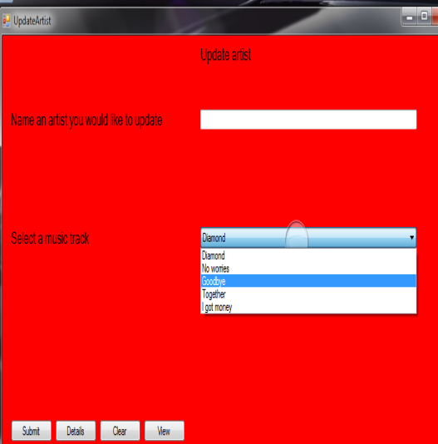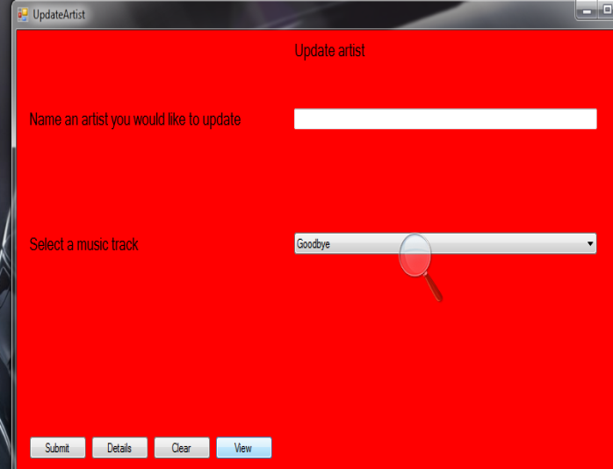

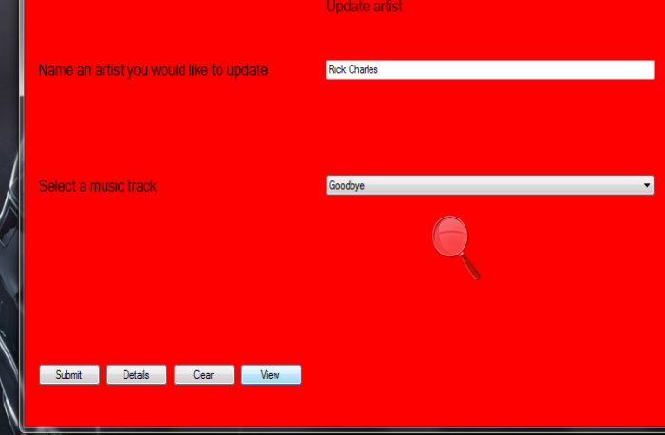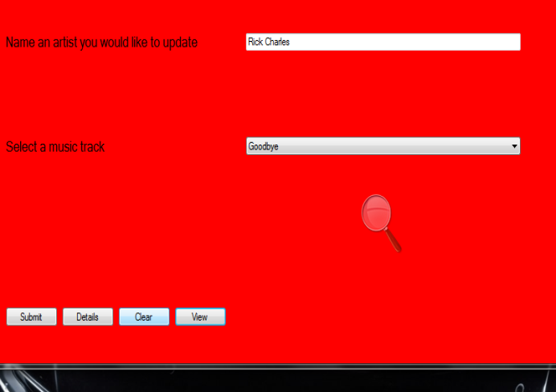

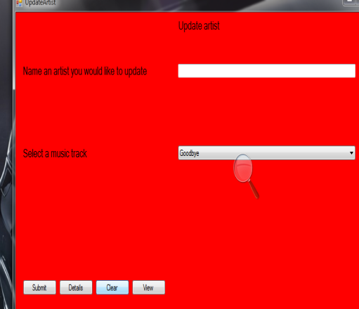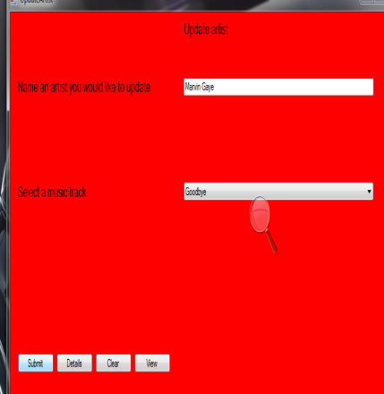

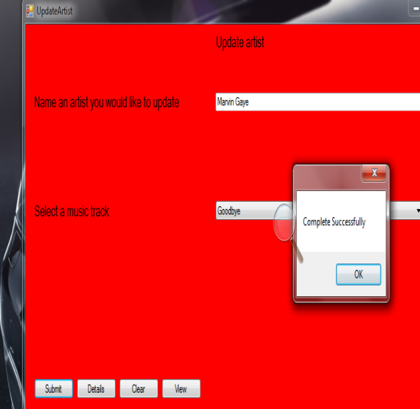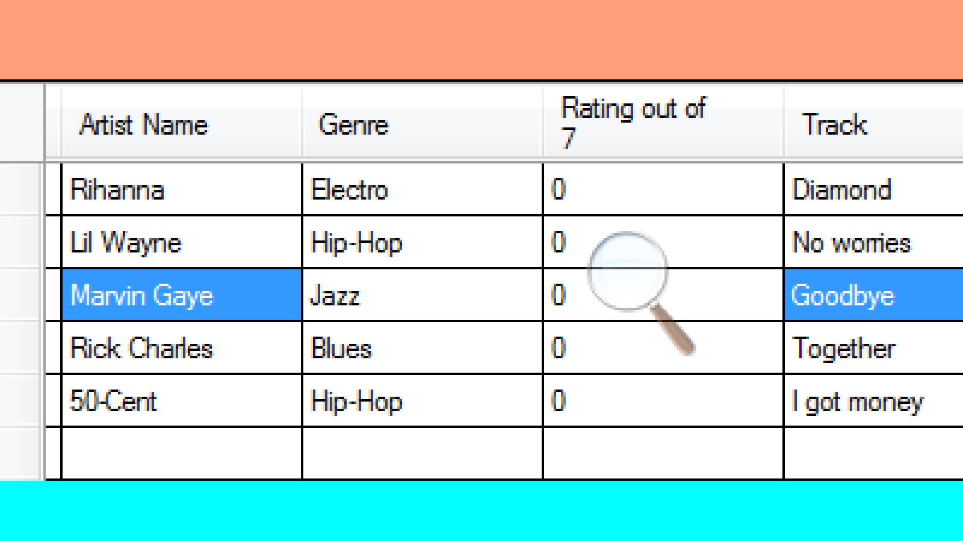

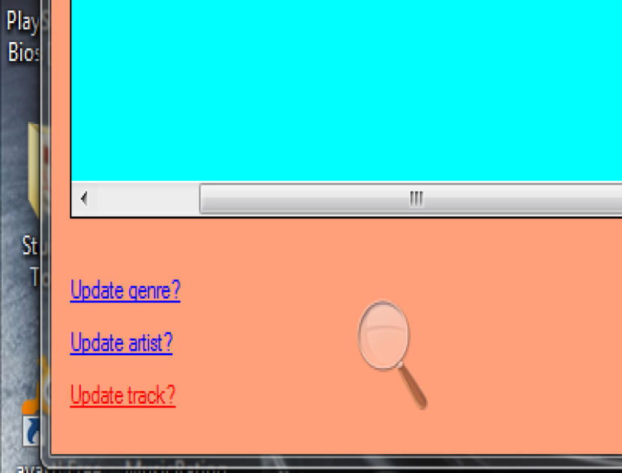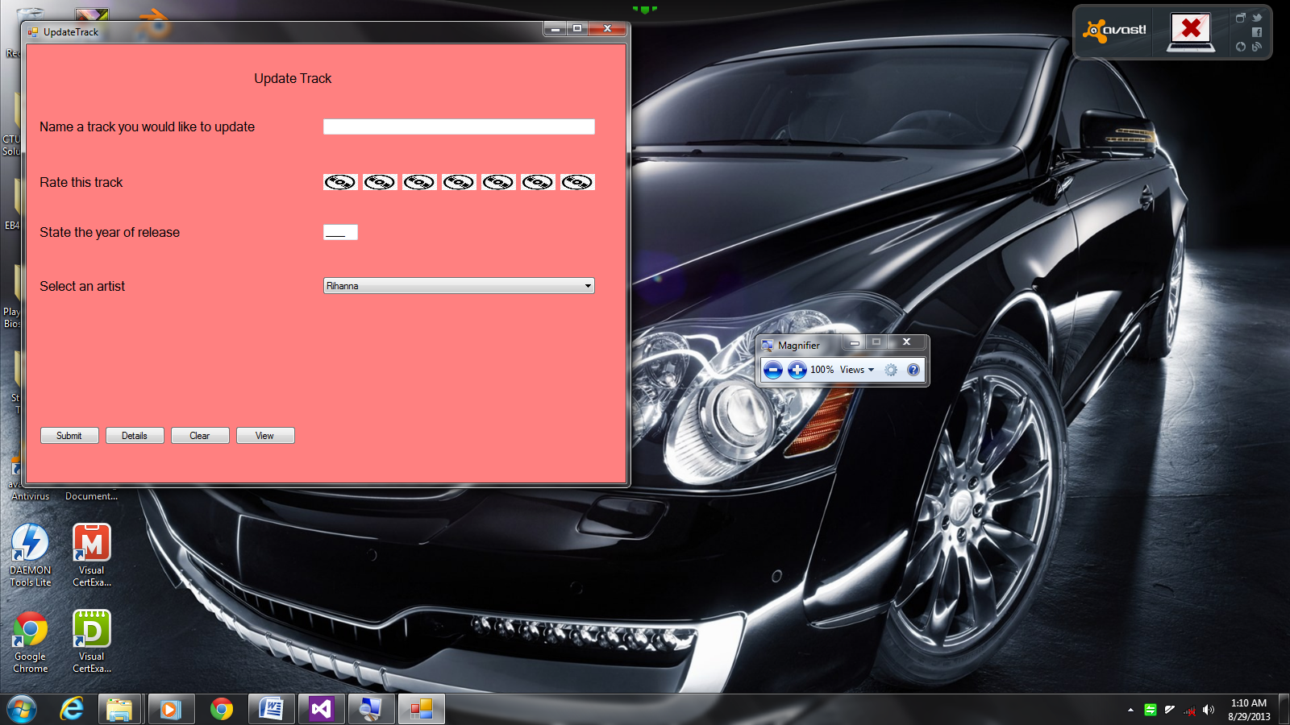

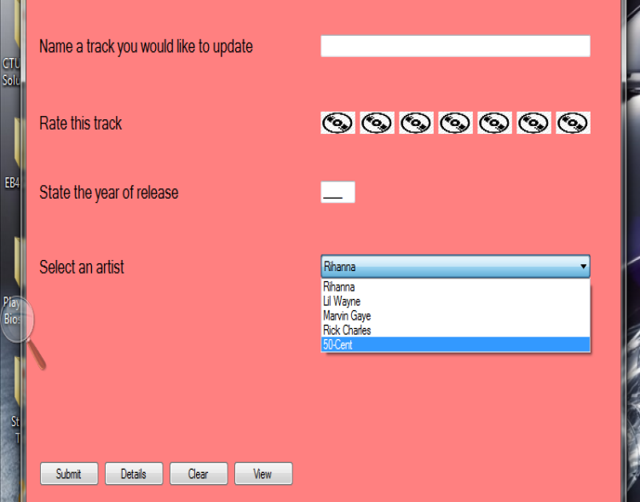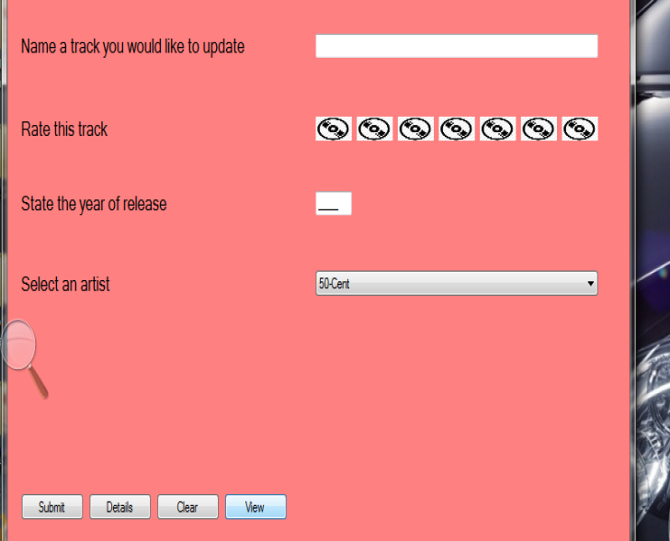

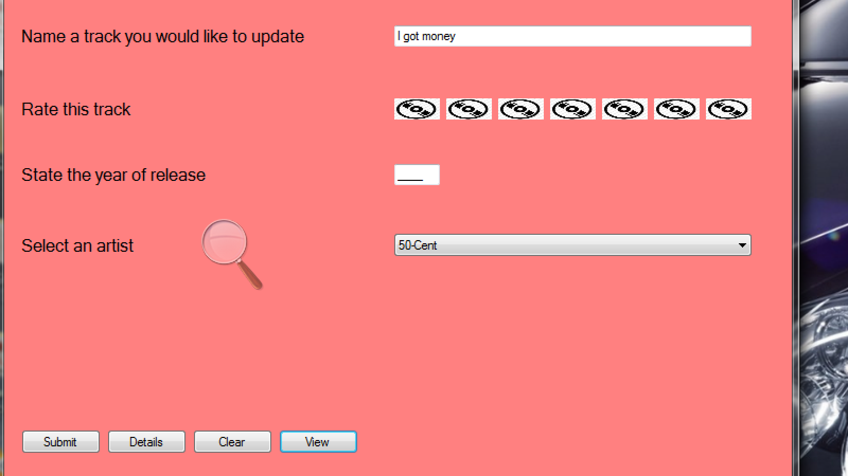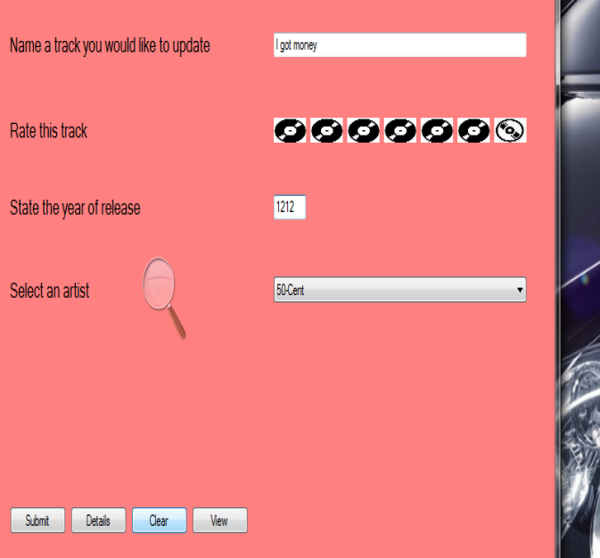

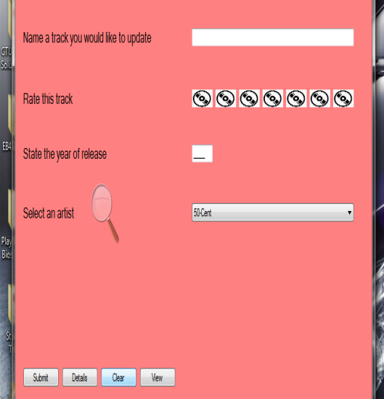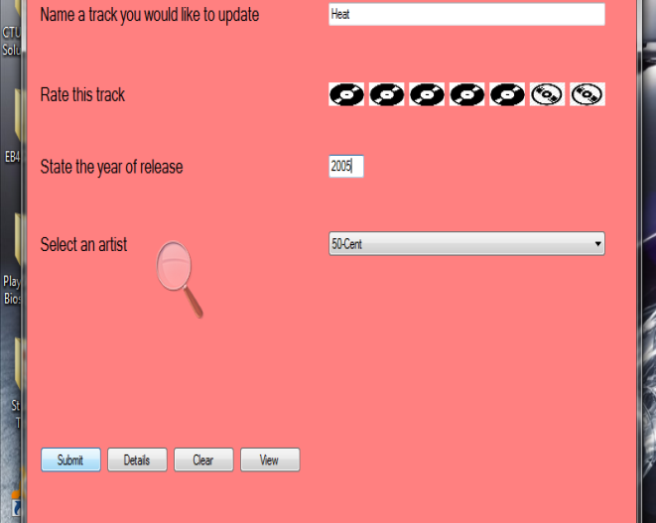

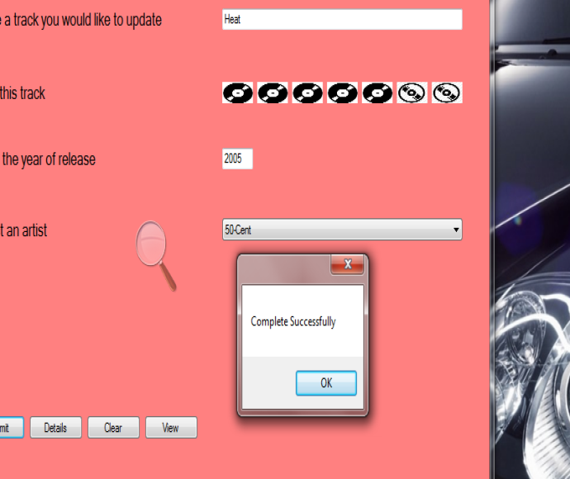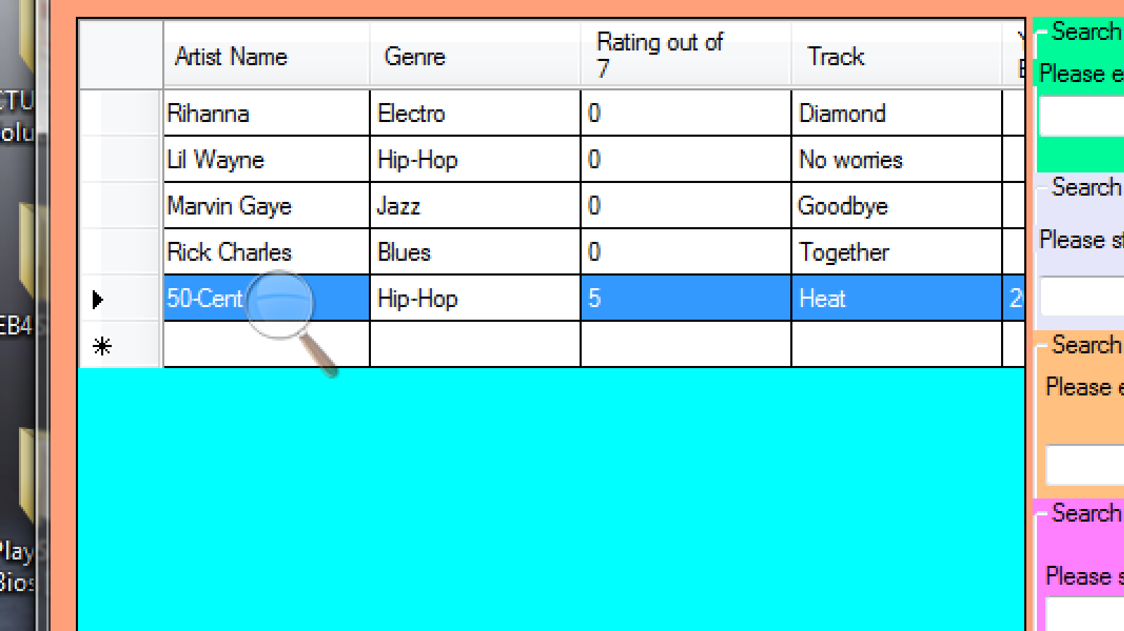

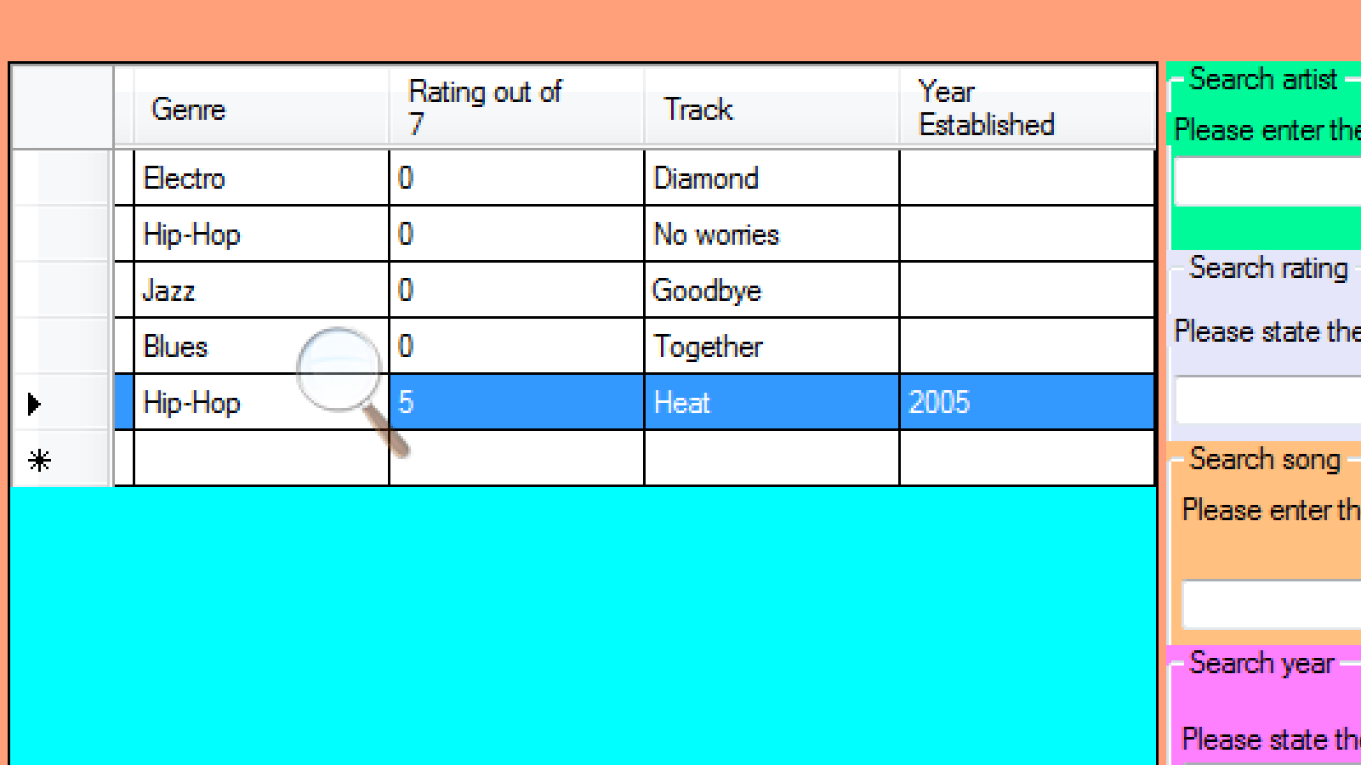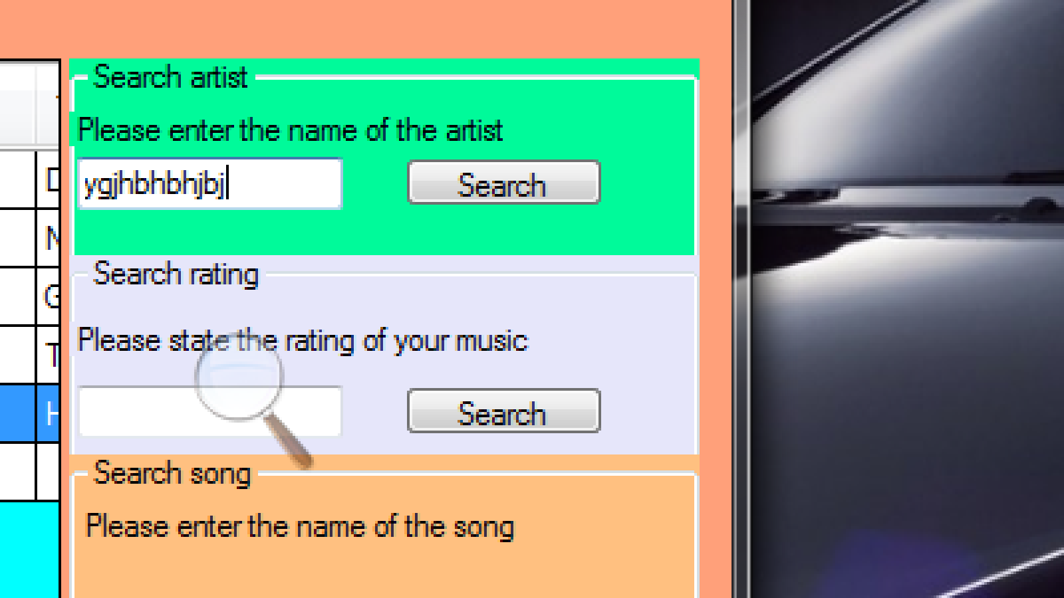

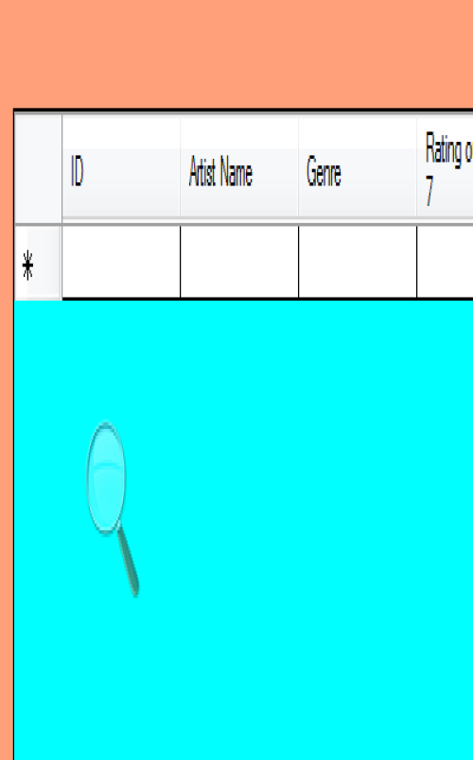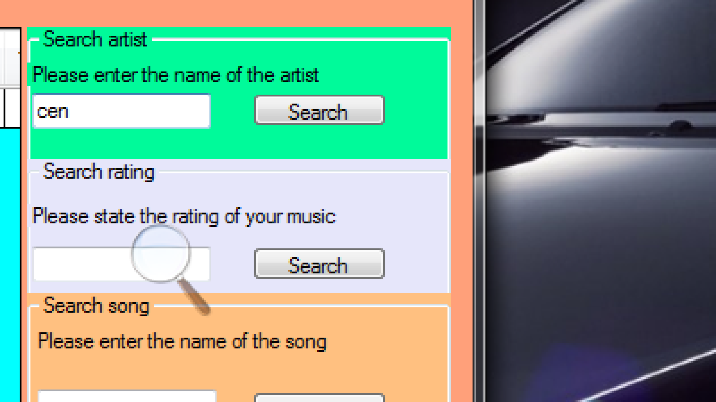

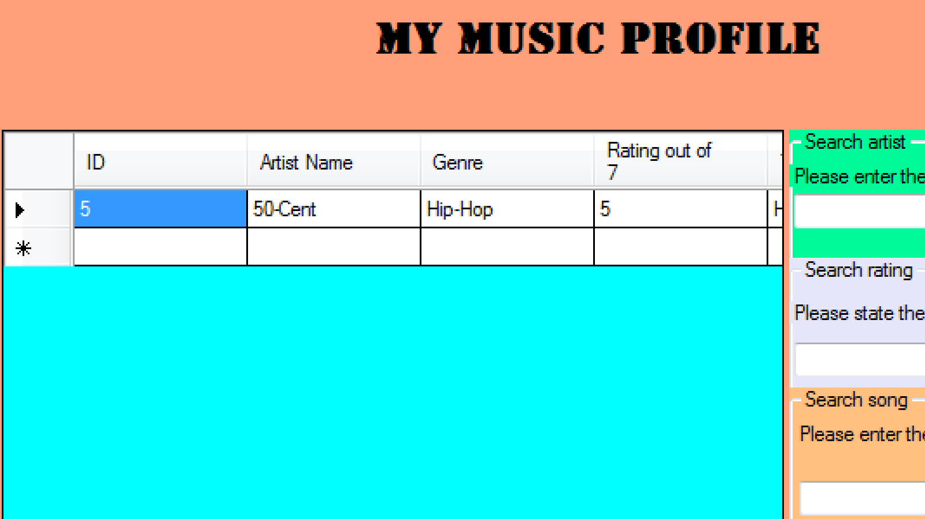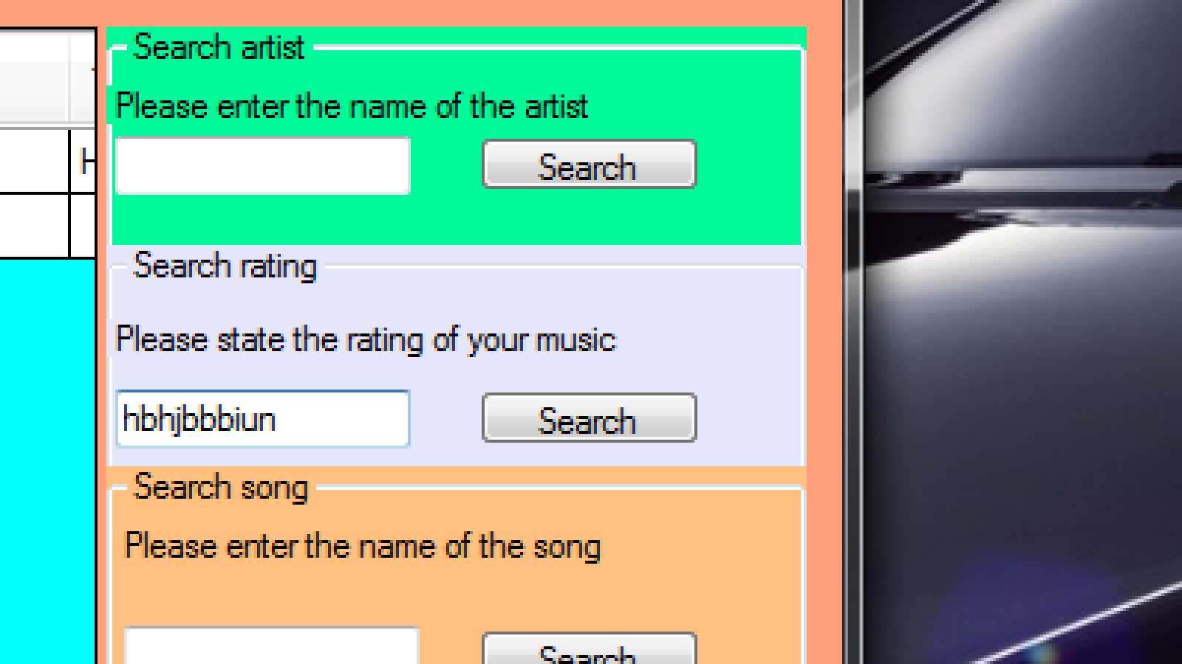

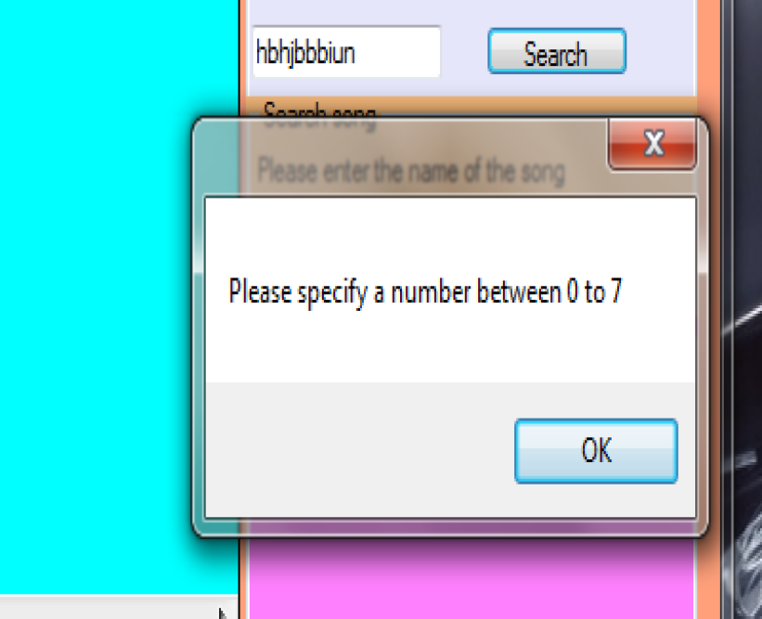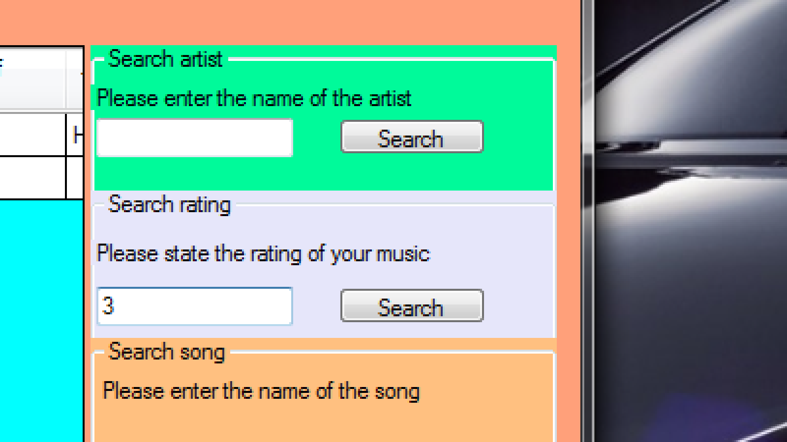

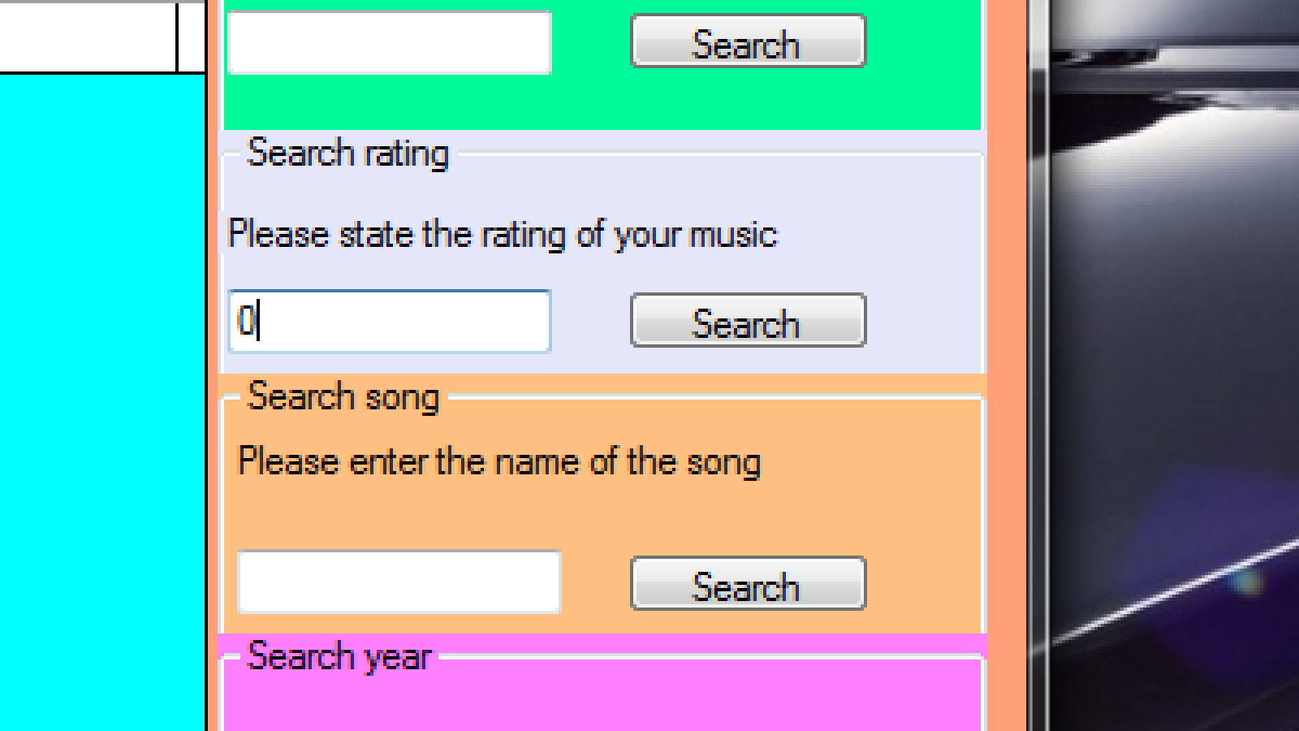

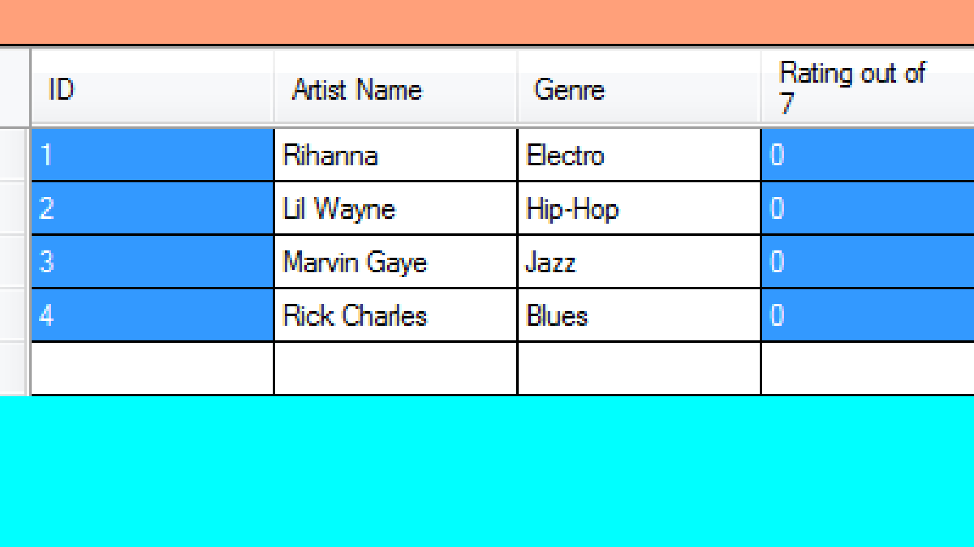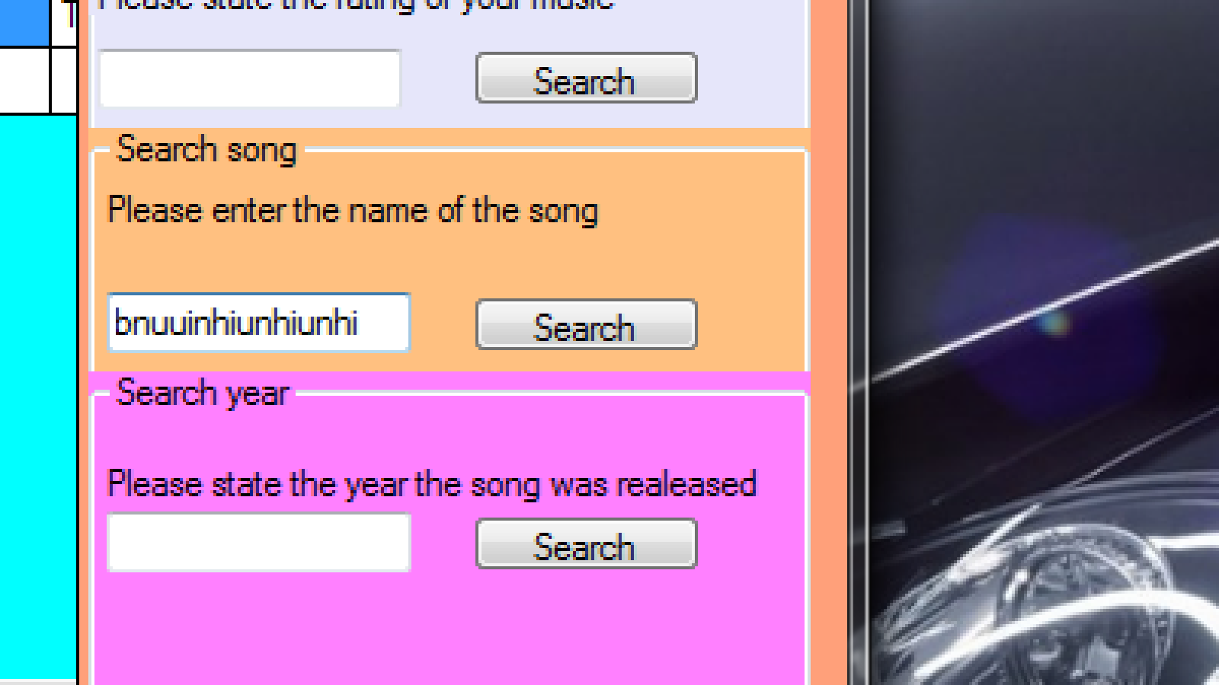

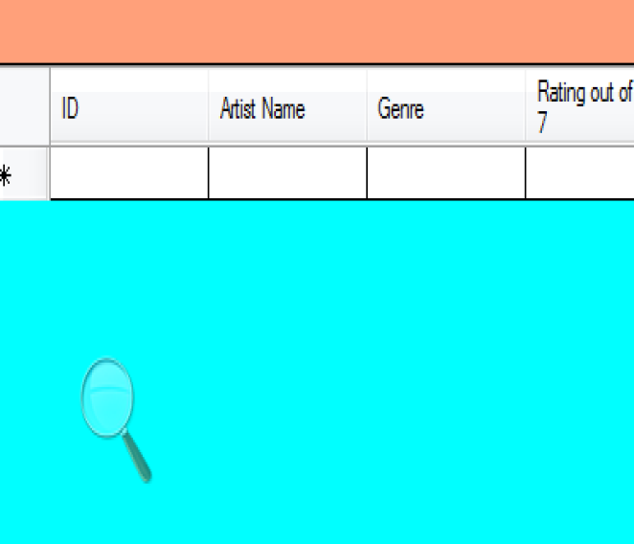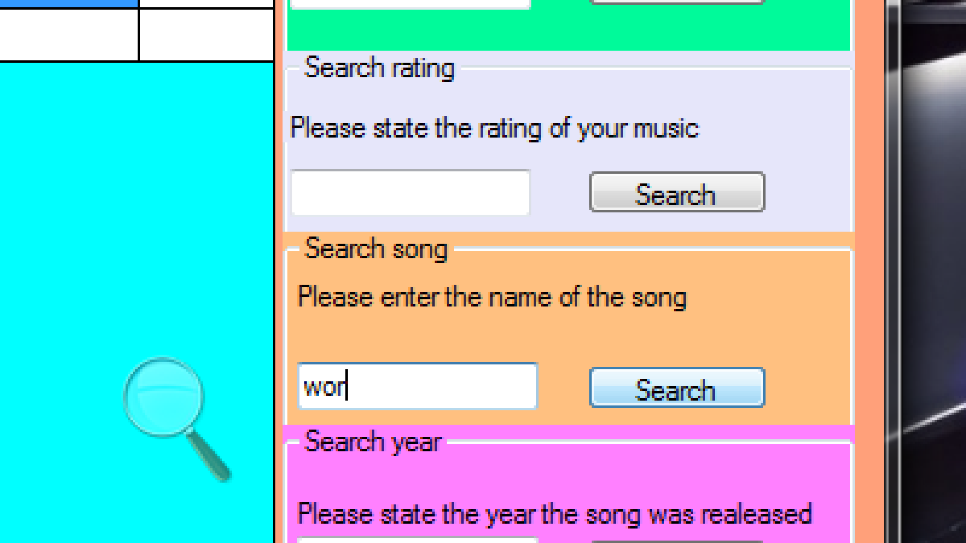

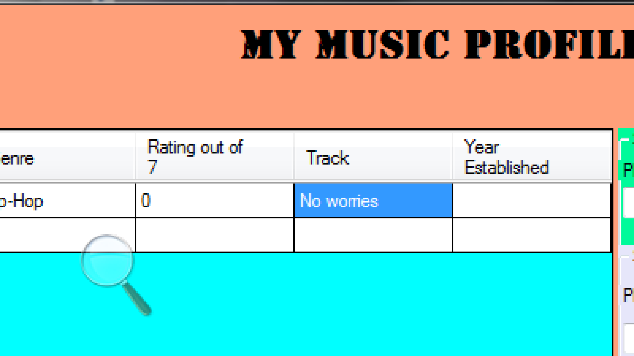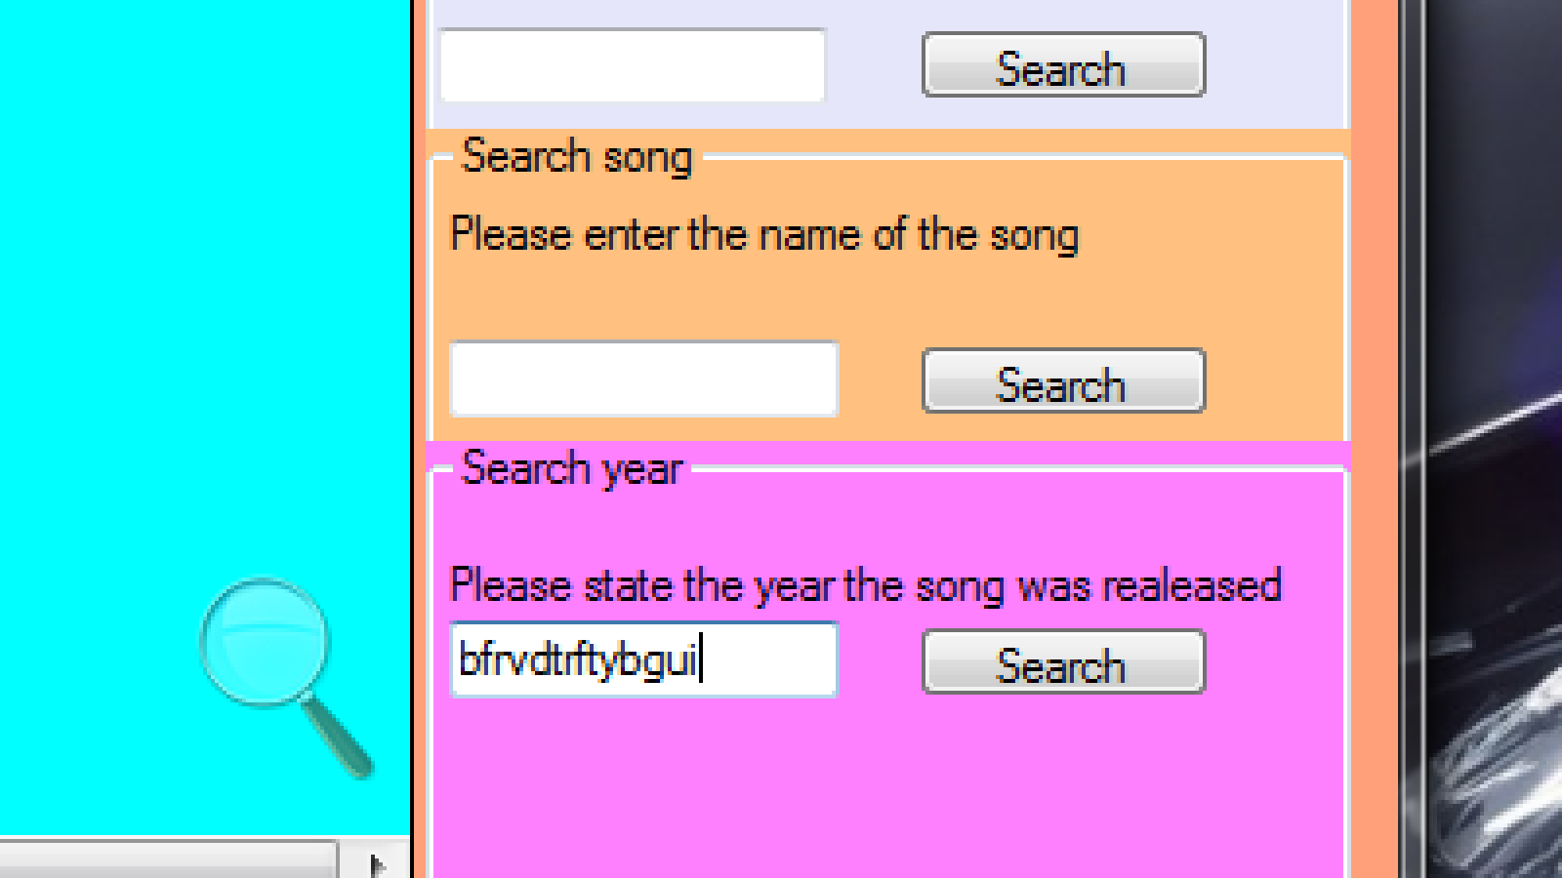

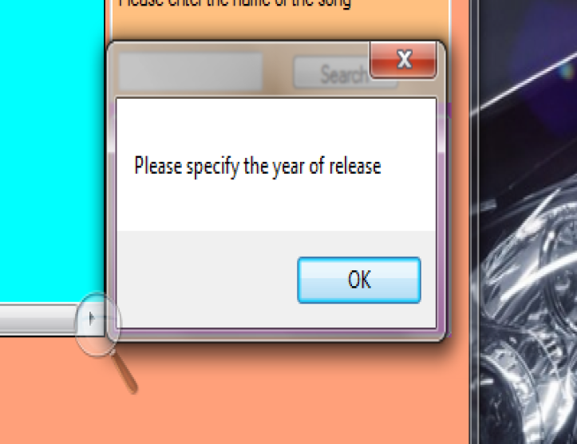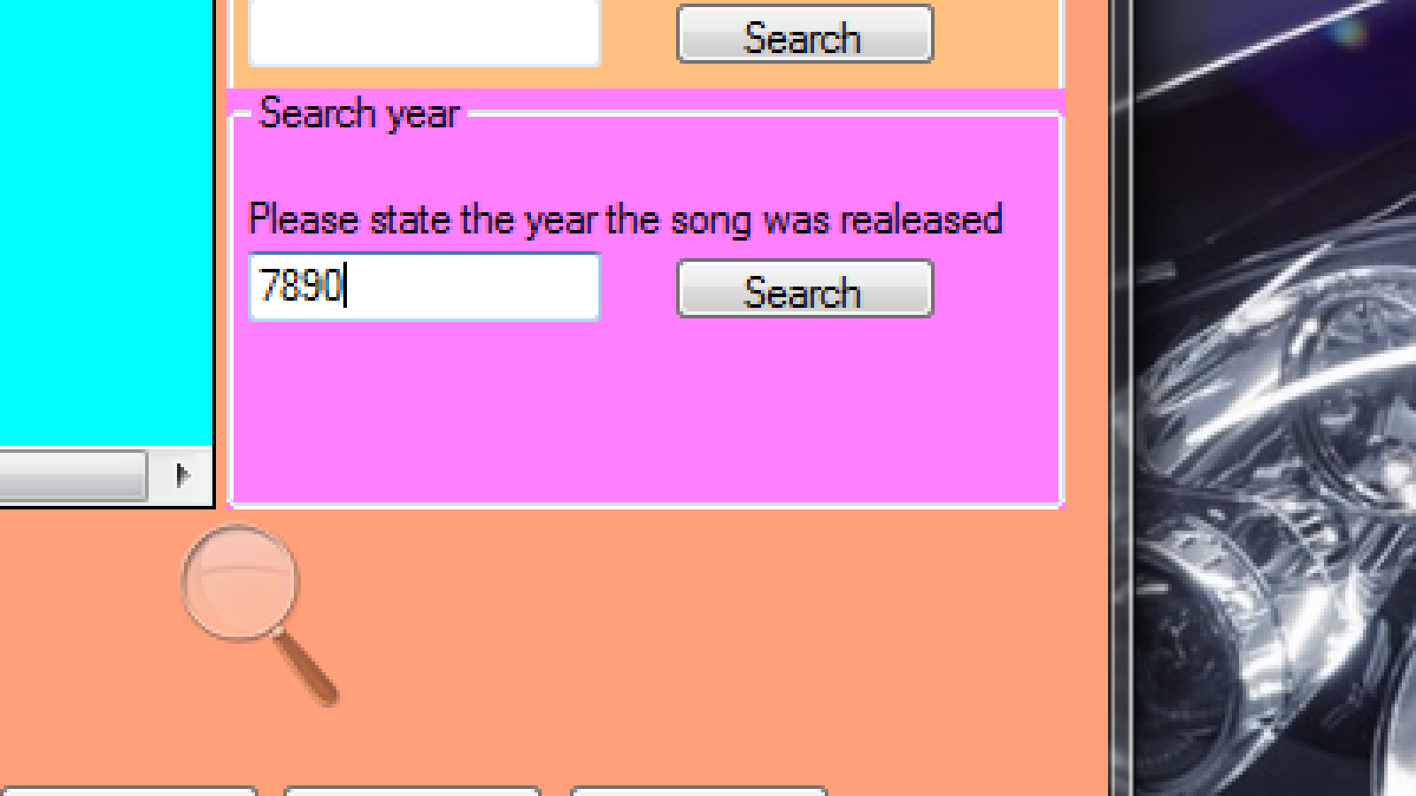

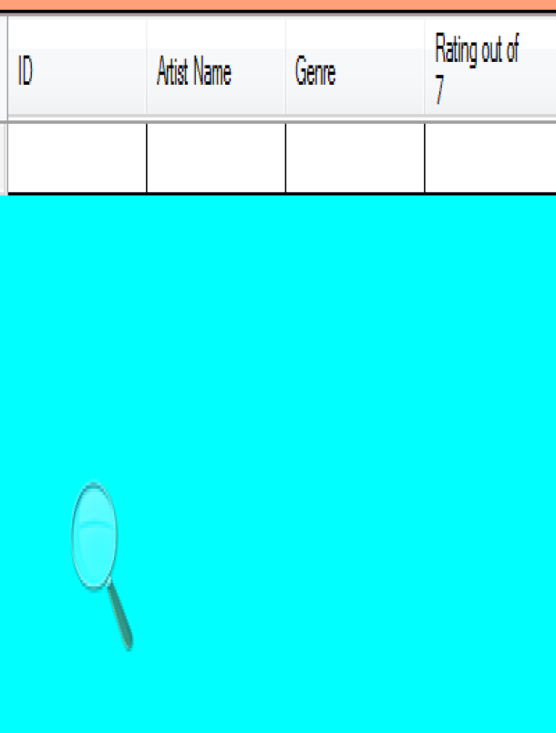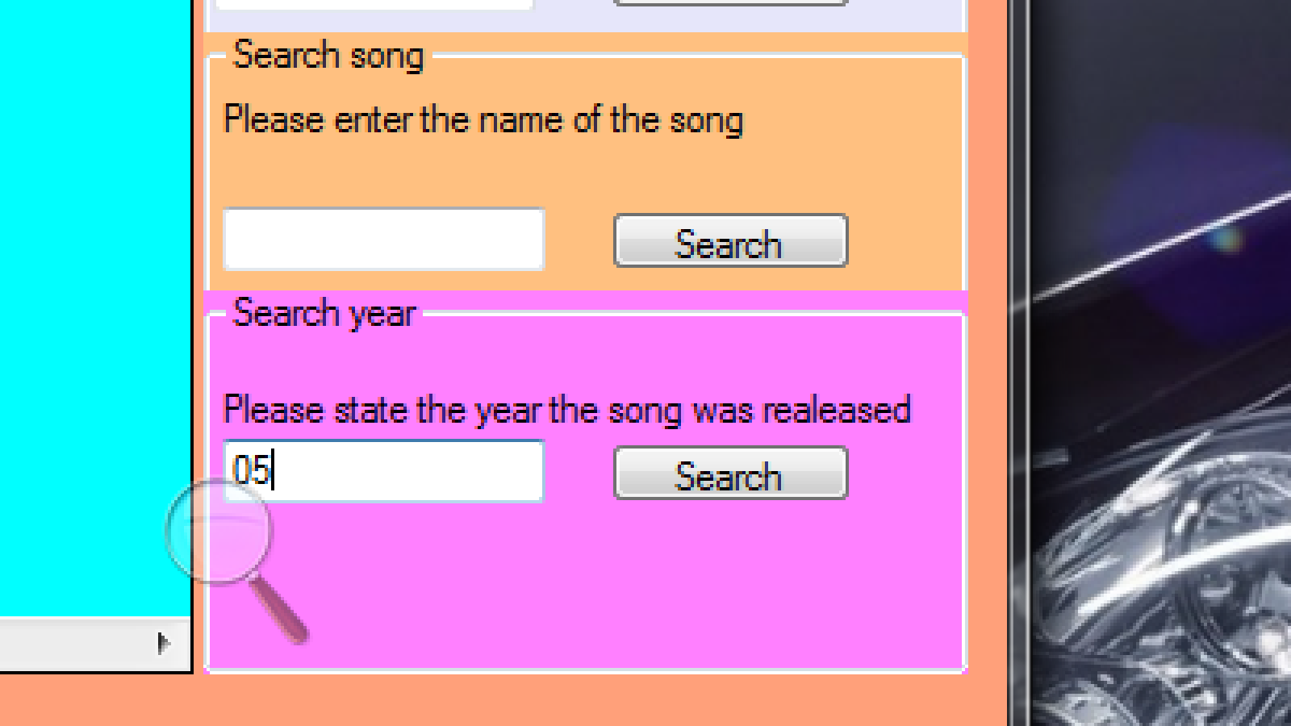

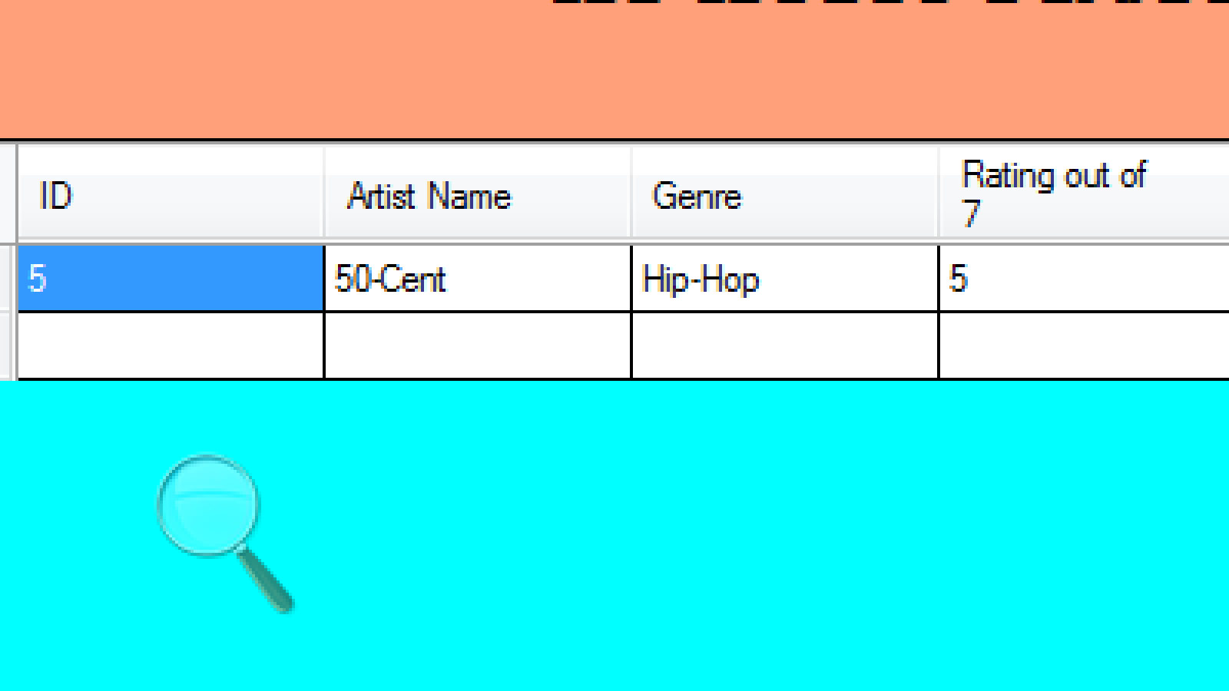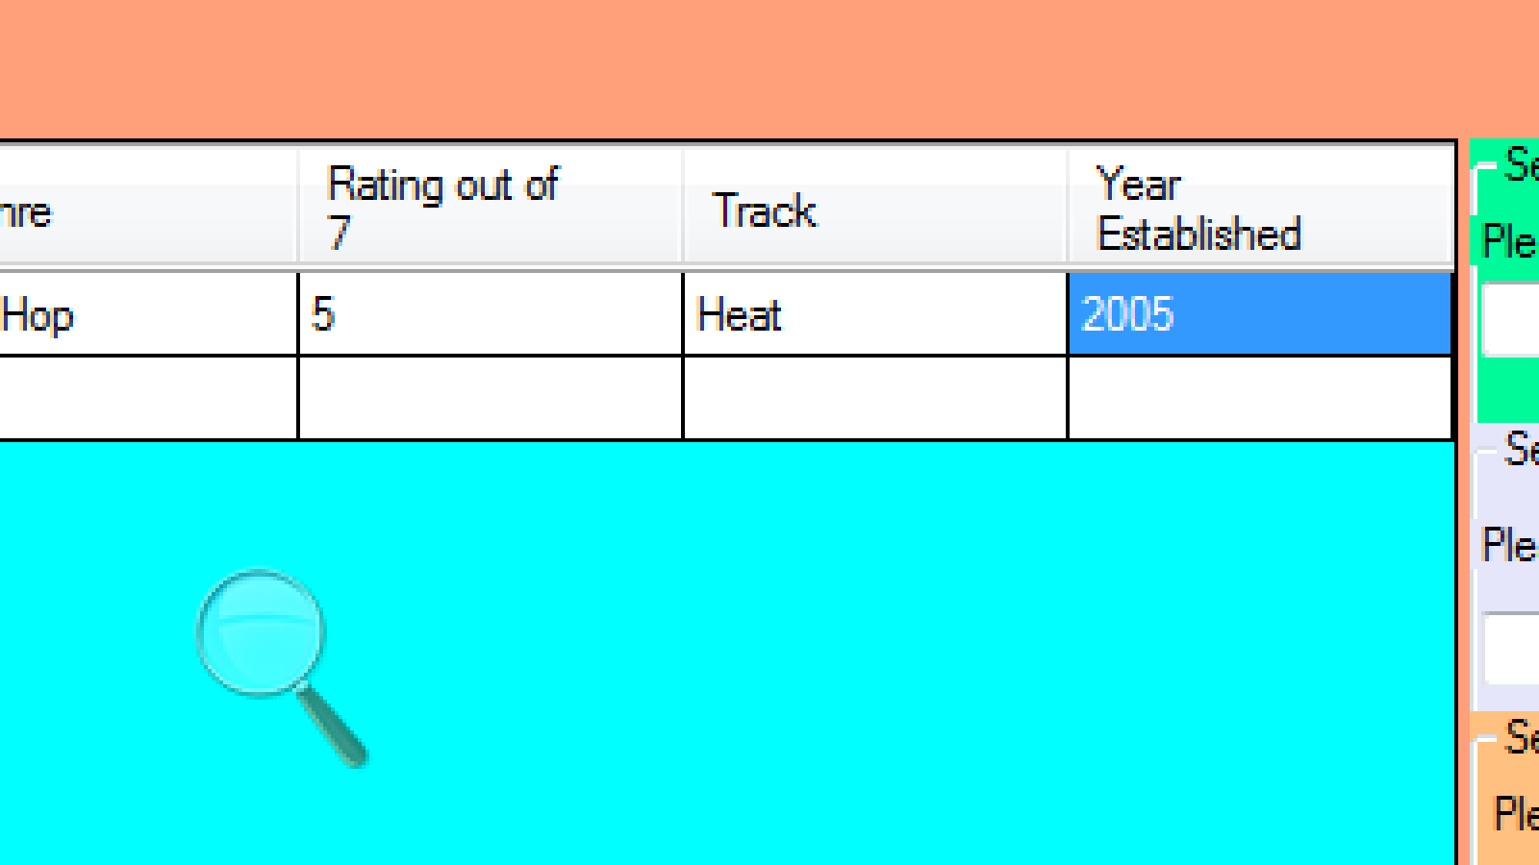

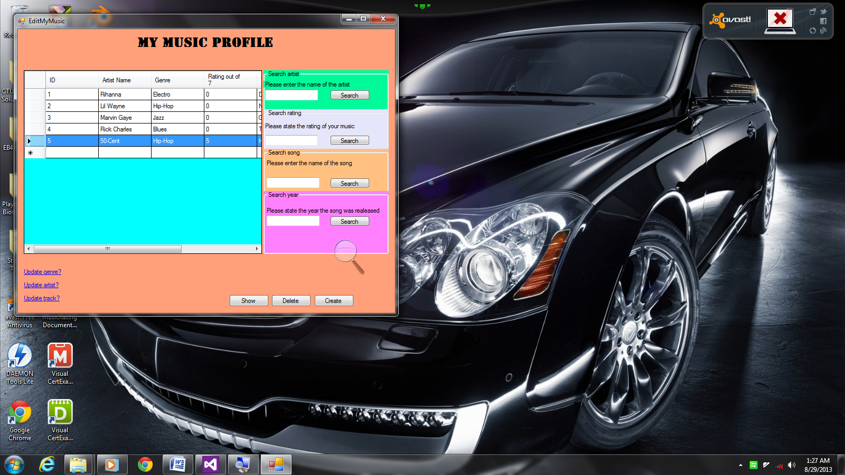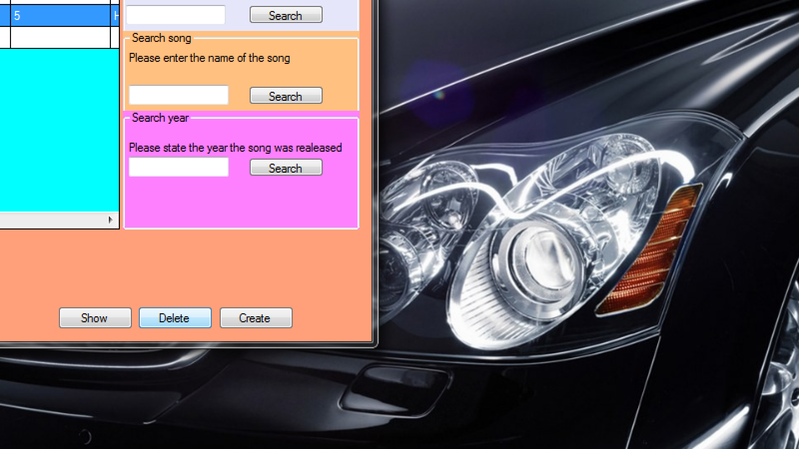

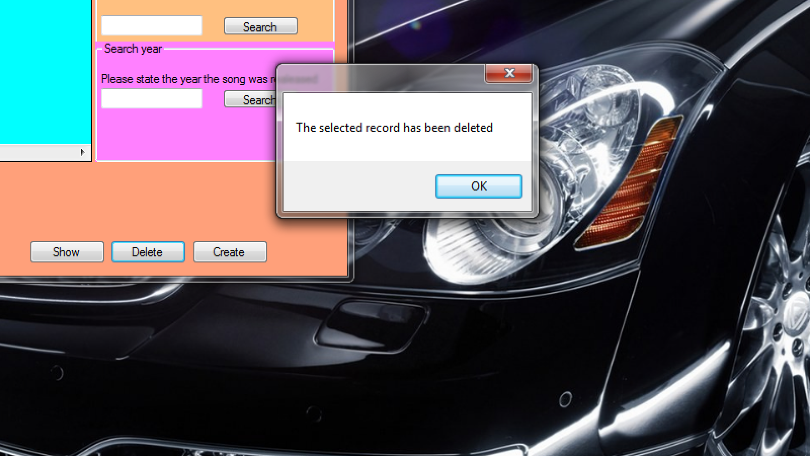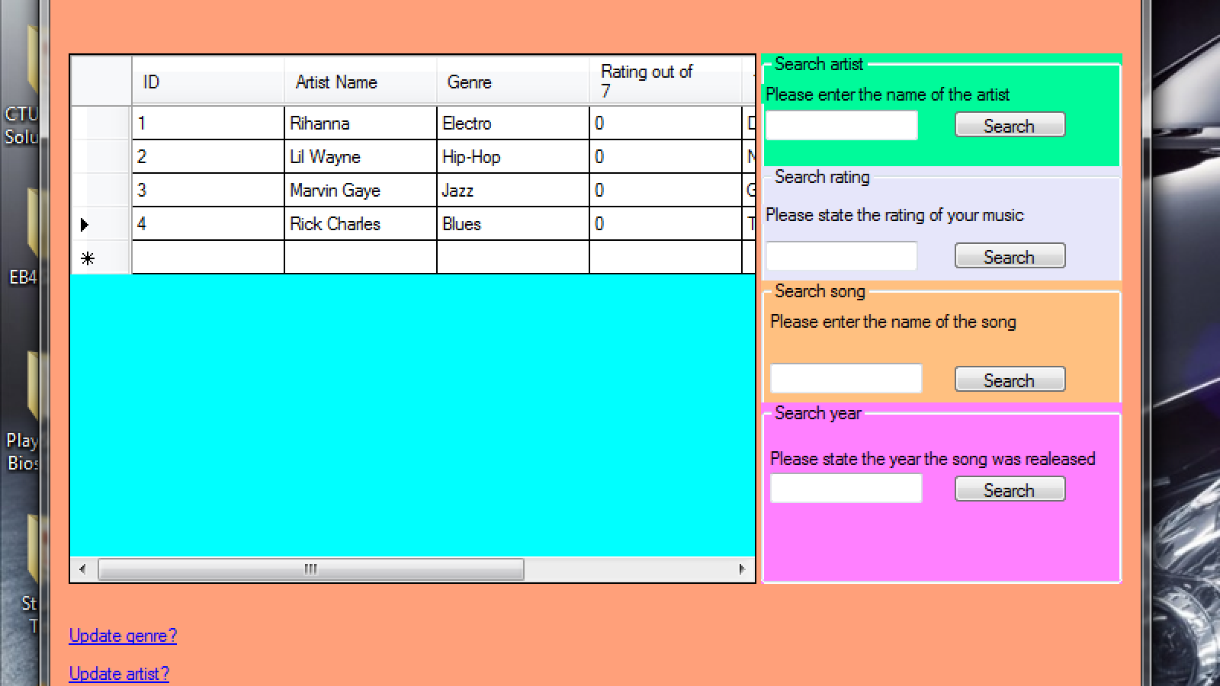

Coding:

SplashScreen.cs

using System;

using System.Collections.Generic;

using System.ComponentModel;

using System.Data;

using System.Drawing;

using System.Linq;

using System.Text;

using System.Threading.Tasks;

using System.Windows.Forms;

namespace MusicRatings

{

public partial class SplashScreen : Form

{

public SplashScreen()

{

InitializeComponent();

}

// set a time limit //

Timer show;

private void SplashScreen_Shown(object sender, EventArgs e)

{

show = new Timer(); // refreshens the timer //

show.Interval = 3000; // a set limit on when the timer should cease //

show.Start(); // the timer begins thus interval will increase //

show.Tick += new EventHandler(show_Tick); // event handler is enabled as the timer continiously runs //

}

// close the splash screen and open the main application //

void show_Tick(object sender, EventArgs e)

{

show.Stop(); // When timer stops, the follwing should occur //

AddGenre on = new AddGenre(); // creating a class variable for the 'AddGenre' class//

on.Show(); // temporarily suspend the current form //

this.Hide(); // open the designated form //

}

}

}

AddArtist.cs

using System;

using System.Collections.Generic;

using System.ComponentModel;

using System.Data;

using System.Drawing;

using System.Linq;

using System.Text;

using System.Threading.Tasks;

using System.Windows.Forms;

namespace MusicRatings

{

public partial class AddArtist : Form

{

public AddArtist()

{

InitializeComponent();

}

private void btn_Next_Click(object sender, EventArgs e)

{

AddTrack track = new AddTrack(); // creating a class variable for the 'AddTrack' class//

this.Hide(); // temporarily suspend the current form //

track.Show();// open the designated form //

}

private void btn_Clear_Click(object sender, EventArgs e)

{

txt_Artist.Clear(); // clear text inside the 'Artist' textbox //

}

private void AddArtist_Load(object sender, EventArgs e)

{

MusicConnection connection = new MusicConnection(); // refreshens the 'MusicConnection' class //

connection.SelectGenre(); //*Selects the specified coloumns in the genre table*//

cmbx_Genre.DataSource = connection.tbl; //*All the selected fields are filtered inside the table*//

cmbx_Genre.DisplayMember = "Genre";//*The combo-box will only display the names of the genre for each field or row*//

cmbx_Genre.ValueMember = "ID";//*The combo-box will only display the stored data referencing its ID*//

}

private void btn_Submit_Click(object sender, EventArgs e)

{

try

{

MusicConnection connection = new MusicConnection(); // refreshens the 'MusicConnection' class //

if (string.IsNullOrEmpty(txt_Artist.Text)) // if the 'Artist' textbox is left empty or text wasn't inputted, execute the following //

{

MessageBox.Show("Please enter the artist's name of this music"); // A messagebox should be displayed only if the condition is met //

}

else

{

connection.GetArtist(txt_Artist.Text, int.Parse(cmbx_Genre.SelectedValue.ToString())); // Adds the Artist's name entered by the user to the database //

}

}

catch

{

}

}

}

}

AddGenre.cs

using System;

using System.Collections.Generic;

using System.ComponentModel;

using System.Data;

using System.Drawing;

using System.Linq;

using System.Text;

using System.Threading.Tasks;

using System.Windows.Forms;

namespace MusicRatings

{

public partial class AddGenre : Form

{

MusicConnection connection; // referencing data from the 'MusicConnection' class //

public AddGenre()

{

InitializeComponent();

}

private void btn_Clear_Click(object sender, EventArgs e)

{

txt_Genre.Clear(); // clear text inside the 'Genre' textbox //

}

private void btn_Submit_Click(object sender, EventArgs e)

{

connection = new MusicConnection(); // refreshens the 'MusicConnection' class //

try

{

if (string.IsNullOrWhiteSpace(txt_Genre.Text)) // if the 'Genre' textbox is left empty or no texts was inputted, execute the following //

{

MessageBox.Show("Please enter the genre of this music"); // A messagebox should be displayed only if the condition is met //

}

else

{

connection.GetGenre(txt_Genre.Text); // Adds the Genre entered by the user to the database //

}

}

catch

{

}

}

private void btn_Next_Click(object sender, EventArgs e)

{

AddArtist artist = new AddArtist(); // creating a class variable for the 'AddArtist' class//

this.Hide(); // temporarily suspend the current form //

artist.Show(); // open the designated form //

}

}

}

AddTrack.cs

using System;

using System.Collections.Generic;

using System.ComponentModel;

using System.Data;

using System.Drawing;

using System.Linq;

using System.Text;

using System.Threading.Tasks;

using System.Windows.Forms;

namespace MusicRatings

{

public partial class AddTrack : Form

{

public AddTrack()

{

InitializeComponent();

}

private void btn_Details_Click(object sender, EventArgs e)

{

EditMyMusic edit = new EditMyMusic(); // creating a class variable for the 'EditMyMusic' class//

this.Hide(); // temporarily suspend the current form //

edit.Show(); // open the designated form //

}

private void btn_Clear_Click(object sender, EventArgs e) {

txt_Track.Clear(); // clear text inside the 'Track' textbox //

}

private void btn_Submit_Click(object sender, EventArgs e)

{

try

{

MusicConnection connection = new MusicConnection(); // refreshens the 'MusicConnection' class //

if (string.IsNullOrEmpty(txt_Track.Text)) // if the 'Tracks' textbox is left empty or no texts was inputted, execute the following //

{

MessageBox.Show("Please enter the name of this track"); // A messagebox should be displayed only if the condition is met //

}

else

{

connection.GetTrack(txt_Track.Text, 0, int.Parse(cmbx_Artist.SelectedValue.ToString())); // Adds the Artist's name entered by the user to the database //

}

}

catch

{

}

}

private void AddTrack_Load(object sender, EventArgs e)

{

MusicConnection connection = new MusicConnection();// refreshens the 'MusicConnection' class //

connection.SelectArtist();//*Selects the specified coloumns in the Artist table*//

cmbx_Artist.DataSource = connection.tbl;//*All the selected fields are filtered inside the table*//

cmbx_Artist.DisplayMember = "Artist Name";//*The combo-box will only display the names of the Artist for each field or row*//

cmbx_Artist.ValueMember = "ID";//*The combo-box will only display the stored data referencing its ID*//

}

}

}

UpdateArtist.cs

using System;

using System.Collections.Generic;

using System.ComponentModel;

using System.Data;

using System.Drawing;

using System.Linq;

using System.Text;

using System.Threading.Tasks;

using System.Windows.Forms;

namespace MusicRatings

{

public partial class UpdateArtist : Form

{

public UpdateArtist()

{

InitializeComponent();

}

private void btn_Details_Click(object sender, EventArgs e)

{

EditMyMusic edit = new EditMyMusic(); // creating a class variable for the 'EditMyMusic' class//

this.Hide(); // temporarily suspend the current form //

edit.Show(); // open the designated form //

}

private void btn_Clear_Click(object sender, EventArgs e)

{

txt_Artist.Clear(); // clear text inside the 'Artist' textbox //

}

private void UpdateArtist_Load(object sender, EventArgs e)

{

MusicConnection connection = new MusicConnection(); // refreshens the 'MusicConnection' class //

connection.SelectTrack(); //*Selects the specified coloumns in the Track table*//

cmbx_Track.DataSource = connection.tbl;//*All the selected fields are filtered inside the table*//

cmbx_Track.DisplayMember = "Track";//*The combo-box will only display the names of the genre for each field or row*//

cmbx_Track.ValueMember = "ID";//*The combo-box will only display the stored data referencing its ID*//

}

private void btn_View_Click(object sender, EventArgs e)

{

MusicConnection connection = new MusicConnection(); // refreshens the 'MusicConnection' class //

connection.GetCertainArtist(int.Parse(cmbx_Track.SelectedValue.ToString()));//*The selected genre must be allocated from the ID*//

txt_Artist.Text = connection.tbl.Rows[0][1].ToString();//*The artist's name will be displayed in the text-box once the genreID has been identified*//

}

private void btn_Submit_Click(object sender, EventArgs e)

{

MusicConnection connection = new MusicConnection(); // refreshens the 'MusicConnection' class //

connection.UpdateArtist(txt_Artist.Text, int.Parse(cmbx_Track.SelectedValue.ToString())); // Updates the Artist's name entered by the user to the database //

}

}

}

UpdateGenre.cs

using System;

using System.Collections.Generic;

using System.ComponentModel;

using System.Data;

using System.Drawing;

using System.Linq;

using System.Text;

using System.Threading.Tasks;

using System.Windows.Forms;

namespace MusicRatings

{

public partial class UpdateGenre : Form

{

public UpdateGenre()

{

InitializeComponent();

}

private void btn_Submit_Click(object sender, EventArgs e)

{

MusicConnection connection = new MusicConnection(); // refreshens the 'MusicConnection' class //

connection.UpdateGenre(txt_Genre.Text, int.Parse(cmbx_Artist.SelectedValue.ToString()));//*The artist's name will be displayed in the text-box once the genreID has been identified*//

}

private void btn_Clear_Click(object sender, EventArgs e)

{

txt_Genre.Clear(); // clear text inside the 'Genre' textbox //

}

private void btn_Details_Click(object sender, EventArgs e)

{

EditMyMusic edit = new EditMyMusic(); // creating a class variable for the 'EditMyMusic' class//

this.Hide(); // temporarily suspend the current form //

edit.Show(); // open the designated form //

}

private void UpdateGenre_Load(object sender, EventArgs e)

{

MusicConnection connection = new MusicConnection(); // refreshens the 'MusicConnection' class //

connection.SelectArtist();//*Selects the specified columns in the Artist table*//

cmbx_Artist.DataSource = connection.tbl;//*All the selected fields are filtered inside the table*//

cmbx_Artist.DisplayMember = "Artist Name";//*The combo-box will only display the names of the Artist for each field or row*//

cmbx_Artist.ValueMember = "ID";//*The combo-box will only display the stored data referencing its ID*//

}

private void btn_View_Click(object sender, EventArgs e)

{

MusicConnection connection = new MusicConnection(); // refreshens the 'MusicConnection' class //

connection.GetCertainGenre(int.Parse(cmbx_Artist.SelectedValue.ToString()));//*The selected Artist must be allocated from the ID*//

txt_Genre.Text = connection.tbl.Rows[0][1].ToString();//*The genre will be displayed in the text-box once the genreID has been identified*//

}

}

}

UpdateTrack.cs

using System;

using System.Collections.Generic;

using System.ComponentModel;

using System.Data;

using System.Drawing;

using System.Linq;

using System.Text;

using System.Threading.Tasks;

using System.Windows.Forms;

namespace MusicRatings

{

public partial class UpdateTrack : Form

{

public UpdateTrack()

{

InitializeComponent();

}

/// <summary>

/// Trieve the integer 'Count' and return the result

/// </summary>

public int Count

{

get;

set;

}

private void btn_Details_Click(object sender, EventArgs e)

{

EditMyMusic edit = new EditMyMusic(); // creating a class variable for the 'EditMyMusic' class//

this.Hide(); // temporarily suspend the current form //

edit.Show(); // open the designated form //

}

private void btn_Submit_Click(object sender, EventArgs e)

{

try

{

MusicConnection connection = new MusicConnection(); // refreshens the 'MusicConnection' class //

connection.UpdateTrack(txt_Track.Text, Count, int.Parse(txtMask_Year.Text), int.Parse(cmbx_Artist.SelectedValue.ToString())); // Updates the name of the track, the rating of the song and the year established//

}

catch(FormatException)

{

MessageBox.Show("Check whether you've entered the correct information"); // display a message-box when the exception occurs //

}

}

private void btn_Clear_Click(object sender, EventArgs e)

{

txt_Track.Clear(); // clear text inside the 'Track' textbox //

txtMask_Year.Clear(); // clear text inside the 'Year' textbox //

this.Count = 0; //the integer 'Count must be set to 0 if this event occurs'//

picbx_CD1.Image = MusicRatings.Properties.Resources._1CD; // the picturebox must display a designated image when assigning it to the propeties' resources//

picbx_CD2.Image = MusicRatings.Properties.Resources._1CD; // the picturebox must display a designated image when assigning it to the propeties' resources//

picbx_CD3.Image = MusicRatings.Properties.Resources._1CD; // the picturebox must display a designated image when assigning it to the propeties' resources//

picbx_CD4.Image = MusicRatings.Properties.Resources._1CD; // the picturebox must display a designated image when assigning it to the propeties' resources//

picbx_CD5.Image = MusicRatings.Properties.Resources._1CD; // the picturebox must display a designated image when assigning it to the propeties' resources//

picbx_CD6.Image = MusicRatings.Properties.Resources._1CD; // the picturebox must display a designated image when assigning it to the propeties' resources//

picbx_CD7.Image = MusicRatings.Properties.Resources._1CD; // the picturebox must display a designated image when assigning it to the propeties' resources//

}

private void UpdateTrack_Load(object sender, EventArgs e)

{

MusicConnection connection = new MusicConnection(); // refreshens the 'MusicConnection' class //

connection.SelectArtist(); //*Selects the specified coloumns in the Artist table*//

cmbx_Artist.DataSource = connection.tbl;//*All the selected fields are filtered inside the table*//

cmbx_Artist.DisplayMember = "Artist Name";//*The combo-box will only display the names of the artist for each field or row*//

cmbx_Artist.ValueMember = "ID";//*The combo-box will only display the stored data referencing its ID*//

}

private void btn_View_Click(object sender, EventArgs e)

{

MusicConnection connection = new MusicConnection(); // refreshens the 'MusicConnection' class //

connection.GetCertainTrack(int.Parse(cmbx_Artist.SelectedValue.ToString()));//*The selected Artist must be allocated from the ID*//

if (connection.tbl.Rows[0][1].ToString() == "0")

{

this.Count = 0;//the integer 'Count must be set to 0 if the condition is met'//

picbx_CD1.Image = MusicRatings.Properties.Resources._1CD; // the picturebox must display a designated image when assigning it to the propeties' resources//

picbx_CD2.Image = MusicRatings.Properties.Resources._1CD; // the picturebox must display a designated image when assigning it to the propeties' resources//

picbx_CD3.Image = MusicRatings.Properties.Resources._1CD; // the picturebox must display a designated image when assigning it to the propeties' resources//

picbx_CD4.Image = MusicRatings.Properties.Resources._1CD; // the picturebox must display a designated image when assigning it to the propeties' resources//

picbx_CD5.Image = MusicRatings.Properties.Resources._1CD; // the picturebox must display a designated image when assigning it to the propeties' resources//

picbx_CD6.Image = MusicRatings.Properties.Resources._1CD; // the picturebox must display a designated image when assigning it to the propeties' resources//

picbx_CD7.Image = MusicRatings.Properties.Resources._1CD; // the picturebox must display a designated image when assigning it to the propeties' resources//

}

else if (connection.tbl.Rows[0][1].ToString() == "1")

{

this.Count = 1;//the integer 'Count must be set to 1 if the condition is met'//

picbx_CD1.Image = MusicRatings.Properties.Resources._2CD; // the picturebox must display a designated image when assigning it to the propeties' resources//

picbx_CD2.Image = MusicRatings.Properties.Resources._1CD; // the picturebox must display a designated image when assigning it to the propeties' resources//

picbx_CD3.Image = MusicRatings.Properties.Resources._1CD; // the picturebox must display a designated image when assigning it to the propeties' resources//

picbx_CD4.Image = MusicRatings.Properties.Resources._1CD; // the picturebox must display a designated image when assigning it to the propeties' resources//

picbx_CD5.Image = MusicRatings.Properties.Resources._1CD; // the picturebox must display a designated image when assigning it to the propeties' resources//

picbx_CD6.Image = MusicRatings.Properties.Resources._1CD; // the picturebox must display a designated image when assigning it to the propeties' resources//

picbx_CD7.Image = MusicRatings.Properties.Resources._1CD; // the picturebox must display a designated image when assigning it to the propeties' resources//

}

else if (connection.tbl.Rows[0][1].ToString() == "2")

{

this.Count = 2;//the integer 'Count must be set to 2 if the condition is met'//

picbx_CD1.Image = MusicRatings.Properties.Resources._2CD; // the picturebox must display a designated image when assigning it to the propeties' resources//

picbx_CD2.Image = MusicRatings.Properties.Resources._2CD; // the picturebox must display a designated image when assigning it to the propeties' resources//

picbx_CD3.Image = MusicRatings.Properties.Resources._1CD; // the picturebox must display a designated image when assigning it to the propeties' resources//

picbx_CD4.Image = MusicRatings.Properties.Resources._1CD; // the picturebox must display a designated image when assigning it to the propeties' resources//

picbx_CD5.Image = MusicRatings.Properties.Resources._1CD; // the picturebox must display a designated image when assigning it to the propeties' resources//

picbx_CD6.Image = MusicRatings.Properties.Resources._1CD; // the picturebox must display a designated image when assigning it to the propeties' resources//

picbx_CD7.Image = MusicRatings.Properties.Resources._1CD; // the picturebox must display a designated image when assigning it to the propeties' resources//

}

else if (connection.tbl.Rows[0][1].ToString() == "3")

{

this.Count = 3;//the integer 'Count must be set to 3 if the condition is met'//

picbx_CD1.Image = MusicRatings.Properties.Resources._2CD; // the picturebox must display a designated image when assigning it to the propeties' resources//

picbx_CD2.Image = MusicRatings.Properties.Resources._2CD; // the picturebox must display a designated image when assigning it to the propeties' resources//

picbx_CD3.Image = MusicRatings.Properties.Resources._2CD; // the picturebox must display a designated image when assigning it to the propeties' resources//

picbx_CD4.Image = MusicRatings.Properties.Resources._1CD; // the picturebox must display a designated image when assigning it to the propeties' resources//

picbx_CD5.Image = MusicRatings.Properties.Resources._1CD; // the picturebox must display a designated image when assigning it to the propeties' resources//

picbx_CD6.Image = MusicRatings.Properties.Resources._1CD; // the picturebox must display a designated image when assigning it to the propeties' resources//

picbx_CD7.Image = MusicRatings.Properties.Resources._1CD; // the picturebox must display a designated image when assigning it to the propeties' resources//

}

else if (connection.tbl.Rows[0][1].ToString() == "4")

{

this.Count = 4;//the integer 'Count must be set to 4 if the condition is met'//

picbx_CD1.Image = MusicRatings.Properties.Resources._2CD; // the picturebox must display a designated image when assigning it to the propeties' resources//

picbx_CD2.Image = MusicRatings.Properties.Resources._2CD; // the picturebox must display a designated image when assigning it to the propeties' resources//

picbx_CD3.Image = MusicRatings.Properties.Resources._2CD; // the picturebox must display a designated image when assigning it to the propeties' resources//

picbx_CD4.Image = MusicRatings.Properties.Resources._2CD; // the picturebox must display a designated image when assigning it to the propeties' resources//

picbx_CD5.Image = MusicRatings.Properties.Resources._1CD; // the picturebox must display a designated image when assigning it to the propeties' resources//

picbx_CD6.Image = MusicRatings.Properties.Resources._1CD; // the picturebox must display a designated image when assigning it to the propeties' resources//

picbx_CD7.Image = MusicRatings.Properties.Resources._1CD; // the picturebox must display a designated image when assigning it to the propeties' resources//

}

else if (connection.tbl.Rows[0][1].ToString() == "5")

{

this.Count = 5;//the integer 'Count must be set to 5 if the condition is met'//

picbx_CD1.Image = MusicRatings.Properties.Resources._2CD; // the picturebox must display a designated image when assigning it to the propeties' resources//

picbx_CD2.Image = MusicRatings.Properties.Resources._2CD; // the picturebox must display a designated image when assigning it to the propeties' resources//

picbx_CD3.Image = MusicRatings.Properties.Resources._2CD; // the picturebox must display a designated image when assigning it to the propeties' resources//

picbx_CD4.Image = MusicRatings.Properties.Resources._2CD; // the picturebox must display a designated image when assigning it to the propeties' resources//

picbx_CD5.Image = MusicRatings.Properties.Resources._2CD; // the picturebox must display a designated image when assigning it to the propeties' resources//

picbx_CD6.Image = MusicRatings.Properties.Resources._1CD; // the picturebox must display a designated image when assigning it to the propeties' resources//

picbx_CD7.Image = MusicRatings.Properties.Resources._1CD; // the picturebox must display a designated image when assigning it to the propeties' resources//

}

else if (connection.tbl.Rows[0][1].ToString() == "6")

{

this.Count = 6;//the integer 'Count must be set to 6 if the condition is met'//

picbx_CD1.Image = MusicRatings.Properties.Resources._2CD; // the picturebox must display a designated image when assigning it to the propeties' resources//

picbx_CD2.Image = MusicRatings.Properties.Resources._2CD; // the picturebox must display a designated image when assigning it to the propeties' resources//

picbx_CD3.Image = MusicRatings.Properties.Resources._2CD; // the picturebox must display a designated image when assigning it to the propeties' resources//

picbx_CD4.Image = MusicRatings.Properties.Resources._2CD; // the picturebox must display a designated image when assigning it to the propeties' resources//

picbx_CD5.Image = MusicRatings.Properties.Resources._2CD; // the picturebox must display a designated image when assigning it to the propeties' resources//

picbx_CD6.Image = MusicRatings.Properties.Resources._2CD; // the picturebox must display a designated image when assigning it to the propeties' resources//

picbx_CD7.Image = MusicRatings.Properties.Resources._1CD; // the picturebox must display a designated image when assigning it to the propeties' resources//

}

else if (connection.tbl.Rows[0][1].ToString() == "7")

{

this.Count = 7;//the integer 'Count must be set to 7 if the condition is met'//

picbx_CD1.Image = MusicRatings.Properties.Resources._2CD; // the picturebox must display a designated image when assigning it to the propeties' resources//

picbx_CD2.Image = MusicRatings.Properties.Resources._2CD; // the picturebox must display a designated image when assigning it to the propeties' resources//

picbx_CD3.Image = MusicRatings.Properties.Resources._2CD; // the picturebox must display a designated image when assigning it to the propeties' resources//

picbx_CD4.Image = MusicRatings.Properties.Resources._2CD; // the picturebox must display a designated image when assigning it to the propeties' resources//

picbx_CD5.Image = MusicRatings.Properties.Resources._2CD; // the picturebox must display a designated image when assigning it to the propeties' resources//

picbx_CD6.Image = MusicRatings.Properties.Resources._2CD; // the picturebox must display a designated image when assigning it to the propeties' resources//

picbx_CD7.Image = MusicRatings.Properties.Resources._2CD; // the picturebox must display a designated image when assigning it to the propeties' resources//

}

txt_Track.Text = connection.tbl.Rows[0][2].ToString(); //*The name of the track will be displayed in the text-box once the ArtistID has been identified*//

txtMask_Year.Text = connection.tbl.Rows[0][3].ToString(); //*The Year established will be displayed in the text-box once the genreID has been identified*//

}

private void picbx_CD1_MouseClick(object sender, MouseEventArgs e)

{

this.Count = 1;//the integer 'Count' must be set to 1 when this event occurs//

picbx_CD1.Image = MusicRatings.Properties.Resources._2CD; // the picturebox must display a designated image when assigning it to the propeties' resources//

picbx_CD2.Image = MusicRatings.Properties.Resources._1CD; // the picturebox must display a designated image when assigning it to the propeties' resources//

picbx_CD3.Image = MusicRatings.Properties.Resources._1CD; // the picturebox must display a designated image when assigning it to the propeties' resources//

picbx_CD4.Image = MusicRatings.Properties.Resources._1CD; // the picturebox must display a designated image when assigning it to the propeties' resources//

picbx_CD5.Image = MusicRatings.Properties.Resources._1CD; // the picturebox must display a designated image when assigning it to the propeties' resources//

picbx_CD6.Image = MusicRatings.Properties.Resources._1CD; // the picturebox must display a designated image when assigning it to the propeties' resources//

picbx_CD7.Image = MusicRatings.Properties.Resources._1CD; // the picturebox must display a designated image when assigning it to the propeties' resources//

}

private void picbx_CD2_MouseClick(object sender, MouseEventArgs e)

{

this.Count = 2;//the integer 'Count' must be set to 2 when this event occurs//

picbx_CD1.Image = MusicRatings.Properties.Resources._2CD; // the picturebox must display a designated image when assigning it to the propeties' resources//

picbx_CD2.Image = MusicRatings.Properties.Resources._2CD; // the picturebox must display a designated image when assigning it to the propeties' resources//

picbx_CD3.Image = MusicRatings.Properties.Resources._1CD; // the picturebox must display a designated image when assigning it to the propeties' resources//

picbx_CD4.Image = MusicRatings.Properties.Resources._1CD; // the picturebox must display a designated image when assigning it to the propeties' resources//

picbx_CD5.Image = MusicRatings.Properties.Resources._1CD; // the picturebox must display a designated image when assigning it to the propeties' resources//

picbx_CD6.Image = MusicRatings.Properties.Resources._1CD; // the picturebox must display a designated image when assigning it to the propeties' resources//

picbx_CD7.Image = MusicRatings.Properties.Resources._1CD; // the picturebox must display a designated image when assigning it to the propeties' resources//

}

private void picbx_CD3_MouseClick(object sender, MouseEventArgs e)

{

this.Count = 3;//the integer 'Count' must be set to 3 when this event occurs//

picbx_CD1.Image = MusicRatings.Properties.Resources._2CD; // the picturebox must display a designated image when assigning it to the propeties' resources//

picbx_CD2.Image = MusicRatings.Properties.Resources._2CD; // the picturebox must display a designated image when assigning it to the propeties' resources//

picbx_CD3.Image = MusicRatings.Properties.Resources._2CD; // the picturebox must display a designated image when assigning it to the propeties' resources//

picbx_CD4.Image = MusicRatings.Properties.Resources._1CD; // the picturebox must display a designated image when assigning it to the propeties' resources//

picbx_CD5.Image = MusicRatings.Properties.Resources._1CD; // the picturebox must display a designated image when assigning it to the propeties' resources//

picbx_CD6.Image = MusicRatings.Properties.Resources._1CD; // the picturebox must display a designated image when assigning it to the propeties' resources//

picbx_CD7.Image = MusicRatings.Properties.Resources._1CD; // the picturebox must display a designated image when assigning it to the propeties' resources//

}

private void picbx_CD4_MouseClick(object sender, MouseEventArgs e)

{

this.Count = 4;//the integer 'Count' must be set to 4 when this event occurs//

picbx_CD1.Image = MusicRatings.Properties.Resources._2CD; // the picturebox must display a designated image when assigning it to the propeties' resources//

picbx_CD2.Image = MusicRatings.Properties.Resources._2CD; // the picturebox must display a designated image when assigning it to the propeties' resources//

picbx_CD3.Image = MusicRatings.Properties.Resources._2CD; // the picturebox must display a designated image when assigning it to the propeties' resources//

picbx_CD4.Image = MusicRatings.Properties.Resources._2CD; // the picturebox must display a designated image when assigning it to the propeties' resources//

picbx_CD5.Image = MusicRatings.Properties.Resources._1CD; // the picturebox must display a designated image when assigning it to the propeties' resources//

picbx_CD6.Image = MusicRatings.Properties.Resources._1CD; // the picturebox must display a designated image when assigning it to the propeties' resources//

picbx_CD7.Image = MusicRatings.Properties.Resources._1CD; // the picturebox must display a designated image when assigning it to the propeties' resources//

}

private void picbx_CD5_MouseClick(object sender, MouseEventArgs e)

{

this.Count = 5;//the integer 'Count' must be set to 5 when this event occurs//

picbx_CD1.Image = MusicRatings.Properties.Resources._2CD; // the picturebox must display a designated image when assigning it to the propeties' resources//

picbx_CD2.Image = MusicRatings.Properties.Resources._2CD; // the picturebox must display a designated image when assigning it to the propeties' resources//

picbx_CD3.Image = MusicRatings.Properties.Resources._2CD; // the picturebox must display a designated image when assigning it to the propeties' resources//

picbx_CD4.Image = MusicRatings.Properties.Resources._2CD; // the picturebox must display a designated image when assigning it to the propeties' resources//

picbx_CD5.Image = MusicRatings.Properties.Resources._2CD; // the picturebox must display a designated image when assigning it to the propeties' resources//

picbx_CD6.Image = MusicRatings.Properties.Resources._1CD; // the picturebox must display a designated image when assigning it to the propeties' resources//

picbx_CD7.Image = MusicRatings.Properties.Resources._1CD; // the picturebox must display a designated image when assigning it to the propeties' resources//

}

private void picbx_CD6_MouseClick(object sender, MouseEventArgs e)

{

this.Count = 6;//the integer 'Count' must be set to 6 when this event occurs//

picbx_CD1.Image = MusicRatings.Properties.Resources._2CD; // the picturebox must display a designated image when assigning it to the propeties' resources//

picbx_CD2.Image = MusicRatings.Properties.Resources._2CD; // the picturebox must display a designated image when assigning it to the propeties' resources//

picbx_CD3.Image = MusicRatings.Properties.Resources._2CD; // the picturebox must display a designated image when assigning it to the propeties' resources//

picbx_CD4.Image = MusicRatings.Properties.Resources._2CD; // the picturebox must display a designated image when assigning it to the propeties' resources//

picbx_CD5.Image = MusicRatings.Properties.Resources._2CD; // the picturebox must display a designated image when assigning it to the propeties' resources//

picbx_CD6.Image = MusicRatings.Properties.Resources._2CD; // the picturebox must display a designated image when assigning it to the propeties' resources//

picbx_CD7.Image = MusicRatings.Properties.Resources._1CD; // the picturebox must display a designated image when assigning it to the propeties' resources//

}

private void picbx_CD7_MouseClick(object sender, MouseEventArgs e)

{

this.Count = 7;//the integer 'Count' must be set to 7 when this event occurs//

picbx_CD1.Image = MusicRatings.Properties.Resources._2CD; // the picturebox must display a designated image when assigning it to the propeties' resources//

picbx_CD2.Image = MusicRatings.Properties.Resources._2CD; // the picturebox must display a designated image when assigning it to the propeties' resources//

picbx_CD3.Image = MusicRatings.Properties.Resources._2CD; // the picturebox must display a designated image when assigning it to the propeties' resources//

picbx_CD4.Image = MusicRatings.Properties.Resources._2CD; // the picturebox must display a designated image when assigning it to the propeties' resources//

picbx_CD5.Image = MusicRatings.Properties.Resources._2CD; // the picturebox must display a designated image when assigning it to the propeties' resources//

picbx_CD6.Image = MusicRatings.Properties.Resources._2CD; // the picturebox must display a designated image when assigning it to the propeties' resources//

picbx_CD7.Image = MusicRatings.Properties.Resources._2CD; // the picturebox must display a designated image when assigning it to the propeties' resources//

}

}

}

EditMyMusic.cs

using System;

using System.Collections.Generic;

using System.ComponentModel;

using System.Data;

using System.Drawing;

using System.Linq;

using System.Text;

using System.Threading.Tasks;

using System.Windows.Forms;

namespace MusicRatings

{

public partial class EditMyMusic : Form

{

MusicConnection connect; // referencing data from the 'MusicConnection' class //

public EditMyMusic()

{

InitializeComponent();

}

private void btn_Create_Click(object sender, EventArgs e)

{

AddGenre r = new AddGenre(); // creating a class variable for the 'AddGenre' class//

this.Hide(); // temporarily suspend the current form //

r.Show(); // open the designated form //

}

private void btn_Delete_Click(object sender, EventArgs e)

{

connect = new MusicConnection(); // refreshens the 'MusicConnection' class //

connect.GetMusic(); //*Selects all specified columns in the Genre, Artist and Track table*//

try

{

for (int i = 0; i < DGV_MusicView.Rows.Count; i++)//when the 'for' loop method is executed, it should count the numbers of rows stored inside the DataGridView //

{

DataGridViewRow delrow = DGV_MusicView.Rows[i];// the newly created 'DataGridViewRow' is equivalent to the numbers of rows stored inside the DataGridView //

if (delrow.Selected == true) //if a row from the DataGridView is selected, do the following //

{

DGV_MusicView.Rows.RemoveAt(i);//the selected row will be removed from the DataDridView//

connect.DeleteMusicRow(i);//the selected row will also be removed from the database//

MessageBox.Show("The selected record has been deleted");// A messagebox should be displayed only if the condition is met //

}

}

}

catch

{

}

}

private void btn_Show_Click(object sender, EventArgs e)

{

connect = new MusicConnection(); // refreshens the 'MusicConnection' class //

connect.GetMusic();//*Selects all specified columns in the Genre, Artist and Track table*//

DGV_MusicView.DataSource = connect.tbl;//*All the selected fields are filtered inside the table and stored inside the grid-view*//

}

private void btn_SearchArt_Click(object sender, EventArgs e)

{

connect = new MusicConnection(); // refreshens the 'MusicConnection' class //

try

{

connect.SearchArtist(txt_SearchArt.Text);//Searches the name of the artist entered in the 'SearchArt' textbox//

DGV_MusicView.DataSource = connect.tbl;//*All the selected fields are filtered inside the table and stored inside the grid-view*//

txt_SearchArt.Clear();// clear text inside the 'SearchArt' textbox //

}

catch (Exception ft)

{

MessageBox.Show(ft.Message); // display a message-box when the exception occurs //

}

}

private void btn_SearchRate_Click(object sender, EventArgs e)

{

connect = new MusicConnection(); // refreshens the 'MusicConnection' class //

try

{

connect.SearchRating(int.Parse(txt_SearchRate.Text));//Searches the rate of the music entered in the 'SearchRate' textbox//

DGV_MusicView.DataSource = connect.tbl;//*All the selected fields are filtered inside the table and stored inside the grid-view*//

txt_SearchRate.Clear();// clear text inside the 'SearchRate' textbox //

}

catch(Exception)

{

MessageBox.Show("Please specify a number between 0 to 7"); // display a message-box when the exception occurs //

}

}

private void btn_SearchSong_Click(object sender, EventArgs e)

{

connect = new MusicConnection(); // refreshens the 'MusicConnection' class //

try

{

connect.SearchSong(txt_SearchSong.Text);//Searches the name of the track entered in the 'SearchSong' textbox//

DGV_MusicView.DataSource = connect.tbl;//*All the selected fields are filtered inside the table and stored inside the grid-view*//

txt_SearchSong.Clear();// clear text inside the 'SearchSong' textbox //

}

catch(Exception ft)

{

MessageBox.Show(ft.Message); // display a message-box when the exception occurs //

}

}

private void btn_SearchYear_Click(object sender, EventArgs e)

{

connect = new MusicConnection(); // refreshens the 'MusicConnection' class //

try

{

connect.SearchYear(int.Parse(txt_SearchYear.Text));//Searches the Year the track was established in the 'SearchYear' textbox//

DGV_MusicView.DataSource = connect.tbl;//*All the selected fields are filtered inside the table and stored inside the grid-view*//

txt_SearchYear.Clear();// clear text inside the 'SearchYear' textbox //

}

catch(Exception)

{

MessageBox.Show("Please specify the year of release"); // display a message-box when the exception occurs //

}

}

private void lblLink_Genre_LinkClicked(object sender, LinkLabelLinkClickedEventArgs e)

{

UpdateGenre genre = new UpdateGenre(); // creating a class variable for the 'UpdateGenre' class//

this.Hide(); // temporarily suspend the current form //

genre.Show(); // open the designated form //

}

private void lblLink_Artist_LinkClicked(object sender, LinkLabelLinkClickedEventArgs e)

{

UpdateArtist artist = new UpdateArtist(); // creating a class variable for the 'UpdateArtist' class//

this.Hide(); // temporarily suspend the current form //

artist.Show();// open the designated form //

}

private void lblLink_Track_LinkClicked(object sender, LinkLabelLinkClickedEventArgs e)

{

UpdateTrack track = new UpdateTrack(); // creating a class variable for the 'UpdateTrack' class//

this.Hide(); // temporarily suspend the current form //

track.Show();// open the designated form //

}

}

}

MusicConnection.cs

using System;

using System.Collections.Generic;

using System.Linq;

using System.Text;

using System.Threading.Tasks;

using System.Data;

using System.Data.Sql;

using System.Data.SqlClient;

using System.Windows.Forms; // using a windows-form format //

namespace MusicRatings

{

class MusicConnection

{

public SqlConnection MyMusic = new SqlConnection("Data Source=(local);Initial Catalog=Music;Integrated Security=True"); // connecting or linking to the designated database //

public SqlCommand cmd = null; // creating a command that the SQL must perform //

public DataTable tbl; // creating a data-table //

public SqlDataReader reader; //creating a reader for analysing data within SQL //

public DataRow row; // creating data - rows //

public void GetMusic()

{

// create a data-table //

tbl = new DataTable(); // refreshens the table //

MyMusic.Open(); // The SQL connection is reference to the database allocated //

cmd = new SqlCommand("select a.ID, a.ArtistName as [Artist Name], g.GenreType as [Genre], t.Rating as [Rating out of 7], t.Song as Track, t.Year as [Year Established] from Artist a inner join Genre g on a.GenreID = g.ID join Track t on a.ID = t.ArtistID ", MyMusic); //*refreshens the command* *creating a link to the designated datasource*//

reader = cmd.ExecuteReader(); //Executing the reader//

for (int i = 0; i < reader.FieldCount; i++)//when the 'for' loop method is executed, the reader should count the numbers of fields or columns stored inside the Database//

{

tbl.Columns.Add(reader.GetName(i));//Adds the number of columns read to the datatable//

}

while (reader.Read()) //While the reader is being executed, do the following//

{

row = tbl.NewRow(); //Adds a new row in the datatable//

for (int i = 0; i < reader.FieldCount; i++)//when the 'for' loop method is executed, the reader should count the numbers of fields or columns stored inside the Database//

{

row[i] = reader[i]; // the newly created row is equivalent to the numbers of rows the reader has executed//

}

tbl.Rows.Add(row);//Adds the numbers of rows that were read to the datatable//

}

MyMusic.Close();//*postphone the sqlconnection and use it later for future reference*//

reader.Close(); //*postphone the reader and use it for future reference*//

cmd.Dispose(); //*permenetally erase the SQL-command*//

}

public void GetGenre(string GenreType) //*Adding parameters within the method which are later referred to*//

{

MyMusic.Open(); // The SQL connection is reference to the designated database //

cmd = new SqlCommand("Insert into Genre values('" + GenreType + "') ", MyMusic); //*The single qoutation marks /''/ and the commas /,/ represent that this whole statement is executed within the SQL database. "MyMusic" basically specifies the execution of the located database*//

cmd.ExecuteNonQuery(); //*executes the statement in the form of an SQL query*//

MyMusic.Close(); //*postphone the sqlconnection and use it later for future reference*//

cmd.Dispose(); //*permenetally erase the SQL-command*//

MessageBox.Show("Record has been inserted in successfully"); //*before creating a messagebox, evaluate whether this class can operate on a windows form-based or not*//

}

public void SelectGenre()

{

tbl = new DataTable(); // refreshens the table //

MyMusic.Open(); // The SQL connection is reference to the database allocated //

cmd = new SqlCommand("select ID, GenreType as [Genre] from Genre", MyMusic); //*refreshens the command* *creating a link to the designated datasource*//

reader = cmd.ExecuteReader(); //Executing the reader//

for (int i = 0; i < reader.FieldCount; i++)//Adds the numbers of rows that were read in the datatable//

{

tbl.Columns.Add(reader.GetName(i));//Adds the number of columns read to the datatable//

}

while (reader.Read())//While the reader is being executed, do the following//

{

row = tbl.NewRow();//Adds a new row in the datatable//

for (int i = 0; i < reader.FieldCount; i++)//when the 'for' loop method is executed, the reader should count the numbers of fields or columns stored inside the Database//

{

row[i] = reader[i];// the newly created row is equivalent to the numbers of rows the reader has executed//

}

tbl.Rows.Add(row);//Adds the numbers of rows that were read to the datatable//

}

MyMusic.Close();//*postphone the sqlconnection and use it later for future reference*//

reader.Close(); //*postphone the reader and use it for future reference*//

cmd.Dispose(); //*permenetally erase the SQL-command*//

}

public void UpdateGenre(string GenreType, int ID)

{

MyMusic.Open(); // The SQL connection is reference to the designated database //

cmd = new SqlCommand("update Genre set GenreType = '" + GenreType + "' where ID = " + ID + "", MyMusic);//*The single qoutation marks /''/ and the commas /,/ represent that this whole statement is executed within the SQL database. "MyMusic" basically specifies the execution of the located database*//

cmd.ExecuteNonQuery(); //*executes the statement in the form of an SQL query*//

MyMusic.Close(); //*postphone the sqlconnection and use it later for future reference*//

cmd.Dispose(); //*permenetally erase the SQL-command*//

MessageBox.Show("Complete Successfully");

}

public void GetArtist(string ArtistName, int GenreID)

{

MyMusic.Open(); // The SQL connection is reference to the designated database //

cmd = new SqlCommand("Insert into Artist values('" + ArtistName + "','" + GenreID + "')", MyMusic);//*The single qoutation marks /''/ and the commas /,/ represent that this whole statement is executed within the SQL database. "MyMusic" basically specifies the execution of the located database*//

cmd.ExecuteNonQuery(); //*executes the statement in the form of an SQL query*//

MyMusic.Close(); //*postphone the sqlconnection and use it later for future reference*//

cmd.Dispose(); //*permenetally erase the SQL-command*//

MessageBox.Show("Record has been inserted in successfully"); //*before creating a messagebox, evaluate whether this class can operate on a windows form-based or not*//

}

public void SelectArtist()

{

tbl = new DataTable(); // refreshens the table //

MyMusic.Open(); // The SQL connection is reference to the database allocated //

cmd = new SqlCommand("select ID, ArtistName as [Artist Name] from Artist", MyMusic); //*refreshens the command* *creating a link to the designated datasource*//

reader = cmd.ExecuteReader(); //Executing the reader//

for (int i = 0; i < reader.FieldCount; i++)//when the 'for' loop method is executed, the reader should count the numbers of fields or columns stored inside the Database//

{

tbl.Columns.Add(reader.GetName(i)); //Adds the number of columns read to the datatable//

}

while (reader.Read())//While the reader is being executed, do the following//

{

row = tbl.NewRow();//Adds a new row in the datatable//

for (int i = 0; i < reader.FieldCount; i++)//when the 'for' loop method is executed, the reader should count the numbers of fields or columns stored inside the Database//

{

row[i] = reader[i];// the newly created row is equivalent to the numbers of rows the reader has executed//

}

tbl.Rows.Add(row);//Adds the numbers of rows that were read to the datatable//

}

MyMusic.Close();//*postphone the sqlconnection and use it later for future reference*//

reader.Close(); //*postphone the reader and use it for future reference*//

cmd.Dispose(); //*permenetally erase the SQL-command*//

}

public void UpdateArtist(string ArtistName, int ID)

{

MyMusic.Open(); // The SQL connection is reference to the designated database //

cmd = new SqlCommand("update Artist set ArtistName = '" + ArtistName + "' where ID = " + ID + "", MyMusic);

cmd.ExecuteNonQuery(); //*executes the statement in the form of an SQL query*//

MyMusic.Close(); //*postphone the sqlconnection and use it later for future reference*//

cmd.Dispose(); //*permenetally erase the SQL-command*//

MessageBox.Show("Complete Successfully");

}

public void GetTrack(string Track, int Rating, int ArtistID)

{

MyMusic.Open(); // The SQL connection is reference to the designated database //

cmd = new SqlCommand("Insert into Track values('" + Rating + "','" + Track + "','','" + ArtistID + "')", MyMusic);

cmd.ExecuteNonQuery(); //*executes the statement in the form of an SQL query*//

MyMusic.Close(); //*postphone the sqlconnection and use it later for future reference*//

cmd.Dispose(); //*permenetally erase the SQL-command*//

MessageBox.Show("Record has been inserted in successfully"); //*before creating a messagebox, evaluate whether this class can operate on a windows form-based or not*//

}

public void SelectTrack()

{

tbl = new DataTable(); // refreshens the table //

MyMusic.Open(); // The SQL connection is reference to the database allocated //

cmd = new SqlCommand("select ID, Song as Track from Track", MyMusic); //*The single qoutation marks /''/ and the commas /,/ represent that this whole statement is executed within the SQL database. "MyMusic" basically specifies the execution of the located database*//

reader = cmd.ExecuteReader(); //Executing the reader//

for (int i = 0; i < reader.FieldCount; i++)//when the 'for' loop method is executed, the reader should count the numbers of fields or columns stored inside the Database//

{

tbl.Columns.Add(reader.GetName(i));//Adds the number of columns read to the datatable//

}

while (reader.Read()) //While the reader is being executed, do the following//

{

row = tbl.NewRow();//Adds a new row in the datatable//

for (int i = 0; i < reader.FieldCount; i++)//when the 'for' loop method is executed, the reader should count the numbers of fields or columns stored inside the Database//

{

row[i] = reader[i];// the newly created row is equivalent to the numbers of rows the reader has executed//

}

tbl.Rows.Add(row);//Adds the numbers of rows that were read to the datatable//

}

MyMusic.Close();//*postphone the sqlconnection and use it later for future reference*//

reader.Close(); //*postphone the reader and use it for future reference*//

cmd.Dispose(); //*permenetally erase the SQL-command*//

}

public void UpdateTrack(string song, int Rating, int YearR, int ID)

{

MyMusic.Open(); // The SQL connection is reference to the designated database //

cmd = new SqlCommand("update Track set Rating = '" + Rating + "', Song = '" + song + "', [Year] = '" + YearR + "' where ID = " + ID + "", MyMusic);//*The single qoutation marks /''/ and the commas /,/ represent that this whole statement is executed within the SQL database. "MyMusic" basically specifies the execution of the located database*//

cmd.ExecuteNonQuery(); //*executes the statement in the form of an SQL query*//

MyMusic.Close(); //*postphone the sqlconnection and use it later for future reference*//

cmd.Dispose(); //*permenetally erase the SQL-command*//

MessageBox.Show("Complete Successfully");

}

public void DeleteMusicRow(int ID)

{

MyMusic.Open();// The SQL connection is reference to the designated database //

cmd = new SqlCommand("delete from Track delete from Artist delete from Genre where ID = '" + ID + "'", MyMusic); //*The single qoutation marks /''/ and the commas /,/ represent that this whole statement is executed within the SQL database. "MyMusic" basically specifies the execution of the located database*//

cmd.ExecuteNonQuery();//*executes the statement in the form of an SQL query*//

MyMusic.Close(); //*postphone the sqlconnection and use it later for future reference*//

cmd.Dispose(); //*permenetally erase the SQL-command*//

}

public void GetCertainTrack(int ID)

{

tbl = new DataTable(); // refreshens the table //

MyMusic.Open(); // The SQL connection is reference to the designated database //

cmd = new SqlCommand("select * from Track where ID = " + ID + "", MyMusic); //*The single qoutation marks /''/ and the commas /,/ represent that this whole statement is executed within the SQL database. "MyMusic" basically specifies the execution of the located database*//

reader = cmd.ExecuteReader(); //Executing the reader//

for (int i = 0; i < reader.FieldCount; i++)//when the 'for' loop method is executed, the reader should count the numbers of fields or columns stored inside the Database//

{

tbl.Columns.Add(reader.GetName(i));//Adds the number of columns read to the datatable//

}

while (reader.Read())//While the reader is being executed, do the following//

{

row = tbl.NewRow();//Adds a new row in the datatable//

for (int i = 0; i < reader.FieldCount; i++)//when the 'for' loop method is executed, the reader should count the numbers of fields or columns stored inside the Database//

{

row[i] = reader[i];// the newly created row is equivalent to the numbers of rows the reader has executed//

}

tbl.Rows.Add(row);//Adds the numbers of rows that were read to the datatable//

}

MyMusic.Close();//*postphone the sqlconnection and use it later for future reference*//

reader.Close();//*postphone the reader and use it for future reference*//

cmd.Dispose();//*permenetally erase the SQL-command*//

}

public void GetCertainArtist(int ID)

{

tbl = new DataTable(); // refreshens the table //

MyMusic.Open(); // The SQL connection is reference to the designated database //

cmd = new SqlCommand("select * from Artist where ID = " + ID + "", MyMusic); //*The single qoutation marks /''/ and the commas /,/ represent that this whole statement is executed within the SQL database. "MyMusic" basically specifies the execution of the located database*//

reader = cmd.ExecuteReader(); //Executing the reader//

for (int i = 0; i < reader.FieldCount; i++)//when the 'for' loop method is executed, the reader should count the numbers of fields or columns stored inside the Database//

{

tbl.Columns.Add(reader.GetName(i));//Adds the number of columns read to the datatable//

}

while (reader.Read())//While the reader is being executed, do the following//

{

row = tbl.NewRow();//Adds a new row in the datatable//

for (int i = 0; i < reader.FieldCount; i++)//when the 'for' loop method is executed, the reader should count the numbers of fields or columns stored inside the Database//

{

row[i] = reader[i];// the newly created row is equivalent to the numbers of rows the reader has executed//

}

tbl.Rows.Add(row);//Adds the numbers of rows that were read to the datatable//

}

MyMusic.Close();//*postphone the sqlconnection and use it later for future reference*//

reader.Close();//*postphone the reader and use it for future reference*//

cmd.Dispose();//*permenetally erase the SQL-command*//

}

public void GetCertainGenre(int ID)

{

tbl = new DataTable(); // refreshens the table //

MyMusic.Open(); // The SQL connection is reference to the designated database //

cmd = new SqlCommand("select * from Genre where ID = " + ID + "", MyMusic); //*The single qoutation marks /''/ and the commas /,/ represent that this whole statement is executed within the SQL database. "MyMusic" basically specifies the execution of the located database*//

reader = cmd.ExecuteReader(); //Executing the reader//

for (int i = 0; i < reader.FieldCount; i++)//when the 'for' loop method is executed, the reader should count the numbers of fields or columns stored inside the Database//

{

tbl.Columns.Add(reader.GetName(i));//Adds the number of columns read to the datatable//

}

while (reader.Read())//While the reader is being executed, do the following//

{

row = tbl.NewRow();//Adds a new row in the datatable//

for (int i = 0; i < reader.FieldCount; i++)//when the 'for' loop method is executed, the reader should count the numbers of fields or columns stored inside the Database//

{

row[i] = reader[i];// the newly created row is equivalent to the numbers of rows the reader has executed//

}

tbl.Rows.Add(row);//Adds the numbers of rows that were read to the datatable//

}

MyMusic.Close();//*postphone the sqlconnection and use it later for future reference*//

reader.Close();//*postphone the reader and use it for future reference*//

cmd.Dispose();//*permenetally erase the SQL-command*//

}

public void SearchArtist(string Artist)

{

tbl = new DataTable();// refreshens the table //

MyMusic.Open();// The SQL connection is reference to the designated database //

cmd = new SqlCommand("select a.ID, a.ArtistName as [Artist Name], g.GenreType as [Genre], t.Rating as [Rating out of 7], t.Song as Track, t.Year as [Year Established] from Artist a inner join Genre g on a.GenreID = g.ID join Track t on a.ID = t.ArtistID where a.ArtistName like '%" + Artist + "%'", MyMusic);//*The single qoutation marks /''/ and the commas /,/ represent that this whole statement is executed within the SQL database. "MyMusic" basically specifies the execution of the located database*//

SqlDataAdapter sda = new SqlDataAdapter();// creating an SQLDataAdapter for data to be exorted out from the database //

sda.SelectCommand = cmd;//The SQLDataAdapter is executed when it is referring to the SQLcommand//

sda.Fill(tbl);//The SQLDataAdapter filters the table after the command has been executed//

}

public void SearchRating(int Rating)

{

tbl = new DataTable();// refreshens the table //

MyMusic.Open();// The SQL connection is reference to the designated database //

cmd = new SqlCommand("select a.ID, a.ArtistName as [Artist Name], g.GenreType as [Genre], t.Rating as [Rating out of 7], t.Song as Track, t.Year as [Year Established] from Artist a inner join Genre g on a.GenreID = g.ID join Track t on a.ID = t.ArtistID where t.Rating like '%" + Rating + "%'", MyMusic);//*The single qoutation marks /''/ and the commas /,/ represent that this whole statement is executed within the SQL database. "MyMusic" basically specifies the execution of the located database*//

SqlDataAdapter sda = new SqlDataAdapter(); // creating an SQLDataAdapter for data to be exorted out from the database //

sda.SelectCommand = cmd;//The SQLDataAdapter is executed when it is referring to the SQLcommand//

sda.Fill(tbl);//The SQLDataAdapter filters the table after the command has been executed//

}

public void SearchSong(string Song)

{

tbl = new DataTable();// refreshens the table //

MyMusic.Open();// The SQL connection is reference to the designated database //

cmd = new SqlCommand("select a.ID, a.ArtistName as [Artist Name], g.GenreType as [Genre], t.Rating as [Rating out of 7], t.Song as Track, t.Year as [Year Established] from Artist a inner join Genre g on a.GenreID = g.ID join Track t on a.ID = t.ArtistID where t.Song like '%" + Song + "%'", MyMusic);//*The single qoutation marks /''/ and the commas /,/ represent that this whole statement is executed within the SQL database. "MyMusic" basically specifies the execution of the located database*//

SqlDataAdapter sda = new SqlDataAdapter();// creating an SQLDataAdapter for data to be exorted out from the database //

sda.SelectCommand = cmd;//The SQLDataAdapter is executed when it is referring to the SQLcommand//

sda.Fill(tbl);//The SQLDataAdapter filters the table after the command has been executed//

}

public void SearchYear(int Year)

{

tbl = new DataTable();// refreshens the table //

MyMusic.Open();// The SQL connection is reference to the designated database //

cmd = new SqlCommand("select a.ID, a.ArtistName as [Artist Name], g.GenreType as [Genre], t.Rating as [Rating out of 7], t.Song as Track, t.Year as [Year Established] from Artist a inner join Genre g on a.GenreID = g.ID join Track t on a.ID = t.ArtistID where t.Year like '%" + Year + "%'", MyMusic);//*The single qoutation marks /''/ and the commas /,/ represent that this whole statement is executed within the SQL database. "MyMusic" basically specifies the execution of the located database*//

SqlDataAdapter sda = new SqlDataAdapter();// creating an SQLDataAdapter for data to be exorted out from the database //

sda.SelectCommand = cmd;//The SQLDataAdapter is executed when it is referring to the SQLcommand//

sda.Fill(tbl);//The SQLDataAdapter filters the table after the command has been executed//

}

}

}

Testing report:

Day 1:

When I start debugging the program, a splash-screen, with an image scripting “music” and concealed with radiant colors, first appears. It takes approximately three seconds displaying before it disappears. Subsequently, another form opens. There is a heading stating to “Please enter your music details”. There are also three textboxes each having their own fields for inputting data. First is the artist name, then it’s the music track and lastly, the music genre. In all three textboxes, I enter my preferred details; in the first textbox (the artist name) I enter in”50-cent”; in the second (the music track), I enter in “I got money”; then, in the last (the music genre), I enter in “Hip-hop”. After filling in all three textboxes, I click on the two buttons, “Submit” and “details”, to which both of them are also mounted on the form. I first start clicking the submit button but unfortunately, nothing happens. I then click on the details button which thus leads me to another form. Two blank grid-views are displayed on the form which either of them does not show or hold any information for the moment. There are also two buttons mounted on the form as well; by clicking on the “Delete” button (the first button), nothing happens; and, by clicking on the “Create” button (the second button), the form suddenly opens back to the previous one.

Day 2:

Similar to the application form of day one, a splash-screen appears first. After it has closed, a second application form appears. The only thing that has changed since day one is the background and the functionality of certain buttons. I enter my descriptions about a specific music in the three textboxes mounted on the form. As I press the “clear” button, all information I have typed within the three textboxes have been erased. No changes have occurred to this button since day one. I then re-enter my description and click on the “submit” button. A message-box appears stating that the “Record has been inserted in successfully”. By clicking the “OK” button on the message-box, the message-box disappears. Afterwards, I click on the “Details” button which, once again, leads me to the music profile form to where I store in and display my music collections. There have been major changes to this form since day one. There are five buttons each with their own name: “update”, “clear”, “show”, “delete” and “create”. The background color as well as the grid-view color has changed. There are also four group-boxes each used for searching a specific item. Each of them is named: “search artist”, “search rating”, “search song” and “search years”. These group-boxes are displayed on the right side of the form. Later on, by clicking on the “show” button, a table appears within the grid-view holding descriptions about the music I created earlier on. It consists of five columns each uniquely defining each cell: “ID”, “Artist name”, “genre”, “rating out of 8”, “Track” and the “Year established”. Surprisingly, I notice a field which is left empty and another one which wasn’t specified when creating a new music – the rating out of 8 and the year established. Hence, by clicking on the “delete” button, the application breaks and an exception occurs. After returning to where left of, I click on the “create” button which leads me back to the previous application form (where I inserted my music details). Then, as I click on the clear button, nothing happens. Finally, I click on the last button named “update” which thus leads me to another application form. By reading the title of this form, I’m aware that this form deals with updating certain music tracks. There are three buttons, a combo-box, four textboxes, each determined by labels located at the left side of the form, and a group-box consisting of eight radio buttons. My first approach is by clicking on the combo-box mounted on the right-end of the form. Apparently, nothing seems to appear within the combo-box. Afterwards, I start typing in my music details within the given textboxes and select a radio button with the number “4” displayed beside it. I click on the “clear” button but, as always, nothing occurs. I then click on the button “update” to which a message-box appears stating “complete successfully”. I close the message-box by clicking the “OK” button and then click on “details” button which leads me back to the music profile form. Repetitively, I click on the “show” button again to check if the relevant information has been entered correctly. Due to the given result, all the information was entered in the appropriate fields.

Day 3:

Similar to the days before, when I debug the program, the first thing that appears on the application is the splash-screen. Afterwards, when it has disappeared, the form for inserting new music tracks appears. Before entering my music details, I click on the submit button. A message-box appears stating to “please enter your artist name”. I close it and then enter my artist details in the textbox. Hence, I then click on the submit button again. For the second time, the message-box appears but with a different description stating to “please enter your music name”. After being told to enter a music name, I enter my music track within the music track textbox. Performing the repetition, I click on the submit button. Another message-box appears stating to “please enter the genre of the music”. After finalizing and entering my details within the specified textboxes, I click on the submit button once again. A message-box pops up stating “the record has been inserted successfully”. Before I could move on to the next form, I enter in a different music description and insert it as second record. I then click on the “details” button which, as I explained in day one and two, leads me to the music profile form to where I store and show my music records. Not much has changed in this form since day two although varies of buttons have changed its functionality. By clicking the “show” button, a table appears inside the grid-view with the same column names as it was on day one and day two. The two music records which I had previously inserted are shown in the table. They’re both uniquely identified by their I.D, by which the first record has an ID number of ‘1’ and the second, an I.D number of ‘2’. I select the first row (in this case, it would be the first music record) and click on the delete button. A message-box appears stating “the selected record has been deleted”. As shown on the grid, the selected row has been removed from the table thus leaves displaying one record.

Day 4:

When I start debugging the program, the first form that appears is the splash-screen. After it has disappeared, a second form appears which is unlike the ones from the previous days. I read off the title which states to “Enter your genre details”. Given the guidance, I enter in a genre within the textbox mounted on the form. Hence, I click on the “submit” button, which is also mounted on the form, and a message-box appears stating “The record has been inserted successfully”. Mounted on this form, I then click on the “next” button which leads me to another form. By reading off the title, it states to “Enter your artist details”. Given a textbox and a combo-box, I enter in an artist name on the textbox and select the genre I had just previously inserted into the record from the combo-box. After completing those steps, I click on the “submit” button on this form and, once again, a message-box appears stating “The record has been inserted successfully”. I click on the “next” button, which is also on this form, to display a third form. Similar to the two previous forms, by where I had it enter in a genre and an artist name, I have to now enter in the name of a track within the textbox and select the artist name I had previously inserted into the record. Afterwards, I click on the “submit button” and the same message-box appears stating “The record has been inserted successfully”. I then click on the “details” button which thus displays the music profile form to where I store or show the inserted records. This form has remained the same throughout these previous days although certain features have been included in it; three link-labels, which are mounted on this form, named “Update genre”, “Update artist” and “Update track”. When I click on the “Update genre” link label, a form opens stating to “Update genre”. I select the name of the artist in the combo-box and click on the “view” button. This will automatically display the genre of the selected artist in the textbox. I then clear the textbox by clicking on the “clear” button and re-enter the genre of the selected artist in the textbox. Afterwards, I click on the “submit” button and, once again, a message-box appears stating the update has been “Completed successfully”. I go back to the music profile form by clicking on the “Details” button and when I am there, a click on the “show” button to check if any changes have been rendered on the specified field. The outcome has shown that the change has been affirmed. Moving on to the second link-label (the “Update genre”), I click on it which then leads me to another form to where I update the name of the artist. I first select the combo-box for a specific track name and then click on the “view” button. The artist’s name that produced the track which I’ve selected is suddenly displayed in the textbox. Similar to the form to where I had to update the genre of a specific record, I click on the “clear” button and re-enter the name of the artist. A message-box appears stating the update has been “Completed successfully”. Finally, I click on the third link-label (named “Update track”) which leads me to a form to where I update vital information about the track. I start by selecting the name of the artist in the combo-box and then clicking on the “view” button. The name of the track suddenly appears in the track textbox. I click on the “clear” button to remove the current track and re-enter a new one according to the selected artist. I also rate the track by clicking on one of the seven picture-boxes. As I perform this action, the images suddenly changes from a white CD to Black CD depending on how I rate the track. I also specify the year the track was released then after, I click on the “submit” button. A message-box appears stating the update has been “Completed successfully”. I then go back to the music profile form to confirm whether the selected record or records have been amended or not inside the data-grid-view- fortunately, the specified record has been updated.

Error report:

Screenshots:

1. 2.

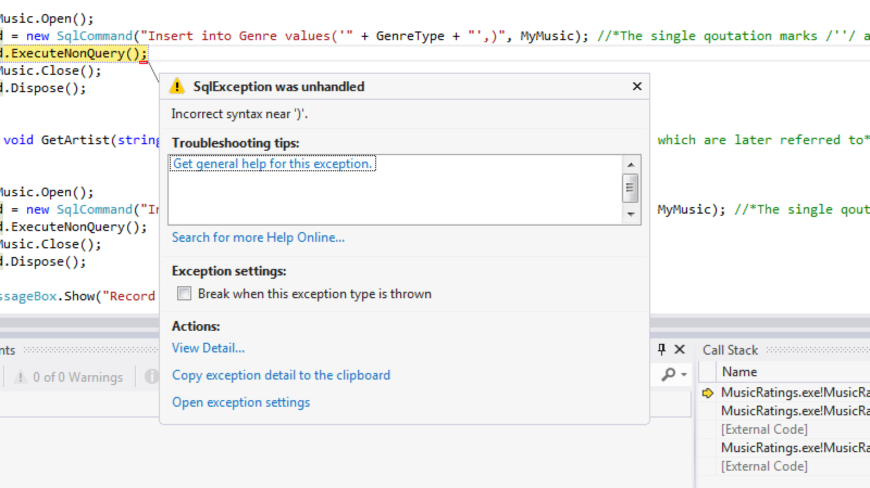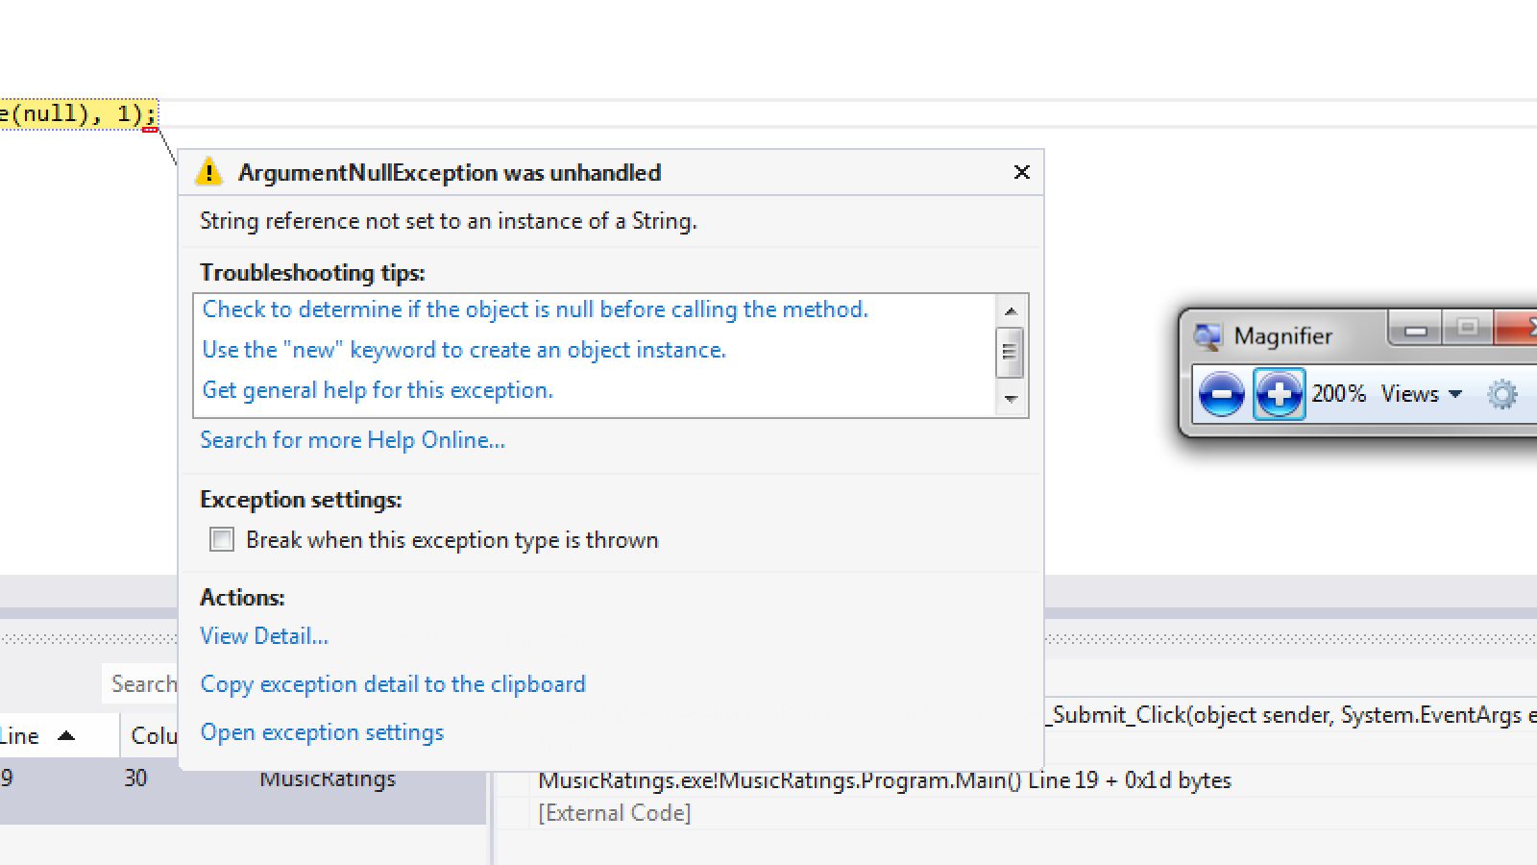

3.

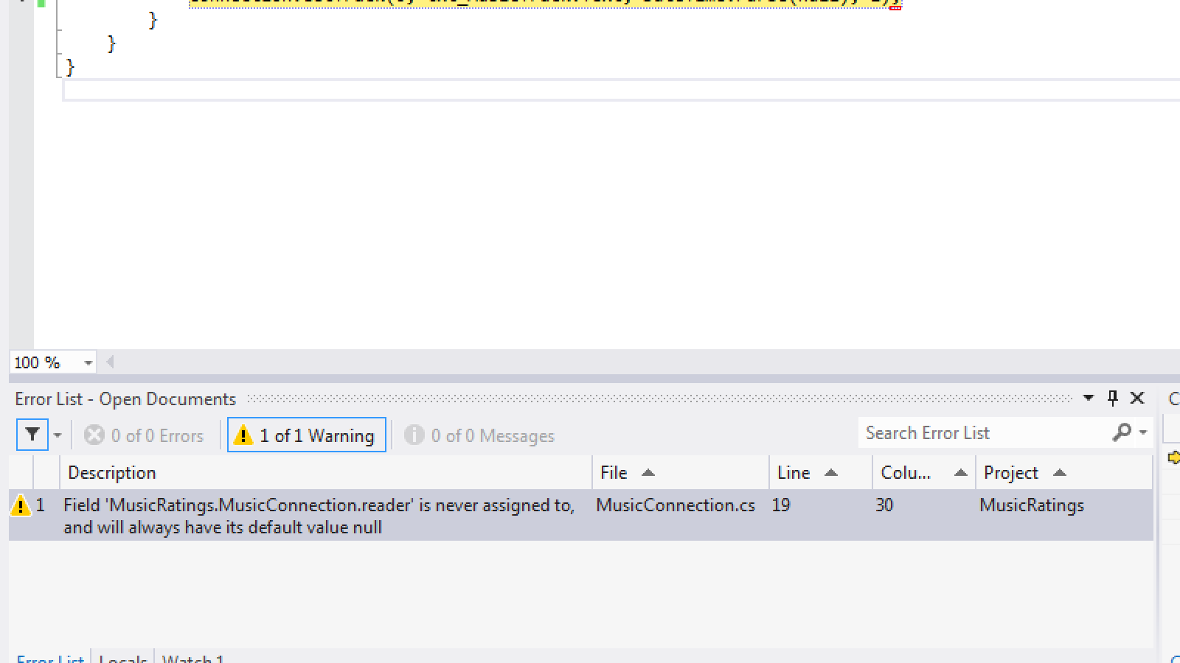

4.and 5.

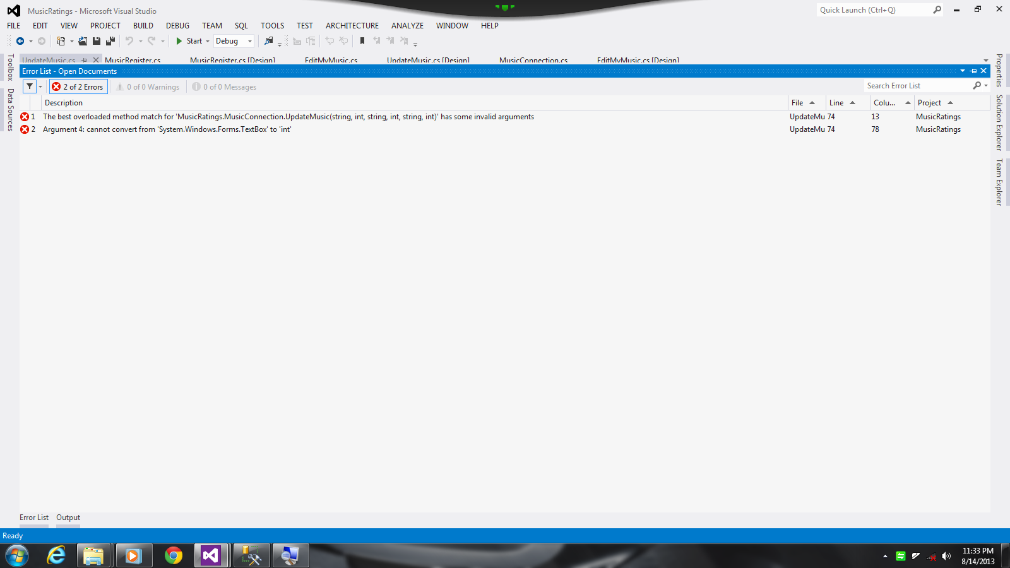

6. 7.

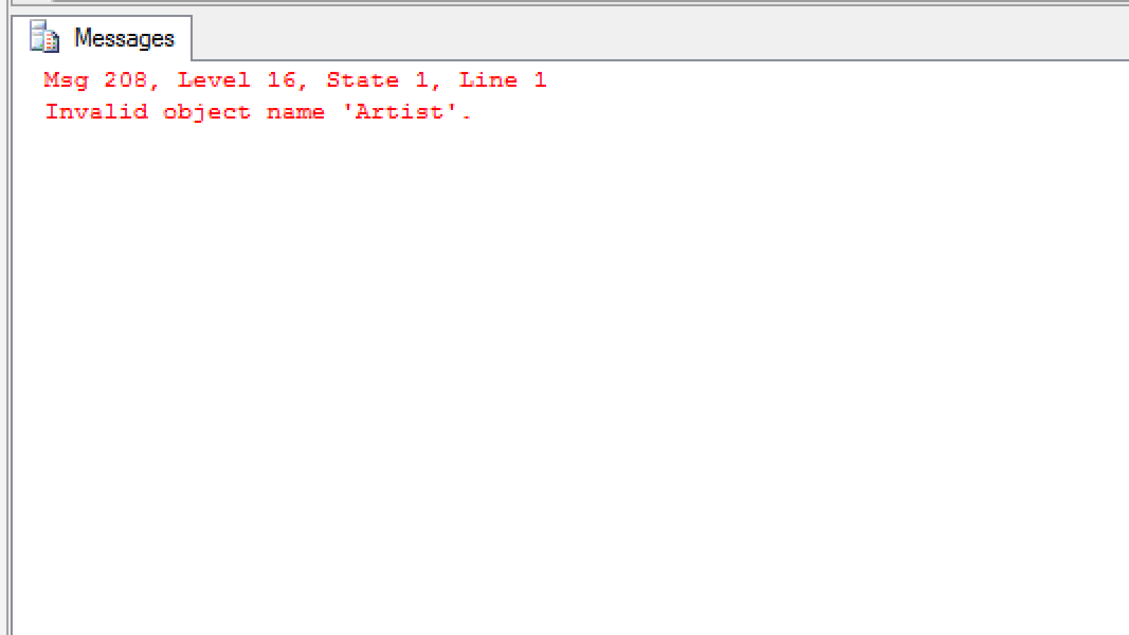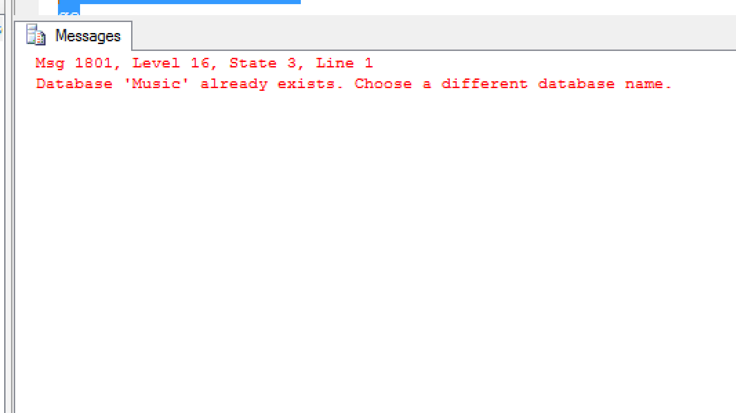

8.

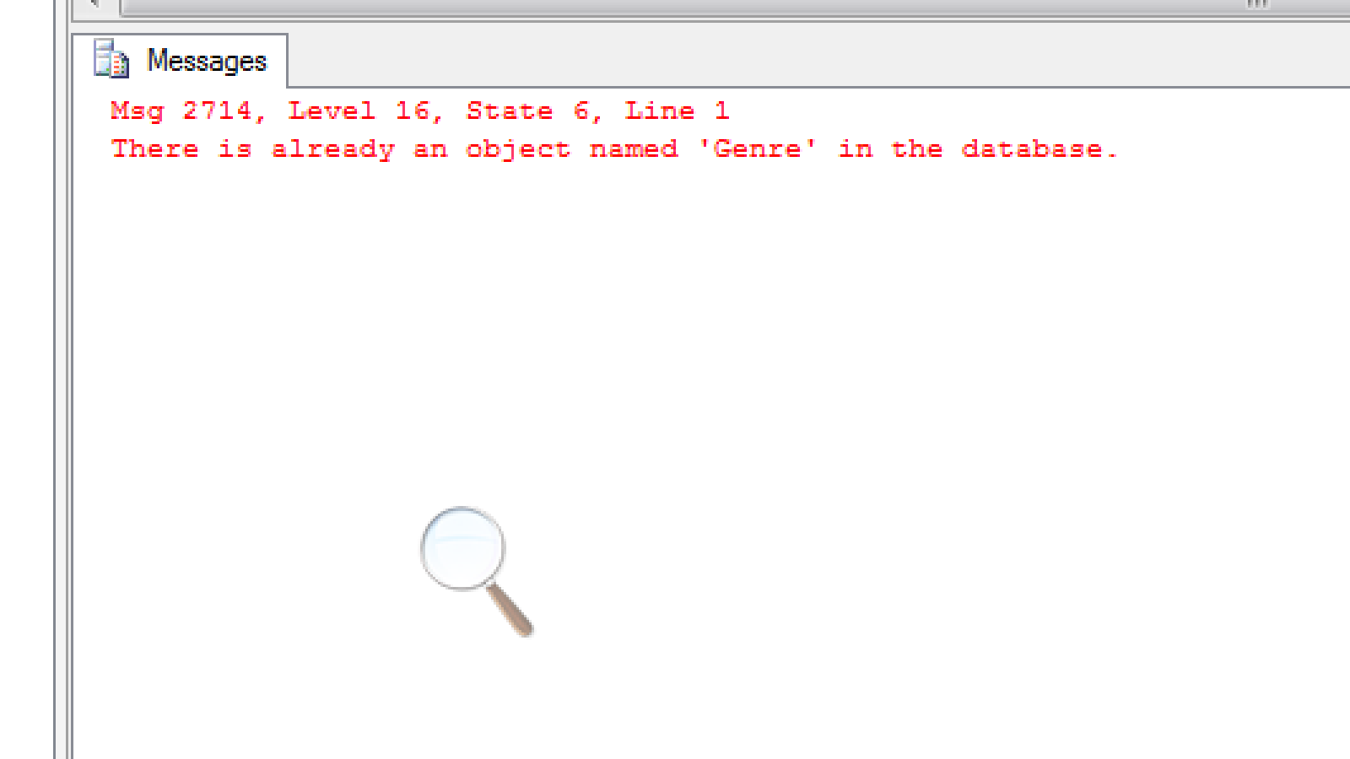

9.

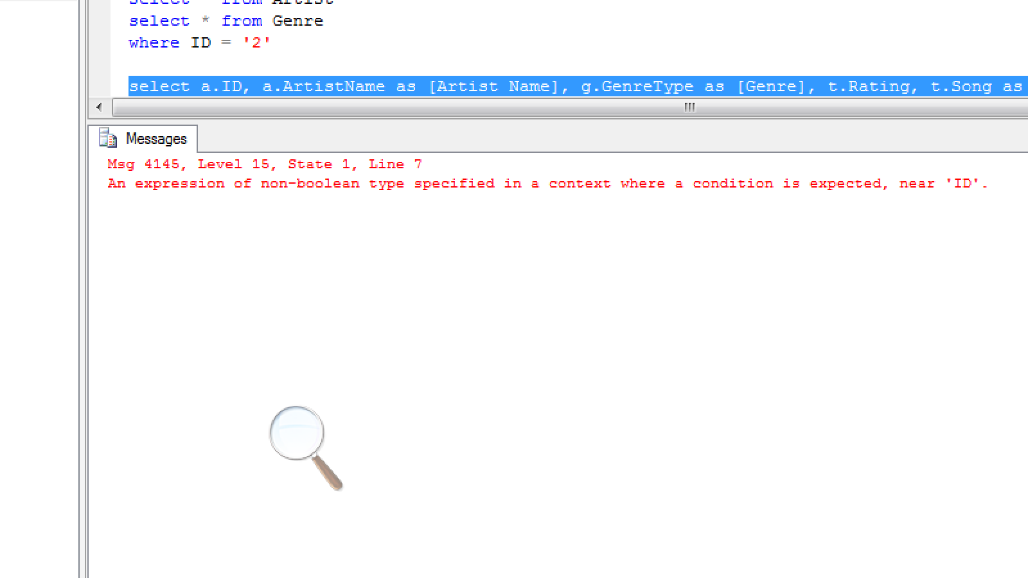

10.

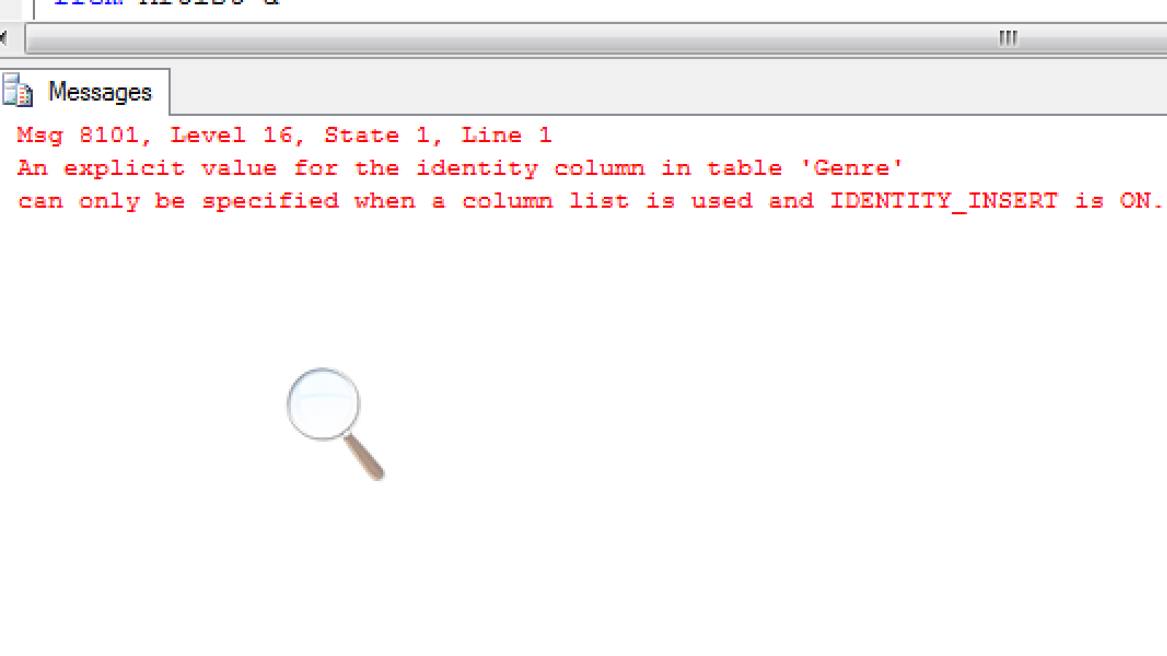

11.

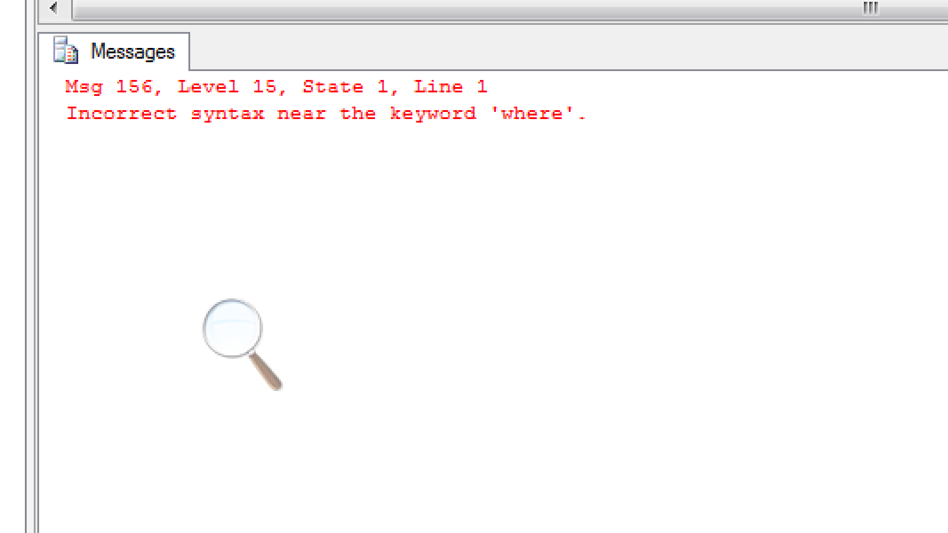

12. 13.

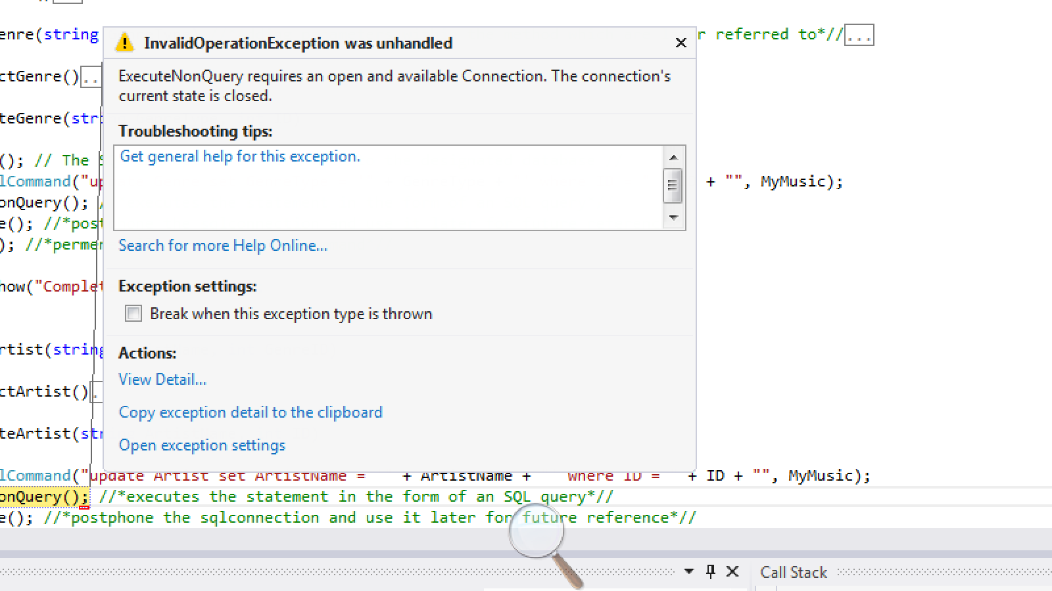 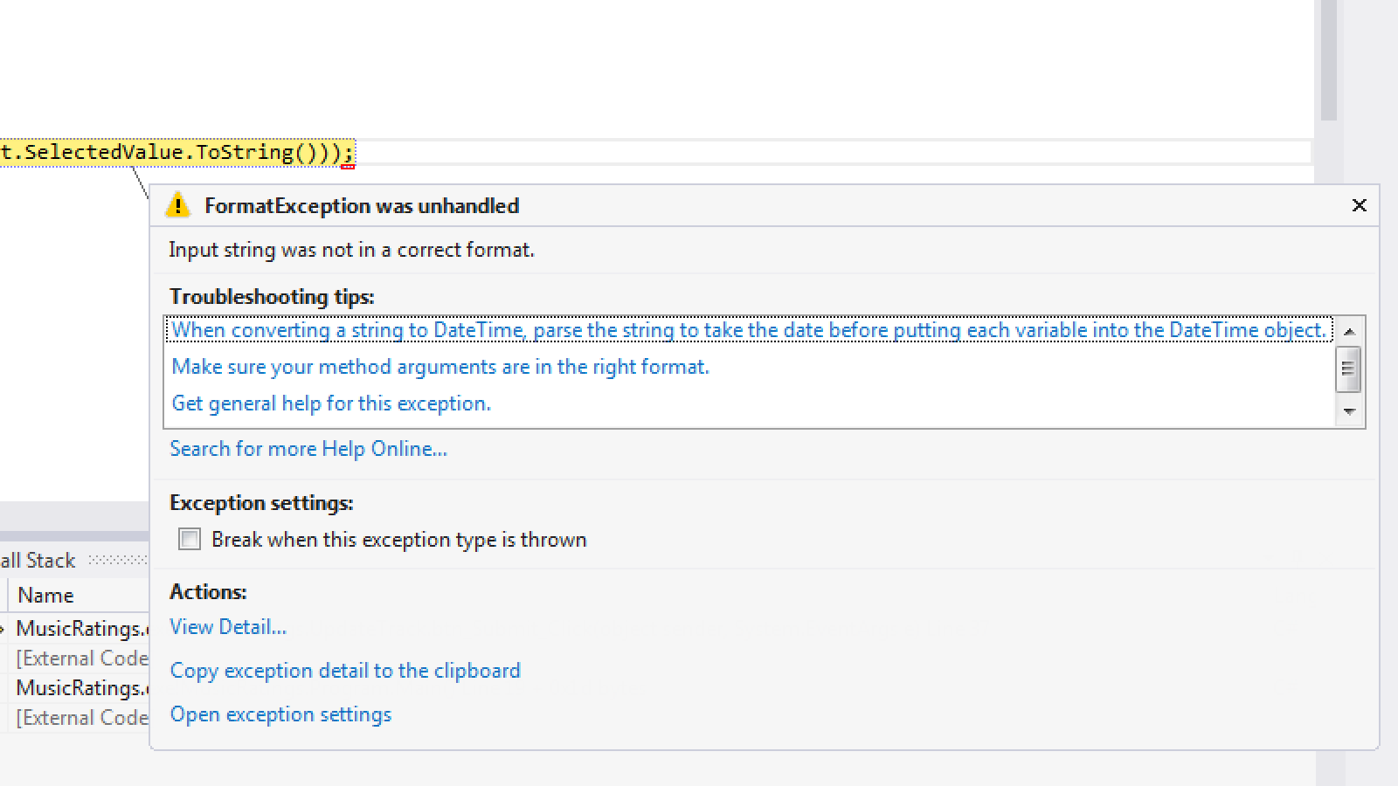

Here are the errors I have encountered:

|  |  |
| --- | --- |
| Problems | Solutions |
| 1. Visual studio   Sql-Exception was unhandled  Incorrect syntax near ')'. | I used the try/catch method handler to prevent this exception from occurring. |
| 1. Visual studio   Argument Exception was unhandled  String reference not set to an instance of a String. | One of my textbox was not in a format of a string.  I added the word “Text” just after the designated textbox. |
| 1. Visual studio   Warning:  'MusicRatings.MusicConnection.reader' is never assigned to, and will always have its default value null | I assign the SQL reader to the SQL command query so it can be executed. |
| 1. Visual studio   The best overloaded method match for 'MusicRatings.MusicConnection.UpdateMusic  (string, int, string, int, string, int)' has some invalid arguments | The argument rendered in this class does not correspond with the method assigned within another class. To undo this mistake, I made sure to set each parameter with the required variables types. |
| 1. Visual studio   cannot convert from'System.Windows.Forms.TextBox' to 'int' | A textbox cannot be set as an integer value. It is an object, not a variable type. |
| 1. SQL   Msg 208, Level 16, State 1, Line 1  Invalid object name 'Artist'. | The current database did not recognize the table named ‘Artist’. My outcome was to create this table so it could be later located inside the database. |
| 1. SQL   Msg 1801, Level 16, State 3, Line 1  Database 'Music' already exists. Choose a different database name. | The database ‘Music’ already exists in the server thus there is no need for me to create another one. |
| 1. SQL   Msg 2714, Level 16, State 6, Line 1  There is already an object named 'Genre' in the database. | The table ‘Genre’ already exists in my current database thus there is no need for me to create another one. |
| 1. SQL   Msg 4145, Level 15, State 1, Line 7  An expression of non-boolean type specified in a context where a condition is expected, near 'ID'. | Given the condition where I must locate a specific field or row, I use an integer value to reference the ID number. |
| 1. SQL   Msg 8101, Level 16, State 1, Line 1  An explicit value for the identity column in table 'Genre'can only be specified when a column list is used and IDENTITY_INSERT is ON. | The specified column can only be assessed once it has been referred to its table. |
| 1. SQL   Msg 156, Level 15, State 1, Line 1  Incorrect syntax near the keyword 'where'. | The query cannot be executed before syntax is correctly inserted in. The word ‘where’ describes the destination located within the database. Due to this, I refer to a specific table along with the attribute or column associated from within the table. |
| 1. Visual studio   ExecuteNonQuery requires an open and available Connection. The connection's current state is closed. | Within the designated method, I refer to the SQL connection string to open the database before a query can be executed. |
| 1. Visual studio   Input string was not in a correct format. | I use the try and catch method to ensure the user is alerted about the mistake he/she rendered. |